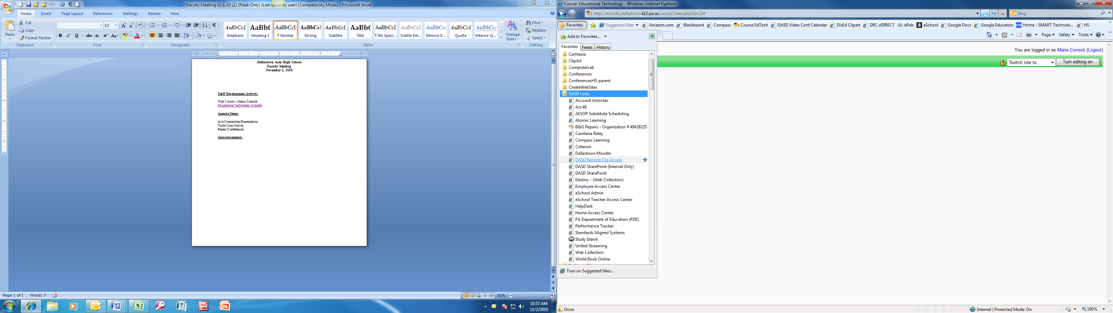

To access lesson plans in SharePoint, please login to the computer

1. Open the internet
2. Click on Favorites
3. Click on DASD SharePoint

User name and password are identical to your login and password

1. Click on the Substitute Files tab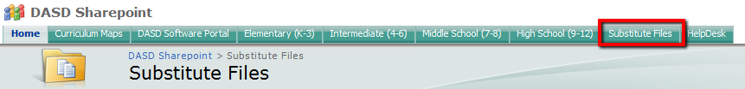
2. Open the teacher folder by double-clicking