Name: U.S. History I
Date: Mr. Melhorn
Period:
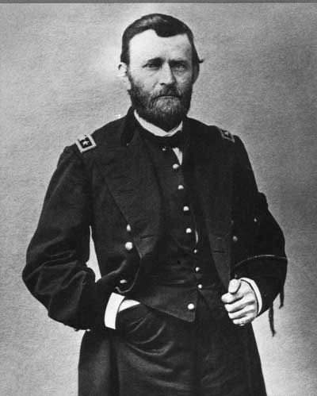
End of the Civil War Powerpoint Notes
1. When did Grant take over the position of the Union Commander?

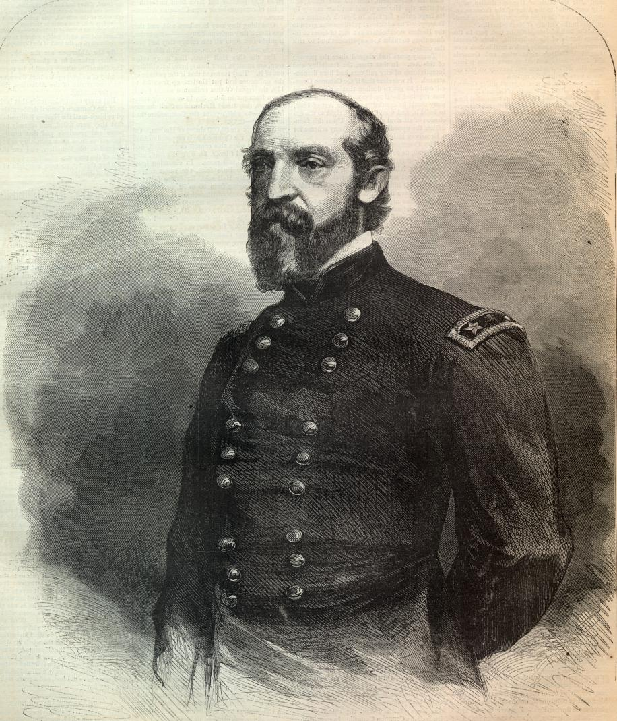
2. Why did Abraham Lincoln and the U.S. War Department feel that George Meade should be replaced?

3. What was the attack plan of Ulysses S. Grant to finally win the War?

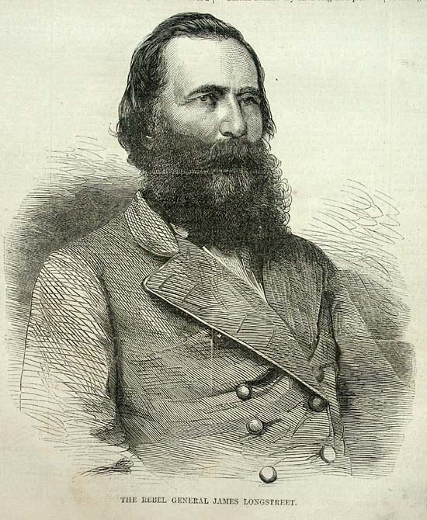
4. Where was the Wilderness?

5. What was strange about this area of the Wilderness?

6. What significant Confederate casualty occurred at the Wilderness?

7. Who won the Battle of the Wilderness?

8. What movement by Grant brought the Union and Confederates to
fighting in Spotsylvania?

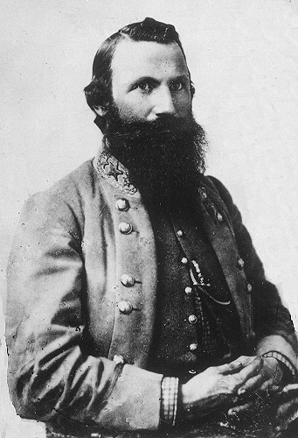
9. What significant Confederate casualty occurred during the time
of the Battle of Spotsylvania?

10. Who won the Battle of Spotsylvania?

11. Where did William Tecumseh Sherman attack in his “March to the Sea?”

12. What did Sherman do to Atlanta?
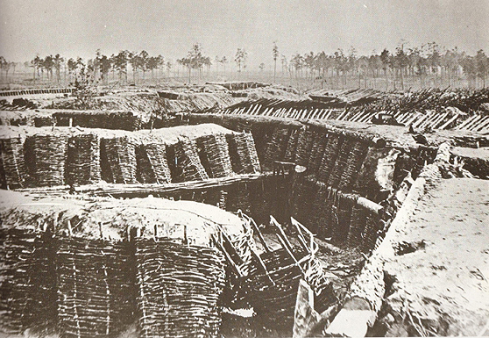
13. What did Sherman do to the land and the homes along the way to Savannah?

14. What movement by Grant led to the Battle of Cold Harbor from June 1-3, 1864?

15. What new style of warfare could be seen at the Battle of Cold Harbor and at Petersburg?

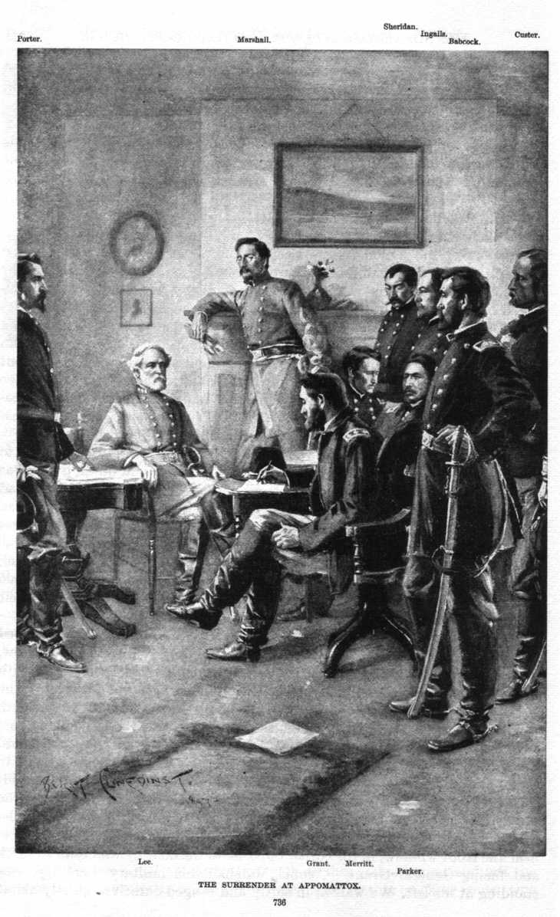
16. How did Grant finally outsmart Lee leading to the Battle of Petersburg?

17. For how long did the siege of Petersburg last?

18. When did Robert E. Lee finally call for the evacuation of Richmond?

19. When and where, finally, did the peace negotiations between Robert E. Lee and Ulysses S. Grant take place?

