Name: U.S. History I
Date: Period: Mr. Melhorn
Gettysburg
Power-point Questions
1. When did the Battle of Gettysburg take place?
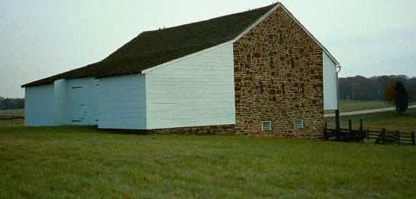
2. Where did the Day 1 fighting occur at the Battle of Gettysburg?
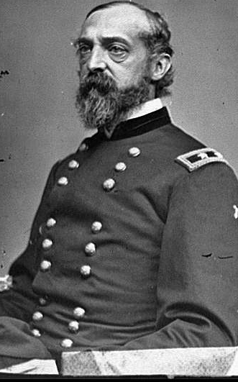
3. Who was the new Union Commander at the Battle of Gettysburg, gaining the leadership merely 2 days before the battle began?

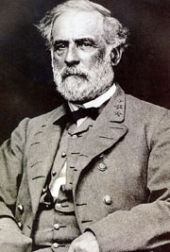
-Who is the overall commander of the Confederate forces?

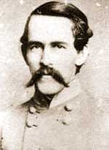
4. Why were the Confederates, led by Robert Rodes, coming to Gettysburg?

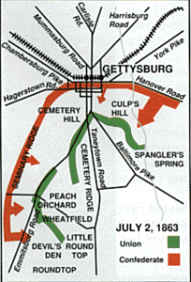
5. Which forces, Union or Confederate, fled into the town after the first day’s fighting?
-How many casualties were there from the first day?

6. Upon what ridge did the Union set up their troops for the second day’s fighting?
-Upon what ridge did the Confederates set themselves for the second day’s fighting?
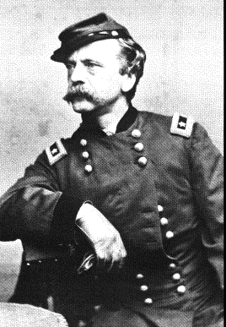
7. Who was the Union General who led his troops out to the Peach Orchard on the morning of July 2, causing his troops to be cut off from supplies and reinforcements?

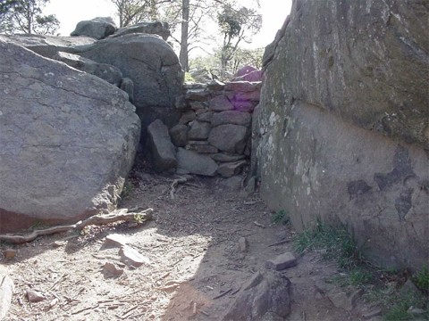
8. What area was taken by the Confederates just before 4:00 P.M. on July 2nd? This strange geological formation is a group of boulders and, after taking this area, the Confederates now centered their efforts on Little Round Top. What was that area called?

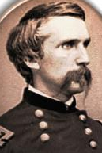
9. Who was the Union Officer that led the 20th Maine in defending Little Round Top for the Union versus Confederate troops on July 2, 1863?

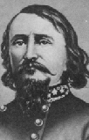
10. What percentage of the Confederate troops did not even make it past Emmittsburg Road while on Longstreet’s Assault/Pickett’s Charge?

11. Where was the aiming point for the Confederate troops taking part in Pickett’s Charge?

12. Longstreet’s Assault or Pickett’s Charge began with two hours of at 1:00 P.M. on July 3, 1863.
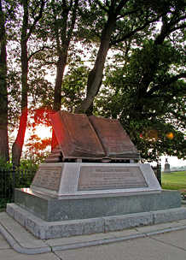
13. According to the figures from the powerpoint (which are the figures provided by the Gettysburg National Military Park), how many total casualties were there at the Battle of Gettysburg?

14. What speech did Abraham Lincoln give on November 19, 1863?

