Bacteria
Domain:
Kingdom:
Characteristics
- Lack
- Usually _____________________________ than eukaryotic cells
- __________________ cells but can form ________________ or _________________________
- Single _____________________ piece of _______________________
- Reproduce by ____________________________________________
  - Can divide every ______________________________________
  - Limited ________________ source reduces actual __________________
______________________________________
- _____________________ that spins for ________________________________
  - Some have ____________________
    - ___________________ and _____________________ than flagella
    - Used for _______________________________
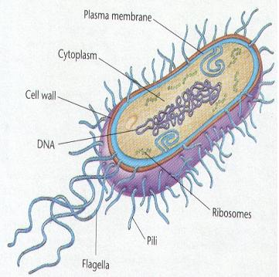
- ______________________ or ______________________________ metabolism
Classification of Bacteria
- Ways Bacteria are classified
- ___________________________ – most common way to classify
- ________________________________ (Number/ size)
- ___________________ requirements
- __________________________ requirements
- How they _____________________/number of _____________________
- Cell ______________________________ composition (gram staining)
- Method of _____________________________ – rarely used

Bacterial Shapes
- Bacillus = ________________________ 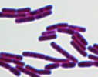

- Coccus = ________________________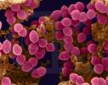

- Spirillum = ________________________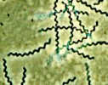

Bacterial Arrangement
- Diplococcus = __________________________ bacteria cells 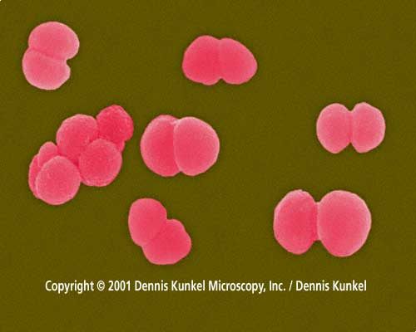

- Streptococcus = ____________________________ bacteria 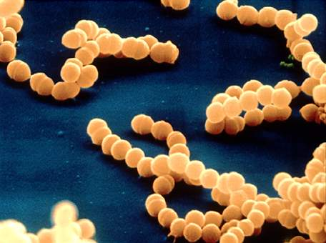

- Staphylococcus = ____________________________ bacteria 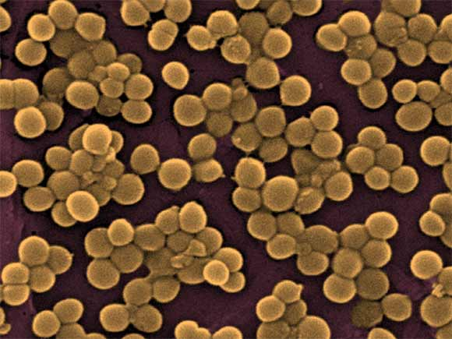

- Tetrad = ____________________ bacteria in a __________________ 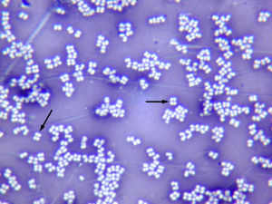

- Diplobacillus = _______________________________ shaped bacteria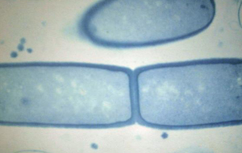

- Streptobacillus = _____________________________ shaped bacteria 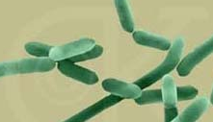

Bacteria Facts
- Bacteria is ________________________________
- The number of bacteria in the _________________________ mouth is greater than the
number of people who _____________________________ on the earth.
- ____________________________________ is a scientist who studies bacteria.
- Bacteria is grown in a lab as a _____________________ with nutrient
_____________________________ (___________________ ____________________).

Gram Staining
- Used to identify the ________________________ of bacteria present
- Used to determine the best __________________________ needed to kill the bacteria
- Antibiotic =
- _____________________________________________________ – penicillin inventor

Why are bacteria so resistant?
- Endospores =
- Ex-
- Endospores will open up when ______________________________________________.

Bacteria Structure
- Draw a bacterial cell. Label cytoplasm, DNA, ribosomes, flagella, pili, capsule, cell wall, cell
membrane

Obtaining energy (nutrition)
- Photosynthetic =
- Heterotrophs =
  - Saprophytes = Eat ____________________ organisms
  - Symbiotic relationships =
    - Mutualism = both organisms are ________________________
      - Example=

    - Parasitism =
      - Host = organism that is _____________________
- Chemoautotrophs
  - Use ______________compounds such as ___________________ and ________________________________________ to make food
  - Use _________________ compounds such as ________________________ to make food

Respiration
- Obligate aerobes –
- Obligate anaerobes –
- Botulism –
- Facultative anaerobes –
Economic Importance
- _____________________________ – disease causing
- Examples: tuberculosis, ___________________, bubonic plague, cholera, ______________________, lyme disease, typhus, _____________________, acne, ______________________, stomach ulcers
- ___________________ Poisoning
- ________________________
- ______________________ (ground beef)
- __________________ spoilage
- _______________________
- _____________________ Production
- _________________, buttermilk, ________________, sauerkraut, olives, _______________________, ____________________________ bread, sausage
- Make __________________
- ________________, _____________________, _________________________
- Mining
- Extracts ______________________ from impure sources
- Clean up ________________________ and ____________________________ spills

Preventing Food Spoilage
- ________________________________
- ________________________________
- ________________________________
- ________________________________
- ________________________________
- ________________________________

