[www.voki.com](http://www.voki.com)

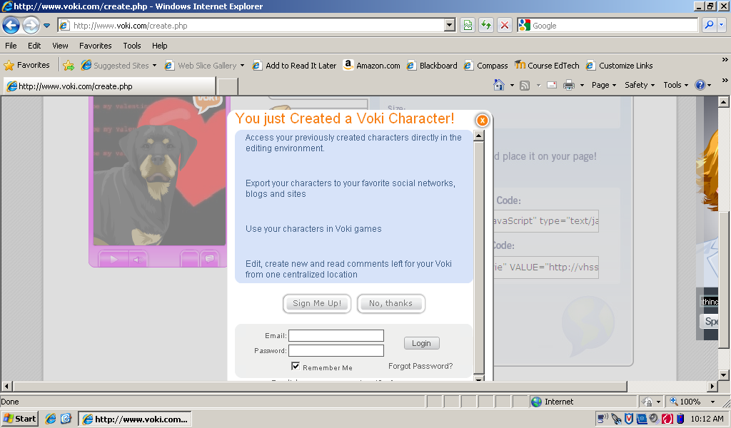When you are finished creating your avatar, follow these steps:

1. Click on **Publish**
2. Click **Save**
3. Click **No thanks** when asked to sign up.
4. **Copy the Embed code**
5. Open Moodle and turn editing on
6. Click on Add a Resource
7. Insert a Label
8. Click on <> (Toggle HTML Source)

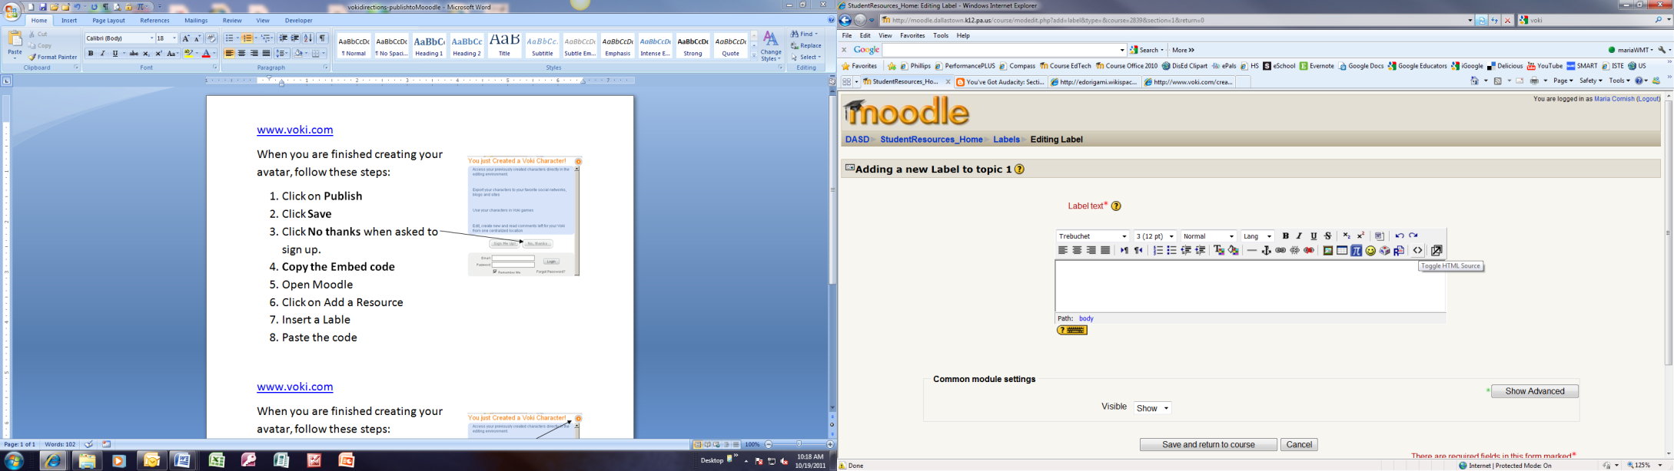

1. Paste the code
2. Save and return to course