Viruses
What is a Virus?
- Segments of nucleic acids wrapped in a _____________________ coat.
- They are not ________________________.
- Smaller than ________________________________ cells.
- Visible only with _________________________________ microscope.
- Are _________________________ = _____________________ causing
- Do not _________________, have ___________________, or _______________________.
- They reproduce by ____________________ cells and using the cell to make more _____________________________.
- In Latin, virus means “_______________________”.
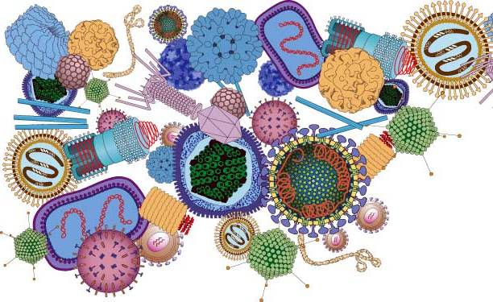
Viral Structure
- Protein coat = ______________________________
- Contains _______________ or _______________, but not both.
- Surrounding membrane of the capsid = ________________
- RNA viruses
- _________, ___________________, _______________
- DNA viruses
- ________________, ________________________________, ____________________________
- _____________________________ = protein with carbohydrates and specific enzymes
Viral Structure
- Viruses come in many _____________.
- Long _______________ (Ebola)
- ________________ (influenza)
- ______________________ (tobacco mosaic)
- ________________________ (many sided) adenoviruses (Respiratory illnesses)
Bacteriophage
- Virus that infects ________________________________ cells
- Most common bacteriophage is the ____________________
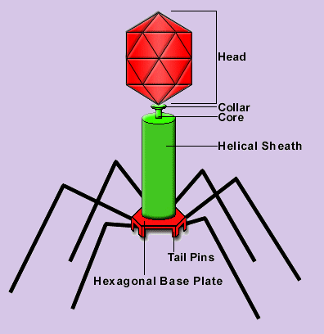

Viral Reproduction
- Most viruses reproduce inside _________________________ cells. What makes this an ideal place?
- Bacteria reproduce ___________________________
- (every ___________ minutes)

- _________________ types of reproductive life cycles are known.
1. Lytic Cycle
- Virus attaches to ________________ cell and injects its ________ into the bacteria
- Uses the host bacteria cell to replicate the ____________________ ____________ and _______________ _____________ (capsid).
- Virus ____________________ the bacteria cell by ___________________ the cell and releasing ___________ viruses.

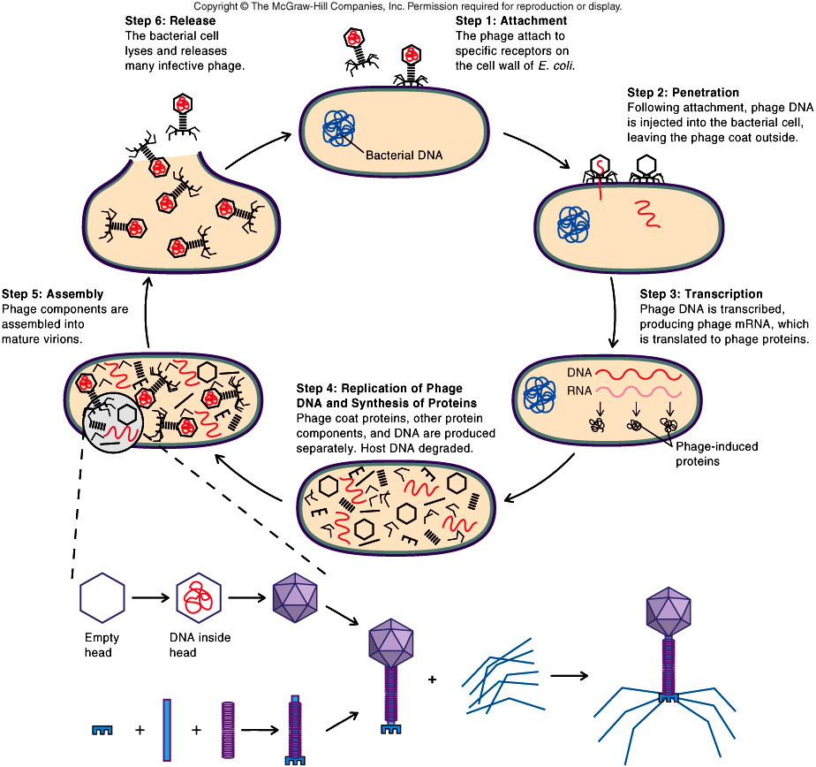
2. Lysogenic Cycle
- Virus attaches to ______________ cell and injects its ________ into bacterium and ____________________ with the bacteria’s DNA
- It is now called a __________________
- Host cell divides ______________________—along with the viral DNA (Virus remains ____________________ inside bacteria)
- If _______________________ of bacteria cell changes, the virus will enter the _________________ cycle and destroy the bacteria cell to release _________________________ viruses
- ____________________ Blisters (cold sores)
- Virus hides deep in __________________ cells
- When conditions become _____________________ (such as stress) the virus _____________________ cells and causes tissue damage, which is a _________________________ blister or _______________________ sore.
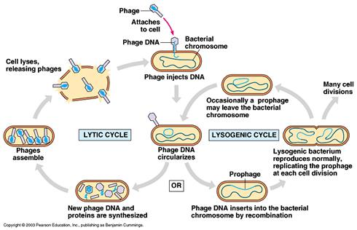

Viral Diseases

- (severe acute respiratory syndrome)

Viral Diseases
- Some viruses cause ______________________
- Hepatitis B → ______________________ cancer (vaccine available)
- Epstein-Barr virus → __________________ _________________
- HPV (Human papilloma virus)→______________________ cancer (vaccine available)
Emerging Viruses
- _____________________ arrived at a location or a new _________________ virus form
- 1999- ___________________ __________________ virus arrives in US
- Came to US on an infected ______________________
- Mild ___________________-like symptoms
- Causes brain ________________________ in elderly or infirm → death
- _____________________________ virus
- _____________________ US - 1993
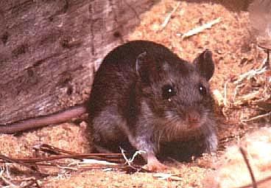
- Found in ___________________________ droppings
- Virus is ______________________ to 38% of its victims
Prions
- Stanley Prusiner found a new class of __________________________ called prions.
- They contain __________________________ but no ______________ acids.
- Cause diseases such as _______________________ (brain disease in sheep), _____________ ___________ ____________________ (brain disease), ______________________-________________ disease (human version of mad cow disease).
Viroids
- Single stranded __________________ with no ______________ coat (capsid)
- Usually affect ____________________ plants such as cucumbers, ___________________, avocados, __________________
Vaccines
- Vaccines prevent a person from ___________________ a disease.
- __________________ or ________________ form of the virus injected into body
- Body __________________ virus and builds _______________________ against the disease.
- Antibodies ___________________ and _____________________ the virus immediately if it enters the body again
- __________________ and _____________________ have been eliminated from earth due to vaccinations
- ___________________ _____________________ –polio vaccine

