

U.S. History I Class Syllabus
Mr. Melhorn Office: Rm. 28 Email: Thomas.Melhorn@Dallastown.net

Scope and Sequence of the Class
I. Introduction to the Class and Three Civics Units
- 1. Declaration of Independence, Articles of Confederation, and the Constitution
- 2. The Bill of Rights
- 3. A Mix of topics such as Naturalization, the Electoral Process, Interest Groups, and Local Government

II. Review of the significant historical events you learned in the 8th Grade U.S. History Class
- Presidencies of Washington, Adams, Jefferson
- Market Revolution and the changes in society due to this monumental change
- Events Leading to the Civil War, relating mostly to the battle over slavery

II. Review of the Civil War and Reconstruction (Chapter 13)

III. Expansion: Rewards and Costs
- Chapter 14- The Expansion of American Industry
- Chapter 15- The West
- Chapter 16- Politics, Immigration, and Urban Life
- Chapter 17- The Gilded Age (Gilded- covered in a thin sheet of gold)

IV. The United States on the Brink of Change
- Chapter 18- Late 1800’s/Early 1900’s- Becoming a World Power
- Chapter 19- Progressivism and Reform
- Chapter 20- World War I

V. Unit 5- Boom Times to Hard Times
- Chapter 21- The 1920’s
- Chapter 22- The 1929 New York Stock Market Crash and Depression
- Chapter 23- The New Deal

Assignments expected of the U.S. History I Student
I. Tests, Quizzes, and Quests- the types of questions will range from multiple choice, fill-ins, matching, identifications, short answer, and essay.

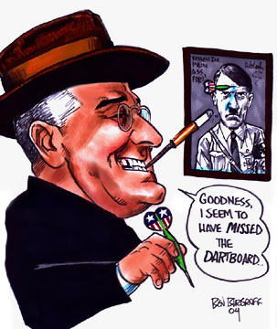

II. Group Presentations and Projects based upon events, political documents, or political figures, completed using computer-based applications or a tangible product.

III. Written reports and blogs based off of important topics or persons discussed within class or studied within personal research

IV. Individual Presentations (sometimes live and occasionally posted on a Wiki/Moodle

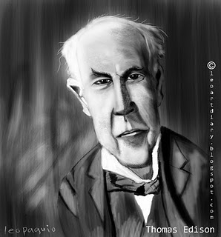

V. Check-up Quizzes on Homework Readings

VI. Class Participation (measured in ability to remain on task, especially while using technology.

Classroom Rules and Expectations
1. Students must be respectful of the teacher at all times. Students should not be talking and may not complete any other work while we are in our classroom session. Also, backpacks should be on the floor, not on your desk.

2. Be Courteous to your classmates. Respectful interaction with your classmates is what I expect and demand.

3. Be prepared for class when the bell rings.

4. All school rules apply in the classroom. We will not have any food or drink in the classroom. All cell phones should be off, not on vibrate (if I see any of these items, they will be confiscated).

5. You will be attentive- lounging around and laying your head down will be considered disrespectful towards the teacher and your classmates.

6. The teacher will dismiss students from class.

7. Tardies- Three or more tardies in a marking period will result in detention.

Late Work Policy
-Anytime a piece of homework or assigned work (essays, take-home tests) is late, there will be a penalty. For each day the piece of work is late, there will be a penalty of a full letter grade, or 10%. If the work is late for a matter of 5 days or more, then the assignment is a 0% in the grade-book.

Absentee Policy
-First note of importance, Absentee work is your responsibility! If you are absent, it is your responsibility to come to me and find out what you have missed.

-When you return from absence, please ask me where you may pick up the work you have missed (In many situations I will simply have a packet ready for you).


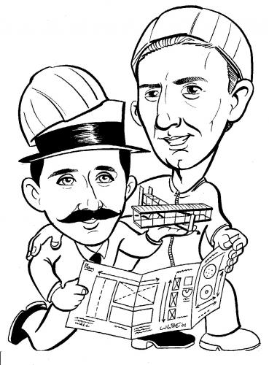
-If you are absent for a test or quiz, you should make arrangements on the day you return to take it as soon as possible!

Extra Credit
-Unless there is an extreme situation where an individual is only a point away from the next highest grade, there will be no extra credit.

Record Keeping Concerning Grades
-Your Grade in the class is based upon your points out of the total points possible. You are to keep your own grade sheet- it is not my responsibility to take time out of class to tell you what your percentage is.

