Keyboard Shortcuts
Ready Reference

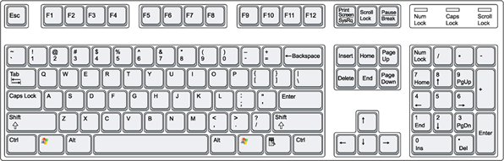
+ E Opens My Computer
Displays the Start Menu
+ D Minimizes all windows and shows the Desktop
+ D Opens all windows, right back to where you were
+ L Lock your computer

FILE
Ctrl + S = Save
Ctrl + N = New Document
Ctrl + O = Open Saved Document
Ctrl + P = Print
Ctrl + W = Close
PARAGRAPH ALIGNMENT
Ctrl + L = Left Aligned
Ctrl + R = Right Aligned
Ctrl + E = Center Aligned
Ctrl + J = Justified
LINE SPACING
Ctrl + 1 = Single Line Spacing
Ctrl + 2 = Double Line Spacing
Ctrl + 5 = 1-1/2 Line Spacing
FONT STYLES (with text selected)
Ctrl + B = Bold
Ctrl + I = Italic
Ctrl + U = Underlined.
PAGE SCROLLING
Ctrl + Home = Top of Document
Ctrl + End = Bottom of Document
Ctrl + Page Up = Top of Page
Ctrl + Page Dn = Bottom of Page
EDIT
Ctrl + A = Select All
Ctrl + X = Cut
Ctrl + C = Copy
Ctrl + V = Paste
Ctrl + F = Find
Ctrl + H = Find & Replace
Ctrl + Z = Undo Ctrl + Y = Redo



+ Tab

+ Left

+ Right
Toggle between open windows
Back in Internet Explorer
Forward in Internet Explorer

