The Mighty Right Click

One principle when working with software is this: When in Doubt, Right-Click on it.
People get stuck when trying to accomplish things on computers. It’s the nature of the beast, and a large element to working effectively with computer software is figuring out how to get “unstuck” quickly. Nothing ruins a day or a project faster than spending an hour trying to figure out how to get a table to line up correctly in Microsoft Word, or figure out how to correctly print an Excel spreadsheet.
Computer novices often think that experts never get stuck while doing things on computers, but this is not the case. No matter what level of expertise you attain with hardware or software, you will always and forever be problem solving on computers. Simply put, both expert and novice computer users get stuck all the time; it’s just that expert computer users know how to get unstuck very quickly, sometimes so fast that it seems like they never got stuck in the first place.
Although a lot of getting unstuck relates to how much you know, there are some general principles that can often help no matter what application you are using, and no matter what level of expertise you have.

http://savvytechtips.com/the-mighty-right-click.htm
December 5, 2006

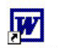
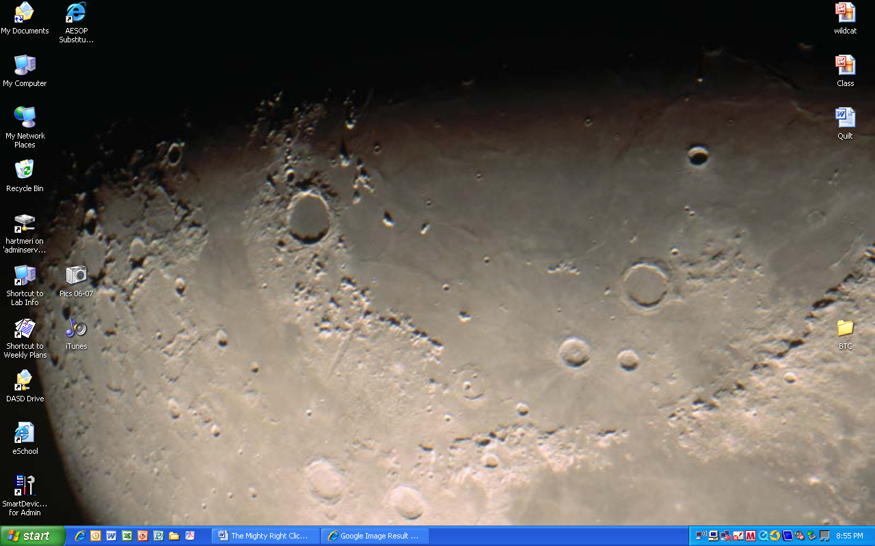
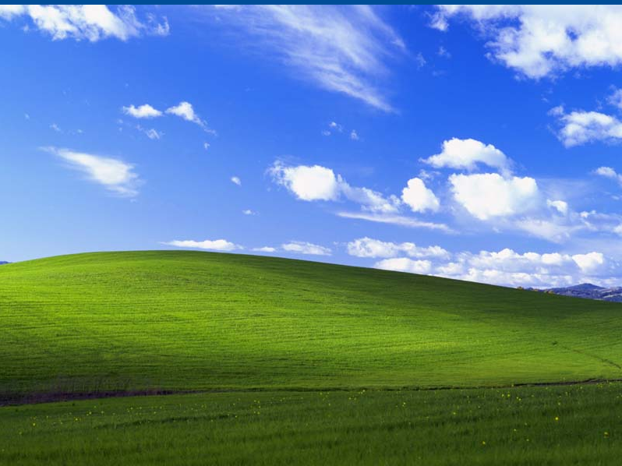
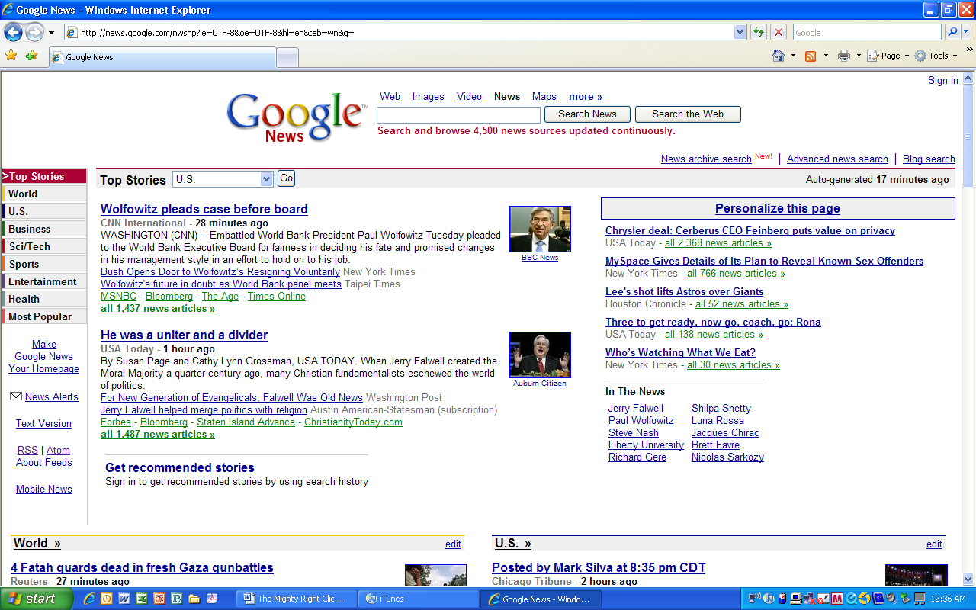
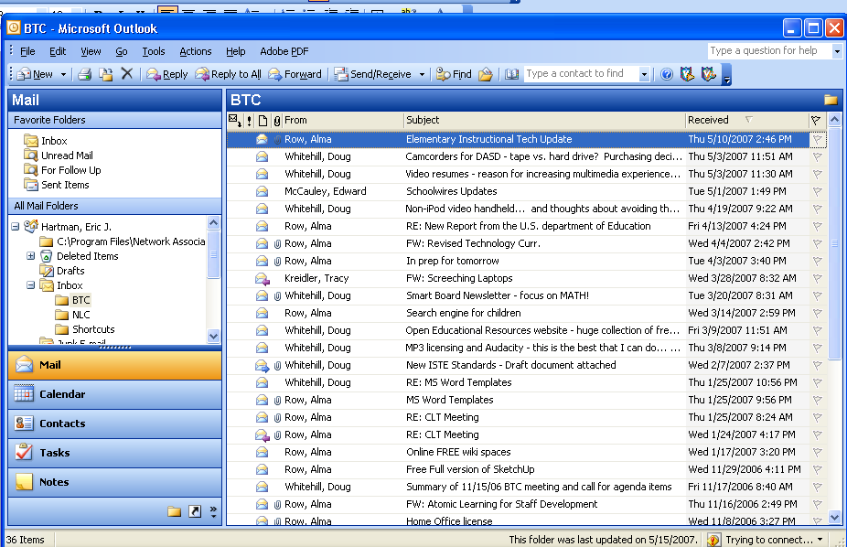
R-Click in Word to access:

- Cut/Copy/Paste
- Font
- Hyperlink
- Synonyms
- Translation
R-Click in Outlook to access:

- Create Rule
- Junk Email list
R-Click in Internet Explorer to access:

- Create Desktop Shortcut
R-Click the Desktop to access:

- New Folder
- Properties
  - Background
  - Screen Saver
  - Power
R-Click a Folder to access:

- Create Desktop Shortcut
- Rename
- Properties
  - Security
  - Folder Icons
R-Click the Taskbar to access:

- Tile/Cascade Windows
- Show Desktop
- Quick launch Shortcuts
- Auto Hide
- URL Address Bar

