BIOLOGY I – Level 1
COURSE REQUIREMENTS
Mrs. Fishel

Classroom Rules
- Be in your seats with your notebook and writing utensil before the bell rings. Backpacks belong on back counter (Do not block fresh air flow.) or on chairs along side of room.
- Be prepared for class each day. If unprepared, a tardy will be given.
3 tardies = 1 night detention.
- Be attentive while someone is speaking.
- Be respectful towards others and property.
- Use appropriate language and behaviors.
- Stay out of lab area unless told to be there.
- Remain seated and on task until dismissed by the teacher—not the bell.
- Follow all school rules.
- NO FOOD IS PERMITTED IN CLASSROOM. WATER/DRINKS IN A RESEALABLE PLASTIC BOTTLE ONLY. NO GLASS.

Materials needed for class
- Three ring binder with notebook paper
- Writing utensils-pens or pencils

Grading System

Total points earned X 100 = your %
Total points possible

Grading Procedures
- Tests
- At the end of each chapter.
- Will announce 2-3 days prior.
- Various formats will be used.
- Students will use a review sheet or note card for each test.
- Quizzes
- Announced or pop variety
- Number of quizzes vary by topic (1-2 days notice is given)
- Labs and lab reports
- Various laboratory exercises will be conducted during each unit of study. Most labs will involve some form of written work, which will be submitted and graded. This will include creation of diagrams as well as a laboratory write up explaining what data was collected.
- Lab reports are due on the date given. Late labs will not be counted for credit. If absent, they are due upon return to school. If you are on a field trip on the day they are due, they are due PRIOR to leaving on the field trip.
- Level 1 lab reports consist of a title page, questions written out and answered, and all lab drawings done during class.

- Notebook checks
- Most notebook checks are open note quizzes and tests. Occasional spot checks can occur, usually when I suspect that a proper notebook is not being kept by the student.
5. Classroom Participation and Citizenship points
- Congratulations! You already have an “A” in Biology!
- At the beginning of each marking period, each student receives a total of 50 classroom participation and citizenship points (CP & C points)
- A student can retain all 50 points if all homework assignments are completed on time and the behavior of the student does not cause points to be deducted.
- Student’s total points will be added to the marking period grade at the end of each marking period only. This can be a huge asset to the overall marking period grade.
6. Homework checks
- Graded for completeness or correctness.
- When graded for completeness, points will be deducted from your CP & C points.
- When graded for correctness, assignments will be collected and graded by teacher.

Student responsibilities

- You are responsible for your own actions, behaviors, and work ethics.
- Be prepared for class and be on time each day. Remain attentive!
- When absent, you must present your admit slip to me before class in order to be given any make up work, if applicable. You have 2 days for each day that you were absent to make up missed work or to arrange a time to make up the work. I will NOT chase after you to make up work. Zeroes will result if work is not completed. Illegal absences will result in zeroes for that day. Be responsible!!
- Follow all directions, especially when in the lab. No “goofing” off will be tolerated in the lab area. If you are asked to sit down during a lab, you will receive a “0” for that lab, and given 1 night detention for your behavior. I cannot allow a student to endanger the lives of other students while working in the lab!
- Lav passes- Use the lav before class after first checking in with me. This will prevent you from being marked tardy. If I am talking to another student and you must use the restroom, sign out on the white board. If I don’t know where you are and you come in late, you will be marked tardy. No lav passes will be issued during a lecture or teacher led discussion. No more than 3 bathroom passes will be issued each marking period. More than 3 visits will result in loss of privilege and detention. No excuses. Unused passes at the end of the marking period can be turned in for bonus points.
- If any problems arise, please see me!!
- I can be contacted by phone at 244-4021 extension 3224 or by email at shelley.fishel@dallastown.net.

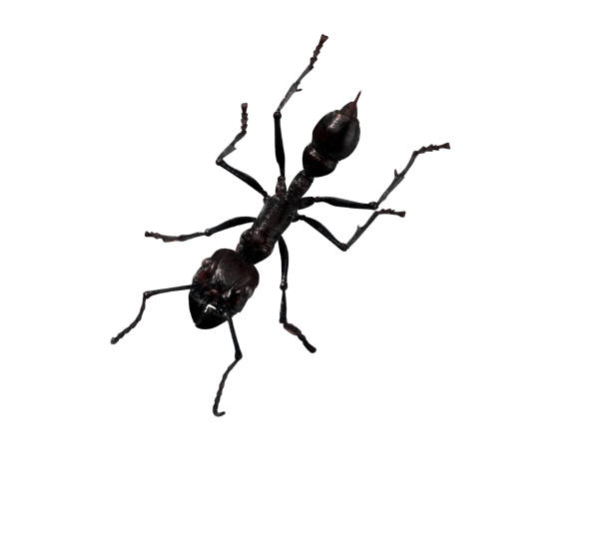

Classroom Participation and Citizenship Points

You will begin each marking period with a 50 out of 50 for classroom participation and citizenship points. You may keep these points if you conduct yourself appropriately during class. Examples of ways you can lose these points are provided below.

For example, you will lose CP & C points if you…

- Fail to be in your seat when the bell rings.
- Disrupt class.
- Fail to complete class assignments or homework.
- Do work for other subjects during biology class.
- Talk when you are not called upon.
- Sleep during class.
- Fail to follow classroom and /or laboratory rules.
- Destroy school property.
- Swear, use abusive language, or use inappropriate gestures.
- Fail to respect the rights and property of others.
- Leave your seat before dismissed at the end of class. The bell does not dismiss you…I do.

*** Reasons for losing points are not limited to the
list provided above.

You will lose 5 to 10 points for each infraction, depending on the severity of the infraction.
How will you know if you lost points? You will be informed about your point deduction after class. I will keep a record of the date of point loss and reasons why points were lost for each individual.

These points can be extremely beneficial to your marking period grade. Losing points will be harmful to your grade. These are your “bonus” points.

WELCOME TO:

B I O L O G Y | COURSE OVERVIEW
B I O L O G Y | UNIT I: INTRO TO BIOLOGY  Branches of Biology  Biological Vocabulary  Characteristics of Life  Scientific Method
B I O L O G Y | UNIT II: TAXONOMY AND EVOLUTION  Classification and Taxonomy (Intro to the 6 kingdoms)  Evolution
B I O L O G Y | UNIT III: CELLULAR BIOLOGY  Biochemistry  Microscope Usage  Cellular Structures and Functions  Cellular Processes (Photosynthesis, respiration, mitosis,  meiosis, diffusion, osmosis, protein synthesis)
B I O L O G Y | UNIT IV: GENETICS  Role of chromosomes  Genetic Inheritance  Genetic Disorders
B I O L O G Y | UNIT V: Ecology  Populations  Communities  Ecosystems; nature’s cycles, ecological succession  Biomes
B I O L O G Y | UNIT VI: Survey of the Kingdoms of Life  Viruses  Kingdoms: Bacteria, Protista, and Fungi  Comparison of Invertebrate Phyla  Comparison of Vertebrate Phyla  Plant Classification  Plant Structures

Information About YOU
Name (first and last)________________________________________________________

Name you wish to be called in class____________________________________________

Hobbies/Activities/Interests __________________________________________________
__________________________________________________________________________

What do you think you will like MOST about Biology? _____________________________

__________________________________________________________________________

What do you think you will like LEAST about Biology? _____________________________

_________________________________________________________________________

Do you enjoy reading?_____________ Why or why not?___________________________

_________________________________________________________________________

What makes reading a science textbook or article more difficult for most people than reading another source? ___________________________________________________

_________________________________________________________________________

Who was your 7th grade Life Science teacher? __________________________________

Who was your 8th grade Earth and Space Science teacher? _______________________

Who was your 9th grade General Science teacher? _______________________________

Do you have internet connection at home? _____________________________________

Special information that you want me to know about you. _________________________

__________________________________________________________________________

Ask me a question. _________________________________________________________

__________________________________________________________________________

Textbook number and condition ______________________________________________

Over please

Please take this sheet home tonight. Show it to your parents and have them fill in the information below and sign it. You will receive your first grade for this assignment. It is worth 10 points when it is returned. 1 point will be deducted each day that the assignment is late. Bring back tomorrow for maximum points.

Parents: Please fill in the contact information below. Then sign this page and send back to school with your student. They will receive points for this assignment. Also, please take a moment to read over my classroom expectations for this year.

Your student will be able to access most of my handouts, power points, worksheets, etc. that I give in class through a Moodle internet site. I will try to keep this as up to date as possible. This will be an excellent resource for students who are out of school for an extended period of time due to illness or educational trip. Internet connection is required.

Parent /guardian names ____________________________________________________

Parent/guardian email address _______________________________________________

Please sign below.

___________________________________
Parent/guardian signature

Thank you for your time. I can be reached at 244-4021 ext 3224 or by email at shelley.fishel@dallastown.net if you have any questions or concerns this year.

Shelley Fishel

