12-2 Pyramids

Pyramid -- a solid with a polygon base and triangular faces that meet at a
single point called a vertex
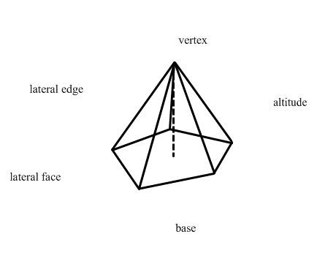
Regular pyramid --pyramid that has:
1.) regular polygon base
2.) all lateral edges congruent
3.) all lateral faces are congruent isosceles triangles
4.) the altitude meets the base at its center

slant height -- the height of the lateral faces

Lateral Area of a regular Pyramid with n lateral faces --
1.) Find the area of one lateral face and multiply by n.
2.) Use the formula L.A. = (1/2)pl

Theorem 12-3
The Lateral area of a regular pyramid equals half the perimeter of the base
times the slant height

Theorem 12-4
The Volume of a pyramid equals one third the area of the base times the height of the pyramid.

