Frank Buckles, Last World War I Doughboy, Is Dead at 110
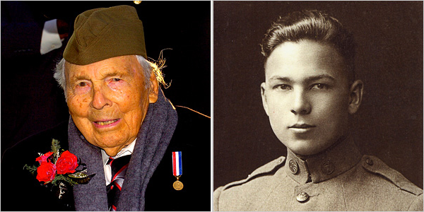
Mike Theiler/European Pressphoto Agency, left; Buckles Family, right
The World War I veteran Frank Buckles, during a Veteran’s Day ceremony at Arlington National Cemetery at Arlington, Virginia, 2007, left, and in his U.S. Army enlistment photo, 1917.

By RICHARD GOLDSTEIN

Published: February 28, 2011
Frank Buckles, who drove an Army ambulance in France in 1918 and came to symbolize a generation of embattled young Americans as the last of the World War I doughboys, died on Sunday at his home in Charles Town, W.Va. He was 110.
His death was announced on his Web site.
He was only a corporal and he never got closer than 30 or so miles to the Western Front trenches, but Mr. Buckles became something of a national treasure as the last living link to the two million men who served in the American Expeditionary Forces in France in “the war to end all wars.”
President Obama said in a statement that Mr. Buckles lived “a remarkable life that reminds us of the true meaning of patriotism and our obligations to each other as Americans.”
Frail, stooped and hard of hearing but sharp of mind, Mr. Buckles was named grand marshal of the National Memorial Day Parade in Washington in 2007. He was a guest at Arlington National Cemetery on Veterans Day 2007 for a wreath-laying ceremony at the Tomb of the Unknowns. He was honored by Defense Secretary Robert M. Gates at the Pentagon and met with President George W. Bush at the White House in March 2008.
United States senators played host to him at the Capitol in June 2008 for the impending 90th anniversary of the World War I armistice. And he appeared before a Senate subcommittee in December 2009 to support legislation named in his honor to bestow federal status on a World War I memorial on the Washington Mall built in the 1930s.
The Department of Veterans Affairs said he would be buried at Arlington National Cemetery with full military honors.
Sought out for interviews in his final years, Mr. Buckles told of witnessing a ceremony involving British veterans of the Crimean War, fought in the 1850s, when he was stationed in England before heading to France. He remembered chatting with Gen. John J. Pershing, the commander of American troops in World War I, at an event in Oklahoma City soon after the war’s end.
And he proudly held a sepia-toned photograph of himself in his doughboy uniform when he was interviewed by USA Today in 2007. “I was a snappy soldier,” he said. “All gung-ho.”
Frank Woodruff Buckles was born Feb. 1, 1901, on a farm near Bethany, Mo. He was living in Oakwood, Okla., when the United States entered World War I, and he tried to enlist in the Marine Corps at age 16, having been inspired by recruiting posters.
The Marines turned him down as under-age and under the required weight. The Navy did not want him either, saying he had flat feet. But the Army took him in August 1917 after he lied about his age, and he volunteered to be an ambulance driver, hearing that was the quickest path to service in France.
He sailed for England in December 1917 on the Carpathia, the ship that helped save survivors of the Titanic’s sinking in 1912. He later served in various locations in France, including Bordeaux, and drove military autos and ambulances. He was moved by the war’s impact on the French people.
“The little French children were hungry,” Mr. Buckles recalled in a 2001 interview for the Veterans History Project of the Library of Congress. “We’d feed the children. To me, that was a pretty sad sight.”
Mr. Buckles escorted German prisoners of war back to their homeland after the Armistice, then returned to the United States and later worked in the Toronto office of the White Star shipping line.
He traveled widely over the years, working for steamship companies, and he was on business in Manila when the Japanese occupied it after the attack on Pearl Harbor in December 1941. He was imprisoned by the Japanese and lost more than 50 pounds before being liberated by an American airborne unit in February 1945.
After retiring from steamship work in the mid-1950s, Mr. Buckles ran a cattle ranch in Charles Town, and he was still riding a tractor there at age 106.
In April 2007, Mr. Buckles was identified by the Department of Veterans Affairs as one of the four known survivors among the more than 4.7 million Americans who had served in the armed forces of the Allied nations from April 6, 1917, when the United States entered World War I, to Nov. 11, 1918, the date of the armistice.
Two of the four — J. Russell Coffey and Harry Landis — had served stateside in the American Army. Mr. Coffey died in December 2007 at 109; Mr. Landis, in February 2008 at 108. John Babcock, who was born in Canada, served in the Canadian Army in Britain in World War I and held dual American and Canadian citizenship, died in Spokane, Wash., in February 2010 at 109.
The last known veterans of the French and German armies in World War I, Lazare Ponticelli and Erich Kästner, respectively, died a few months apart in 2008; Harry Patch, the last British soldier, died in 2009. Claude Choules, who served in Britain’s Royal Navy and now lives in Australia, and Florence Green, a member of Britain’s Women’s Royal Air Force and who lives in England, are thought to be the only two people still living who served in any capacity in the war.
Mr. Buckles is survived by his daughter, Susannah Flanagan. His wife, Audrey, died in 1999.
More than eight decades after World War I ended, Mr. Buckles retained images of his French comrades. And he thought back to the fate that awaited them.
“What I have a vivid memory of is the French soldiers — being in a small village and going in to a local wine shop in the evening,” he told a Library of Congress interviewer. “They had very, very little money. But they were having wine and singing the ‘Marseillaise’ with enthusiasm. And I inquired, ‘What is the occasion?’ They were going back to the front. Can you imagine that?”

