  - & 8-3 The Pythagorean Theorem and Its Converse

Theorem 8-2 – Pythagorean Theorem
In a right triangle, the square of the hypotenuse is equal to the sum of the squares of the legs
25
24
5
x
12
w
8
10
y

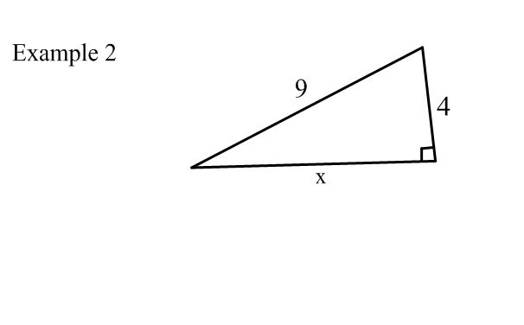
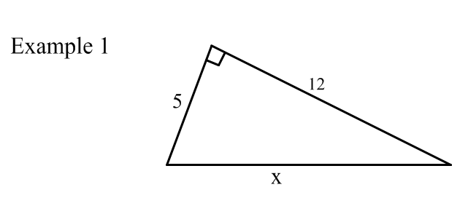
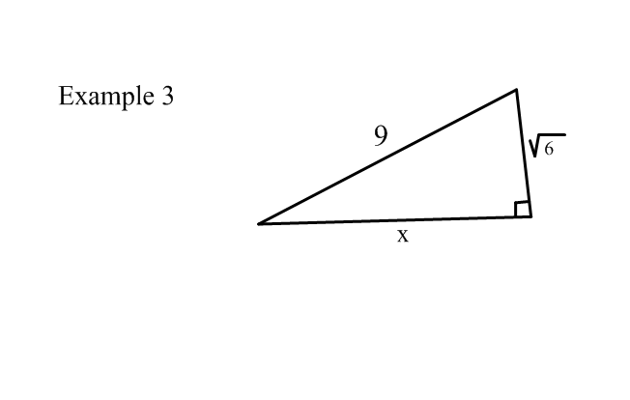
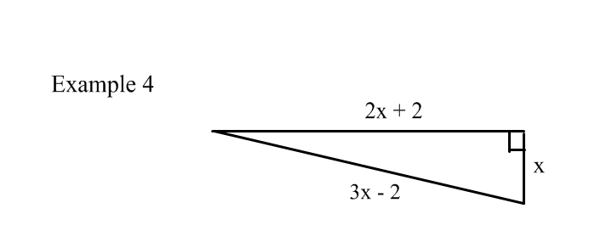
Example 5
The length of a side of a square is 8 cm. What is the length of a diagonal of this square?

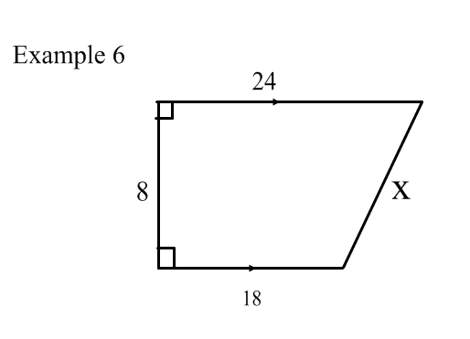

Theorem 8-3 – (converse of Pythagorean Thm)
If the square of one side of a triangle is equal to the sum of the squares of the other two sides, then the triangle is a right triangle.

3
4

5
12
8
17
13
6
15
Yes No Yes

Some Common Right Triangle Lengths
3, 4, 5 5, 12, 13 8, 15, 17 7, 24, 25
6, 8, 10 10, 24, 26
9, 12, 15
12, 16, 20
15, 20, 25

Theorem 8-3 Theorem 8-4 Theorem 8-5
C
A
B
b
C
a
c
A
B
b
C
a
c
A
B
b
a
c

Assessment Problem: Pythagorean Theorem
Find the value of w on this right triangle. Round to the nearest tenth.

Assessment Problem: Pythagorean Theorem
Find the value of w on this right triangle. Round to the nearest tenth.

10
w
16
10

w
16

Assessment Problem: Pythagorean Theorem
Find the value of w on this right triangle. Round to the nearest tenth.

w
16
10
Assessment Problem: Pythagorean Theorem
Find the value of w on this right triangle. Round to the nearest tenth.

w
16
10

A 26 foot ladder is leaned up against a wall to complete some house painting. If the base of the ladder is placed 10 feet from the bottom of the wall, how far up the wall will the ladder reach?

A 26 foot ladder is leaned up against a wall to complete some house painting. If the base of the ladder is placed 10 feet from the bottom of the wall, how far up the wall will the ladder reach?

?
26 ft

?
26 ft

10 ft
10 ft

A 26 foot ladder is leaned up against a wall to complete some house painting. If the base of the ladder is placed 10 feet from the bottom of the wall, how far up the wall will the ladder reach?

?
26 ft
A 26 foot ladder is leaned up against a wall to complete some house painting. If the base of the ladder is placed 10 feet from the bottom of the wall, how far up the wall will the ladder reach?

?
26 ft
10 ft
10 ft

