[www.voki.com](http://www.voki.com)

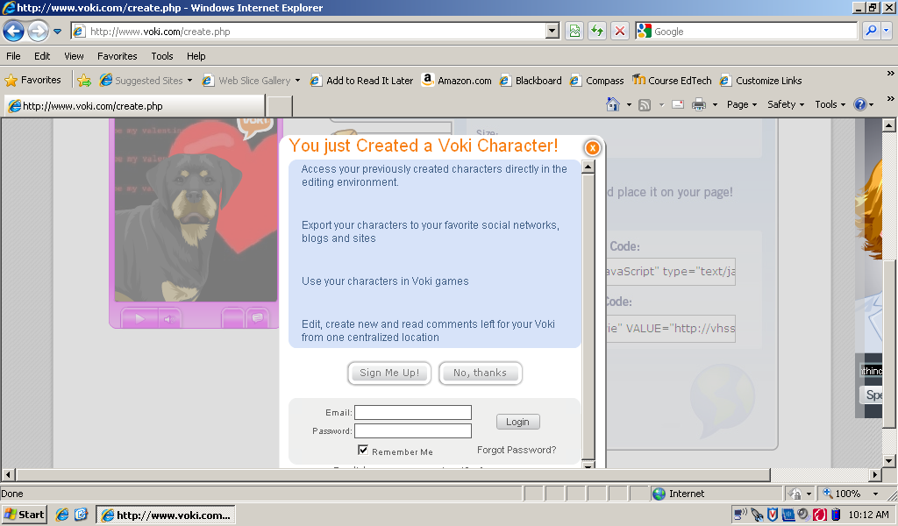When you are finished creating your avatar, follow these steps:

1. Click on Publish
2. Click Save
3. Click the x in the orange circle
4. Highlight the script under,   
   “**For Most Sites Use This Code”**or (if eventually publishing to Moodle) **“For MySpace Use This Code”**
5. **Copy**
6. Open MS Word
7. Paste the code and save the script as **“AvatarNov2010”**

[www.voki.com](http://www.voki.com)

When you are finished creating your avatar, follow these steps:

1. Click on Publish
2. Click Save
3. Click the x in the orange circle
4. Highlight the script under,   
   “**For Most Sites Use This Code”**or (if eventually publishing to Moodle) **“For MySpace Use This Code”**
5. **Copy**
6. Open MS Word
7. Paste the code and save the script as **“AvatarNov2010”**