Name______________________________________________ Period ____________ Date _________

**United States History II A**

**“The Battle of Britain”**

**World War II**

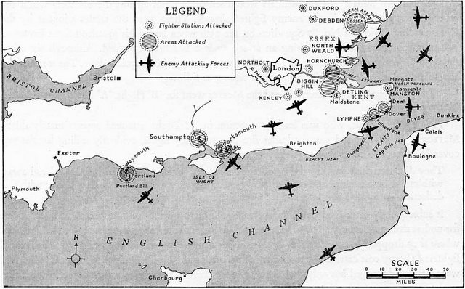

**INSTRUCTIONS:** Using the web sites provided, please answer the questions based on what you find online about the Battle of Britain. The questions are each worth one point and all answers will be used according to the web site listed above the questions. Please also watch the video link using the address provided to get some additional visual information about this significant event.

*Part One: BBC – “What was the secret to winning the Battle of Britain?”*

<http://www.bbc.co.uk/guides/zgs34j6#z93cdmn>

1. Why was the Battle of Britain a turning point in the war?
2. Why did Hitler want “air superiority” before invading Great Britain?
3. What was the name of the German Air Force?
4. What were the pilots of the RAF (Royal Air Force) known as for nickname?
5. When was the Battle of Britain?
6. Looking at the number of Luftwaffe versus Royal Air Force (RAF), why was the victory of the RAF so unlikely?
7. How many men were on a ground crew?
8. What was the responsibility of a ground crew?
9. How much warning would the radar operations/operator give a crew when an enemy was approaching their location?
10. How many anti-aircraft guns were made in July of 1940?
11. How many German Luftwaffe were shot down by the Anti Air Command?
12. How many new aircraft were produced by air factory workers in the summer of 1940?
13. How would productivity help to win the war?

*Part Two: “The Battle of Britain”*

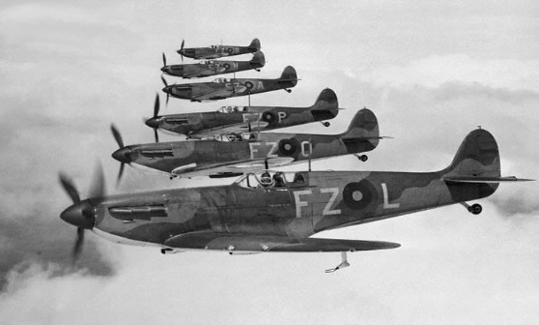

http://battleofbritain1940.com/#/overview

Overview

1. What was the name of the German armed forces?
2. Who was the Prime Minister of Great Britain during the Battle of Britain?
3. What was the German code name for the Battle of Britain?
4. What was the “Chain Home”?
5. What was Hitler’s Directive No. 17?
6. Why was August 15, 1940 known to the RAF as the “Greatest Day”?
7. What happened on August 24 and 25, 1940 to the country of England?
8. What was the “Blitz”?
9. How many consecutive nights was London bombed?
10. How did this defensive victory by Great Britain help them in the later years of the war?
11. What does this famous quote by Winston Churchill mean with regard to the Battle of Britain? “Never in the field of human conflict was so much owed by so many to so few.”

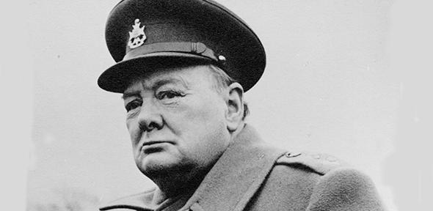

*Part Three: “The Battle of Britain: The Finest Hour” (2:38)*

<https://www.youtube.com/watch?v=YBAIeinH09Y&feature=youtu.be>

Watch the video and answer the following questions below:

1. What did Churchill say to inspire his country during the Battle of Britain?
2. What day did German launch their attack?
3. How many British civilians were killed?
4. How many British civilians were wounded?
5. After seeing the visuals of the destruction of London during the Battle of Britain, what might the civilians of London had to endure just to survive? What type of hardships did they endure during this pivotal moment in history?

*Part Four: The Royal Air Force – RAF Museum*

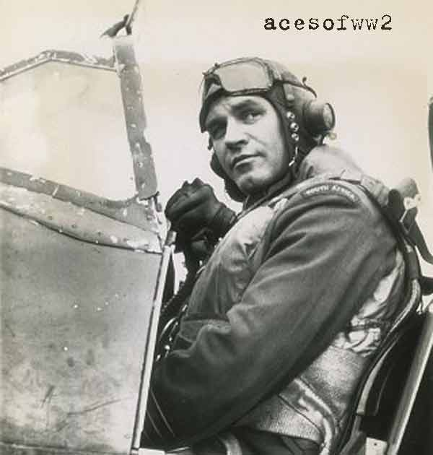

[*http://www.rafmuseum.org.uk/documents/London/Downloads-and-worksheets/The-Daily-Scramble-KS2-Lesson-Pack.pdf*](http://www.rafmuseum.org.uk/documents/London/Downloads-and-worksheets/The-Daily-Scramble-KS2-Lesson-Pack.pdf)

1. What time was the blackout in effect in Great Britain each day? (from when to when?)
2. What was the name of the fighter planes used by Great Britain?
3. What could civilians sign up to do to help the war effort?
4. What do men in the Observer Corps do for the British War Effort?
5. What was the secret weapon used in the war?
6. Why would the people donate pots and pans for the war effort?