**Speciation/Mechanisms of Evolution**

* + The formation of a new _________________________
  + When species are _____________________________ separated over long periods of time, new _________________________ can result
  + Population is split into two or more smaller groups by a ________________________ barrier
    - 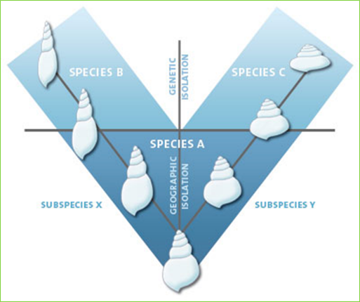_________________________, streams, ____________________, desert, etc.

**Geographic separation**

**Reproductive isolation**

* Over time, geographically separated species evolve separately and become ____________________________ isolated
* Reproductive isolation:
  + Members of a species ___________________ mate and/or produce viable offspring
  + When reproductive isolation occurs:

🡪______________________ species!

* **Many reproductive isolating mechanisms:**

**Reproductive Isolating mechanisms**

1. Temporal
   * Species have different _______________________ _____________________, periods of fertility, or periods of activity (morning vs. night)
2. Ecological
   * Species only mate in their ______________________ ______________________________, which is not shared by a different species
3. Behavioral
   * Species have different mating ____________________________________ (calls, [dances](http://www.youtube.com/watch?v=7dx2CUMtZ-0), etc.)
4. Mechanical
   * _________________________, ____________________________ differences prevent mating

5. Post-mating Mechanisms

* + Mating takes place, but:
    - _______________________ does not occur (gametic isolation),
    - Zygote or embryo __________________ (hybrid inviability),
    - Or, offspring is _____________________ (hybrid sterility)
  + Examples:
    - Mule:
      * Sterile hybrid of _______________ and _________________
    - Liger:
      * Sterile hybrid of ___________________ and _____________________

**Two hypotheses about how evolution occurs:**

* + Gradualism
    - Genetic changes are _________________________ but steadily occurring
    - Over time, small changes add up to the formation of a new _________________________
  + Punctuated Equilibrium
    - Periods of _______________________ to ______ change, followed by a __________________________ change
    - Mutation occurs that causes a ______________________ change in a ________________________ number of individuals
      * If the change is advantageous , these individuals will have high fitness and ___________________________ the trait along

**Natural Selection**

* ________________________________ = any trait that aids the chances of survival and reproduction of an organism.
* Examples:
* Two Types of Adaptations : _____________________ and ________________________________
  + STRUCTURAL ADAPTATIONS arise over ________________ ____________________________.
    - Types of Structural adaptations:
    - **_________________________________** = provides protection for an organism by enabling it to copy the appearance of another dangerous species.
      * Examples:
    - **________________________** = enables an organism top blend in with its surroundings
      * More likely to escape predators and survive to reproduce
      * Examples
  + PHYSIOLOGICAL ADAPTATIONS can **____________________** **__________________________**
    - Changes in an organism’s **______________________** **__________________________**
    - Ex: ________________________________ – was discovered 50 years ago as a wonder drug because it could kill many types of disease-causing bacteria
    - Now penicillin is not as effective as it used to be because many species of bacteria have evolved physiological adaptations that make them resistant to penicillin.
    - Ex: insects/ weeds have been selected for physiological resistance to chemicals used in pesticides

**Mechanisms of Evolution**

1. Natural __________________________
   1. Survival of the _____________________________
2. Mutation
   1. Changes _____________________________ frequency of populations
3. ______________________________ drift
4. ______________________-

**Genetic Drift**

* Definition
  + Change in allele frequency of a population due to _______________________________
  + _________________________ populations are more susceptible
* In a population, some individuals will produce _________ offspring, and pass on more of their genes
* Result:
  + Over time, only one allele for a trait may ________________________ in a population (Fixation)
    - Reduce in genetic _____________________________

**Migration**

* Definition:
  + Movement of individuals from ___________ population to a _______ population
* Movement of individuals between populations can ___________________ allele frequency
* Founder effect
  + 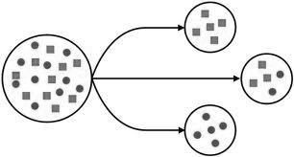A colony is __________________________ by members of an existing population
  + Small colony population may have:
    - Lower genetic _______________________________
    - A ___________________________________________ collection of genes from the original population

**Founder Effect in the Amish**

* Live in ____________________________, PA
* Founded by 200 ___________________________________ immigrants
* These immigrants had a high proportion of the ________________________ alleles that cause _______________________________________________ syndrome
  + Symptoms:
* Closed gene pool keeps the _____________________________ alleles in the population

**Population Bottleneck**

* 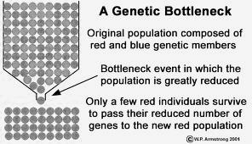Definition:
  + A populations size is greatly ________________________ for at least one generation
  + Genetic diversity is greatly _______________________________
  + If population increases again, the genetic diversity will be extremely ________________

**Bottleneck Examples**

* Elephant seals
  + Almost hunted to _______________________ in the 1890s
  + Population dwindled to _________________________ seals
  + Once the species was protected, it was able to ____________________________
  + Today, population is 30,000
* Cheetahs
  + Near extinction __________________ years ago
    - End of last __________ age
  + Population further ___________________ due to poaching
  + Today, all cheetahs have almost identical __________________________
    - Reduced ____________________, _______________________ and _________________________