**Notes: Evidence of Evolution**

**Evidence of Evolution**

* Remember, evolution is a _________________, so there must be extensive evidence that supports it!
* Lines of evidence:

**Fossil Record**

* Show ______________________________ between extinct organisms and organisms living today
* Many types of ______________________
  + _______________________, imprints (footprints, leaves), ___________________, plants, _____________________, eggs, fossilized amber (insects)
* Transitional Species
  + Show link between _____________________________ of organisms
    - Example: Archaeopteryx–Link between reptiles and birds
* Shows _______________________ between living and extinct species
  + - Example:

**Anatomical Features**

* Similarities in ________________________ suggest common descent/ancestry among organisms

**Homology vs. Analogy**

* Homology- traits inherited by two _______________________________ organisms from a _________________________ ancestor (forelimbs of a dog and human arm)
* Analogy- similarity due to convergent evolution __________ common ________________________ (wings of a bird and wings of a butterfly)

**Convergent Evolution**

* Convergent evolution
  + Two separate organisms evolve similar characteristics ________________________ of one another
  + Happens when two species are facing similar selective pressures/same _________________________________ pressures

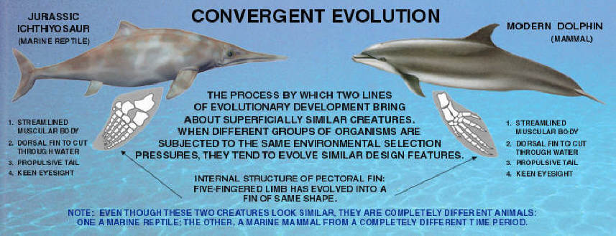

**Divergent Evolution**

* Divergent evolution is the accumulation of ____________________________; results in different ___________________________

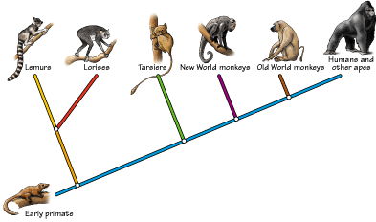

**Homologous Structures**

* Definition:
  + Bones or organs that appear in different organisms but share a ___________________________ ancestry
  + Same basic _________________________, but ___________________________ ____________________________
  + Example:
    - ________________________ of vertebrates:




      * These bones are very similar but have **very different functions**

**Vestigial Structures**

* Definition
  + Body structure that has been _______________________ in size and function
  + But, _______________________ a fully functional structure in another organism
* Examples
  + _____________________ (coccyx) in humans
  + _________________________ in humans
  + ______________________ in flightless birds
    - Related to wings used for _____________________
  + ________________________ fold in human eye
    - Remnant of _____________________________ membrane
  + ____________________________ in humans
    - Attempt to ________________________ _______ fur when cold

**Embryology**

* Embryology Definition:
  + The study of embryos and their __________________________
* Different organisms show very __________________ developmental patterns and structures
  + Suggests _________________________ ancestry between species
* Example:
  + All vertebrates have _________________ ______________________ and a ____________________ at some point during development

**Biochemistry**

* Nucleic acids carry ___________________________ information in all organisms
  + __________ or _______________
* _________________________________ genetic code
  + ____________________ code and _________________ acids are the same for all organisms
  + ___________ sequences
  + The more closely related organisms are, the more similar their _____________________ sequences
* Proteins
  + Vital proteins are found in ___________________ organisms
  + Example:
* ATP
  + ________________________ source for all organisms