**WATER**

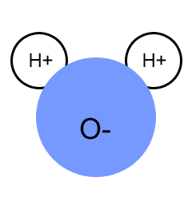**Most Important Inorganic Compound = _______________________**

* + - _____________________
    - Accounts for ________________________% of the weight of a living thing.
    - Helps to ___________________________ substances
    - Helps to carry _____________________________ from the body
    - Regulates __________________ _____________________ by absorbing heat
    - Essential for the processes of _______________________, ___________________________, __________________________ and many other ______________________________________ reactions
    - Major component of ______________________________ of all cells
    - # 1 ______________________________________ in ALL living things

**Properties of Water**

1. **Water is a __________________________ molecule**
   1. Forms ___________________ bonds with other molecules of ______________________
   2. Water as a solid = ____________________
   3. Water as a liquid = __________________________
   4. Water as a gas = ____________________________
      * Almost no hydrogen bonds between molecules

**Water Density**

* Unlike most liquids when they freeze, water is _______________ dense when frozen
* Explains why ice _________________________________
* 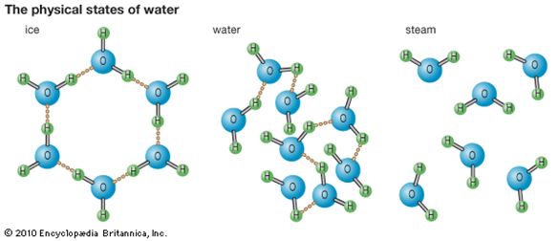Water’s greatest density occurs at ________ °C. This is why the surface of a pond freezes and yet water remains in liquid form at the bottom of the pond.
* The angles of the hydrogen bonds form a crystal pattern, making frozen water less dense than liquid water
* Due to the unique arrangement of the polar water molecules, water _________________________ when frozen and contacts when heated. (opposite of most substances)
* Water molecules are joined together by covalent ____________________ bonds.

1. **Water is an excellent ________________________________**
   * Water can __________________________ many substances
   * Creates a ___________________________
   * Water is the ____________________________
   * _____________________________ is substance being dissolved in water

**Importance = water helps to break down molecules into smaller pieces that are small enough to move in and out of cells!**

1. **Water has a _______________ ___________________________ ______________________**
   * Water can _______________________ heat but its temperature changes very ___________________
   * Water can ________________________ large amounts of _____________________ but its temperature changes very ______________________________
   * Water _______________________ surfaces as it evaporates (ex. = _____________________________)

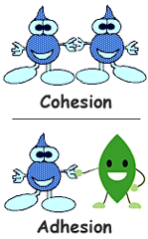**Importance = Helps keep your body at a _____________________ ____________________________; helps to keep the ________________________ (____________________) ______________________________ stable.**

1. **_______________________ = water is ____________________** = it likes to ______________ to _____________________ ________________________ compounds and to __________________.

Examples = water droplets sticking to the grass or a plant leaf, to the window of a car, to the inside of a glass

1. **_________________________ = water is ___________________** = it likes to ________________ to ________________________. Hydrogen bonds create __________________________ of water
2. **______________________ ______________________ = due to _______________________ - water has a surface tension.** The surface can resist a force from an object denser than water.

Examples = a paper clip can float on the surface of water, water striders can “walk” on water

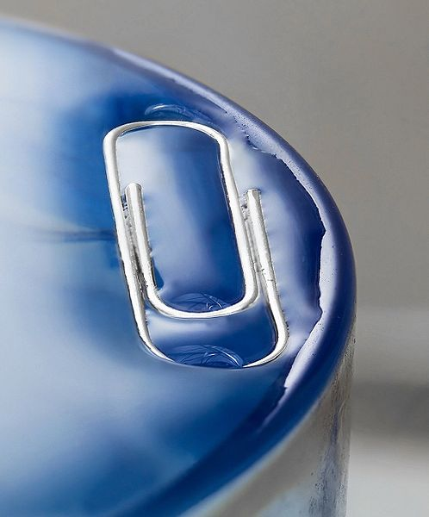

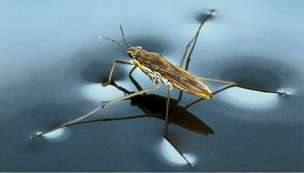

1. **_________________________ ______________________ = ____________________________ and ____________________________ between molecules that causes water to move up in a small tube**

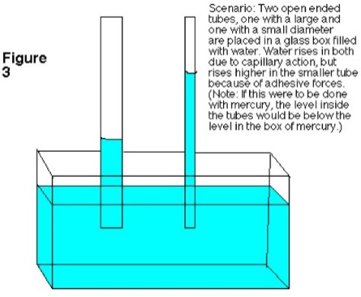Example = Allows for water to move from roots to leaves in a plant through tiny tubes (veins) in plant

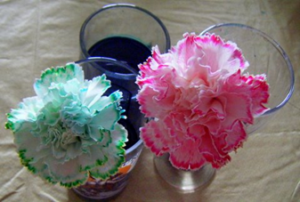

1. 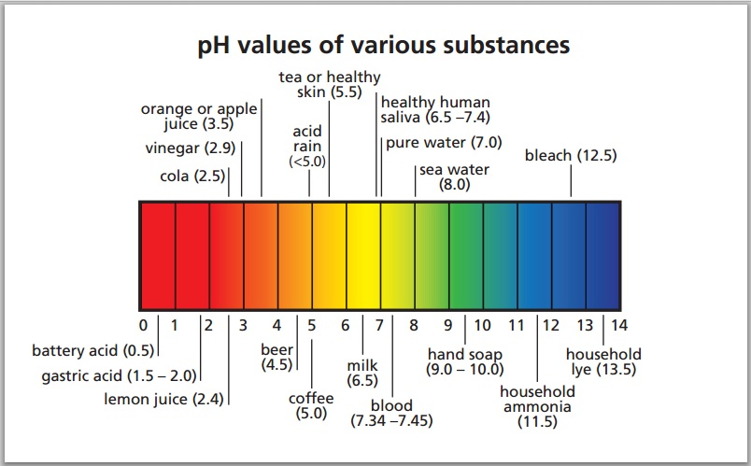 **Pure water has a neutral ____________.**

* Measure of the acidity or basicity of a solution.