**Cell Membrane Structure** Name ______________________________

**Processes that Transport Molecules into/out of cells** Date _______________

The Structure of the Cell Membrane

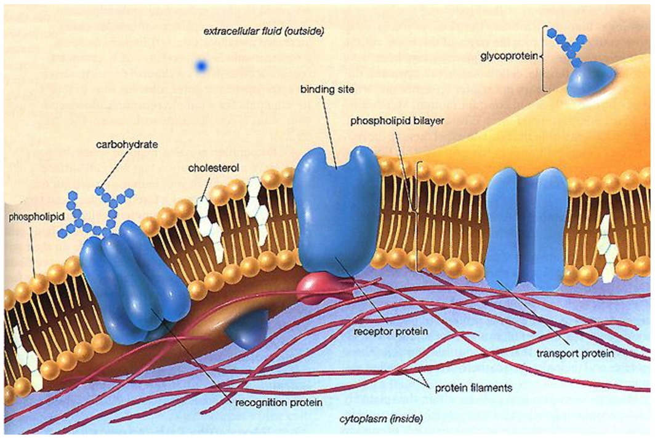

A.

**D.**

**C.**

**B.**

**Letter A = The _______________________ ___________________________**

____________ ___________________ material in the cell membrane

______________ ___________________ thick

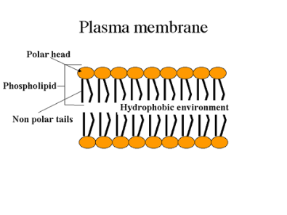Each layer has a _________________ ________________ end (___________________________________ = _______________ ____________________) that always faces the water based solution (either the cell’s ________________________ or the cell’s ______________________________.

Each phospholipid has ______________ _______________ on one end (_____________________ = ______________ ________________) that always face away from the water-based solutions.

Round ends of the phospholipids don’t fit tightly together which creates tiny spaces, called _____________________, in the cell membrane.

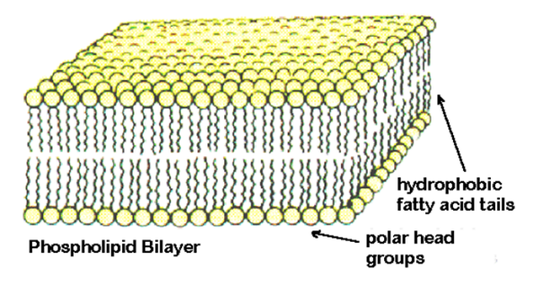Small molecules like ________________, _______________________ __________________, and ____________________ can pass through these pores.

The membrane is _____________________________ to these materials.

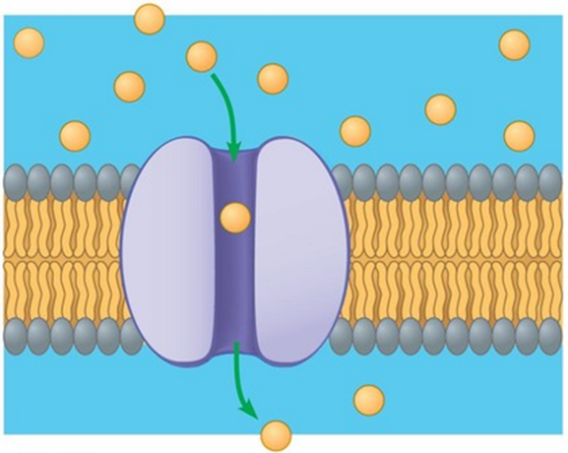**Letter B = ___________________________ ____________________________ (also called Channel or Carrier proteins)**

_____________________ ___________________________ in the phospholipid bilayer.

Open up to help ____________________ ________________________ go across the cell membrane to move into or out of the cell.

**Letter C = ___________________________ ____________________________**

A place where ______________________ can attach to the cell membrane

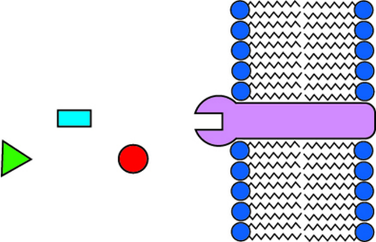

**Letter D = __________________________ __________________________________**

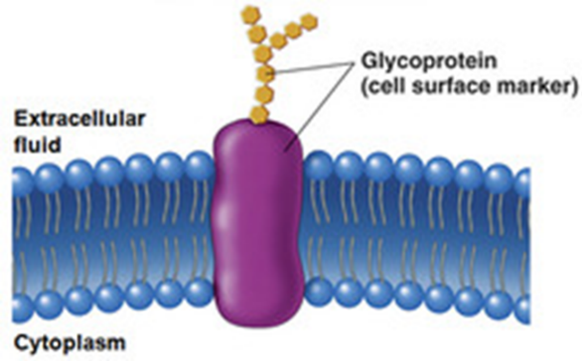Help to identify _____________________ ______________ (mammal, human, liver, lung, etc.)

Like an ID tag!

Helps cells _______________________ together to form ____________________

Also called _______________________________

**Model of cell Membrane**

* Called __________________ ______________________ model
  + Fluid = _________________________, ___________________
  + Mosaic = made of a _______________________ of ____________________ ___________________________