Name ____________________________________ Period______ Date ____________________

Karyotypes

**I. What is a Karyotype?**

* _______________________________ = a test to identify and evaluate the size, shape, and number of chromosomes in a sample of body cells.
* Extra, missing, or abnormal positions of chromosome pieces can cause problem’s with a person’s growth, development, and body functions.

**II. Why Is It Done?**

1. Determine whether the chromosomes of an adult have an __________________________ that can be passed on to a child.
2. Determine whether a chromosomes defect is preventing a woman from becoming pregnant or causing miscarriages.
3. Determine whether a chromosome ______________________ is present in a fetus.
4. Determine the cause of a baby’s birth defects or disability.
5. Identify the ________________ of a person by determining the presence of the Y chromosome.
   * May be done when a newborn’s sex is not clear.

**III. How is A Karyotype Created?**

1. Human karyotypes are usually prepared from _______________________ of chromosomes that have been spread, fixed, and stained to highlight banding patterns.
2. The chromosomes on the photograph are ___________ _______________________ and then arranged in homologous pairs just as you will be doing in an upcoming activity.
3. Chromosomes are obtained through carious test: _______________, bone __________________, ______________________ fluid, or tissue from the _________________________ (the organ that develops during pregnancy to feed a growing baby).

* ____________________ blood cells are used most frequently because they are easily induced to divide and grow in culture.
* To test amniotic fluid, an _____________________________________ is done. A long needle will withdrawal fluid surrounding the fetus. It will contain cells shed by the fetus.
* A bone marrow specimen requires a bone marrow _______________________.

1. The sample is placed into a special dish and allowed to _____________________ in the laboratory.
2. Various _____________________________ are added to stop the cell’s growth during prophase and metaphase.
3. The cells are placed on a microscope slide and __________________________ so they swell and their chromosomes spread apart.
4. Then various stains are used to highlight ___________________ patterns.
5. Experienced geneticists observe the karyotype for chromosomal abnormalities

* _____________________ __________________ of chromosomes
* ____________________ chromosomes
* ___________________ chromosomes
* The _________________ of the person

1. The treated chromosomes can then be photographed, enlarged, if desired, and ___________ ____________ to do the karyotype.

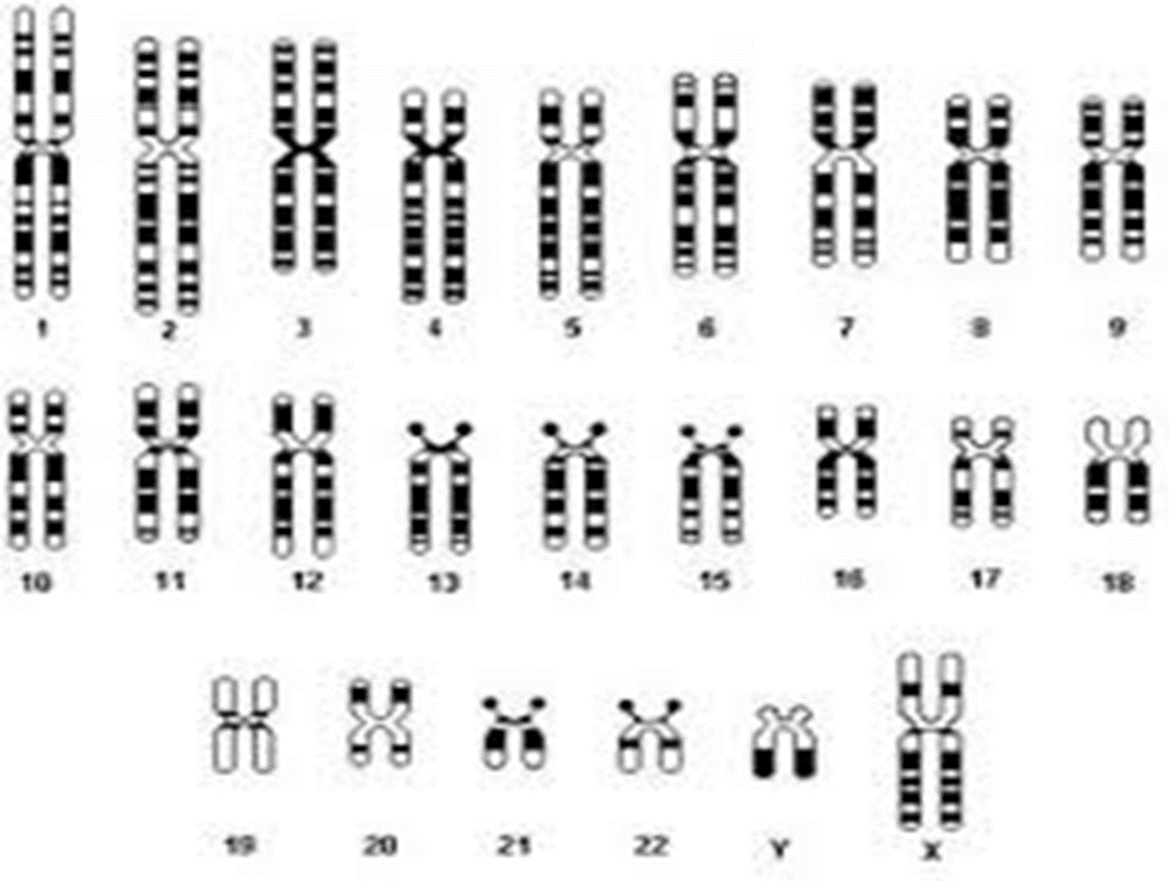

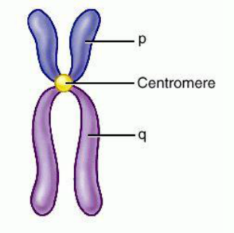**IV. What are Genetists Looking For?**

1. Differences in ____________________ of chromosomes
2. Differences in the position of the ______________________
   * This is brought about by ____________________________.
3. Differences in basic number of ______________________________ = ___________________________________________

**V. Common Abnormalities**

1. Down syndrome (Trisomy 21)

* Cause = nondisjunction of the ____________________ pair of chromosomes
* 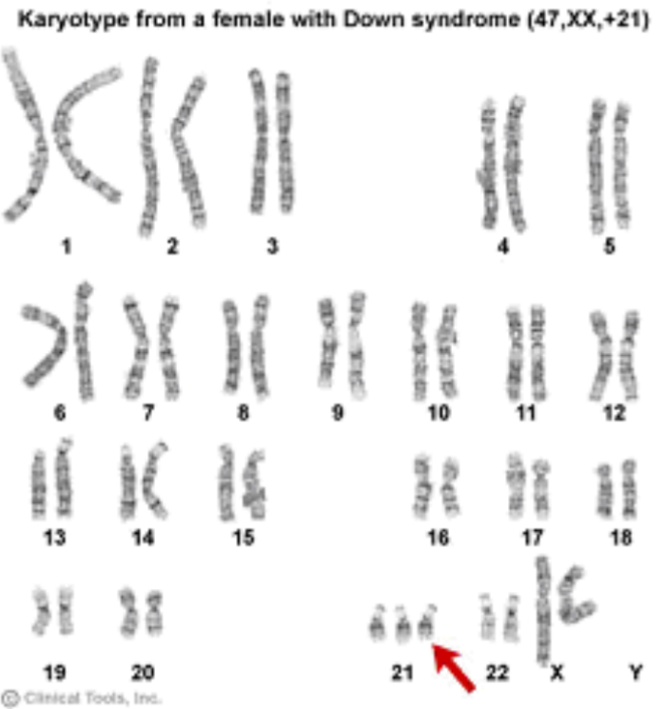Characteristics
  + Happens ___________________ in males and females since it does not involve the sex chromosomes
  + Individuals have ________________________ disabilities but the severity varies with the individual.
  + The probability of giving birth to a child with Down syndrome ________________________ with the age of the mother, increasing significantly after age ___________________.

1. 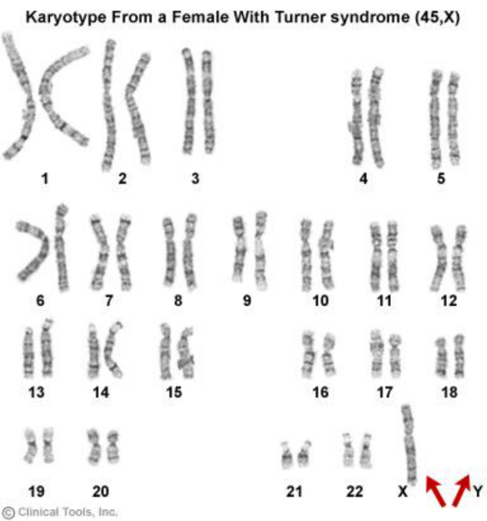Turner’s syndrome (______________________)

* Cause = nondisjunction of the ____________ ______________________________ during meiosis so individuals are missing one copy of the _____ chromosome.
* They have _______ pairs of autosomal chromosomes and only one X chromosomes.
* Characteristics
  + Affects only _________________
  + Women are usually ______________, sexually underdeveloped, and sterile.
  + Women with this function well within society and are not diagnosed until they are assessed for _________________ as adults.

1. Klinefelter's Syndrome (______________________)

* Cause = ________________________ of the sex chromosomes during meiosis so individuals have an extra X chromosome.
* The person has 22 pairs of autosomal chromosomes and _____ sex chromosomes (XXY)
* Characteristics
  + Affects only _____________
  + 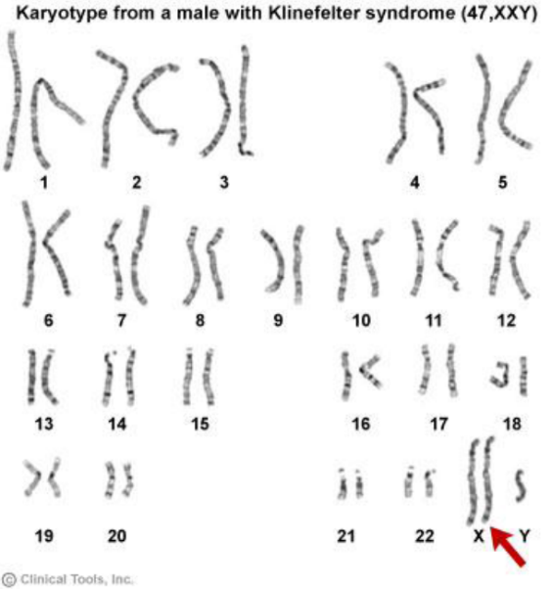Males are often __________, sexually _____________________ and may have slight intellectual impairment.
  + Recognition of this syndrome before puberty does not occur.
  + Many males with this function well within society and are not diagnosed until they are assessed for ____________________ as adults.

1. Jacob’s Syndrome (XYY) (_____________________)

* 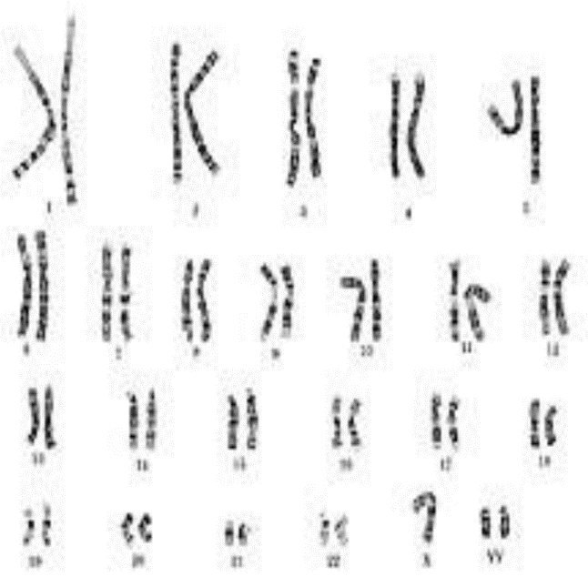Cause – occurs when a male inherits _______ Y chromosomes from his father instead of one. The exact cause of why this occurs is unknown.
* He is an _________ male.
* Characteristics
  + Affects only ____________________
  + The most common symptoms are learning problems at school and delayed ________________ maturity.
  + Males are ______________, thin, have acne, _____________ problems, and reading problems.