Mutation notes

What are mutations?
- ____________________________ in the nucleotide sequence of DNA
- May occur in ______________________ cells (aren’t passed to offspring); called somatic mutations
- May occur in ______________________ (sperm and egg) and be passed to offspring (__________ mutations)
Are mutations helpful or harmful?
- Mutations happen _______________________
- Some mutations are __________________________ or neutral
- _________________________ and ___________ radiation causes mutations
- Many mutations are __________________________ by _______________________
- Some types of __________________ cancers and _________________ result from somatic mutations
- Some mutations may _________________________ an organism’s survival (beneficial)
- Most changes in DNA are ________________ beneficial
Types of mutations
A. Gene Mutations
- Change in the nucleotide sequence of ________________ ___________________
- May only involve a _______________ nucleotide
- May be due to ___________________ errors, _________________, __________________, etc.
- Two types of gene mutations exist
  - Point mutations - change in DNA at one ________________ (addition, deletion, substitution)
    - Substitution – substituting a _____________________ for another
    - Insertions – ______________________ a nucleotide
    - Deletions – _______________________ a nucleotide
  - Frameshift – changes the DNA triplet resulting in changes to _______________ and ____________ acid
Point mutation
- Changes a ___________________ nucleotide
- Includes the __________________, ________________________, or _________________________ of ONE nucleotide in a gene
      - Only _____________ amino acid is changed if it is a substitution.

      - THE CAT ATE THE BIG RAT
      - Substitute a “T” for the “A” in ATE
      - THE CAT TTE THE BIG RAT
- _______________ __________________ disease is the result of one nucleotide substitution
  - Occurs in the hemoglobin of the blood
Frameshift Mutation
    - Frameshift Mutation is really just an effect of a Point mutation.
    - _________________ or ____________________ one or more nucleotide
    - Changes the “________________ _________________” like changing a sentence
      - THE CAT ATE THE BIG RAT
        - Insert an “A” after CAT
      - THE CAT AAT ETH EBI GRA T
    - Protein is built ________________________________

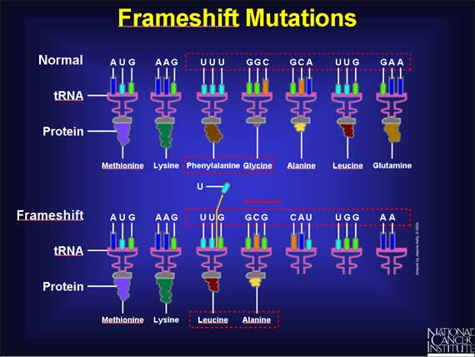

Nonsense mutations
- A point mutation that codes for a _____________________ codon in the middle of a protein.
- ______________________________________ protein.
- Makes no _____________________________.
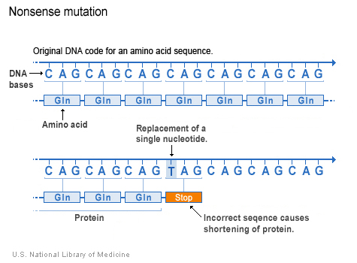

Silent mutation
- Change in the base sequence that does ______________ alter the amino acid placement in the protein.
- Has ______ ____________________________ on the protein.
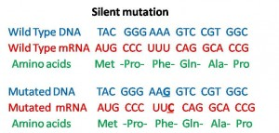

Missense mutation
- Mutations when a single ______________________________ mutation occurs and a different amino acid is inserted, changing the _____________________________.
- Protein ____________________________________________-.
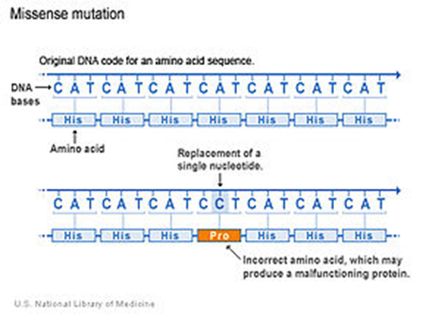

B. Chromosomes Mutations
- May involve:
  - Changing the ________________________ of a chromosome
Deletion
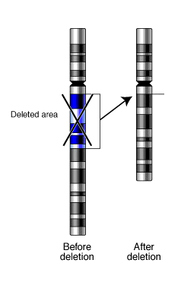
  - The ______________ or _____________ of part of a chromosome
  - More _________________ changes to organism
- Six types of chromosome mutations exist:
  - _____________________
  - _____________________
  - _____________________
  - _____________________
  - _____________________
  - _____________________
    - Deletion
Inversion
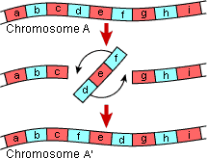
      - Due to ______________________
      - A piece of a chromosome is ________
    - Inversion
      - Chromosome segment _________ off
      - Segment __________ around backwards
      - Segment ______________________

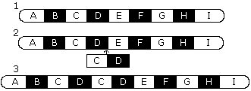
    - Duplication
      - Occurs when a gene sequence is ________________
    - Nondisjunction
      - Failure of chromosomes to ____________________ during meiosis
      - Causes gametes to have too _____________ or too _________ chromosomes
      - Disorders
        - _________________ syndrome – three 21st chromosomes
        - ________________ syndrome – single X chromosome
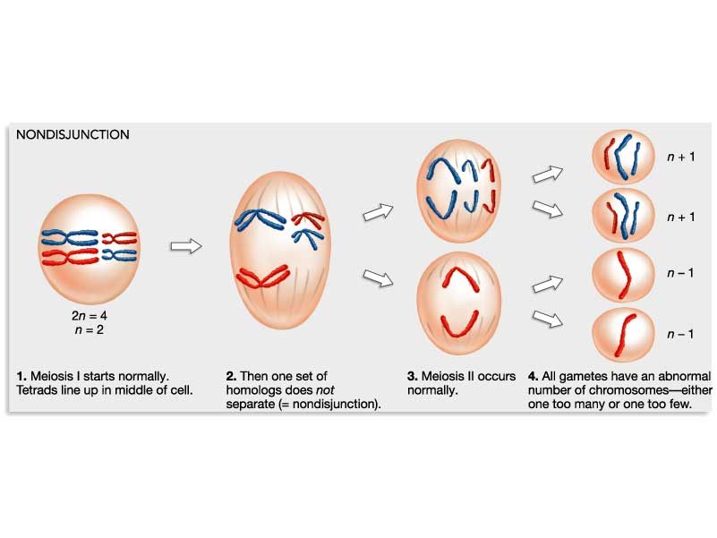
        - ____________________ syndrome –XXY chromosomes

    - Translocation
      - Involves ______ chromosomes that are not ___________________________
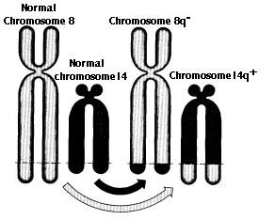
      - Part of one ___________________ is transferred to ____________ chromosome

    - Insertion
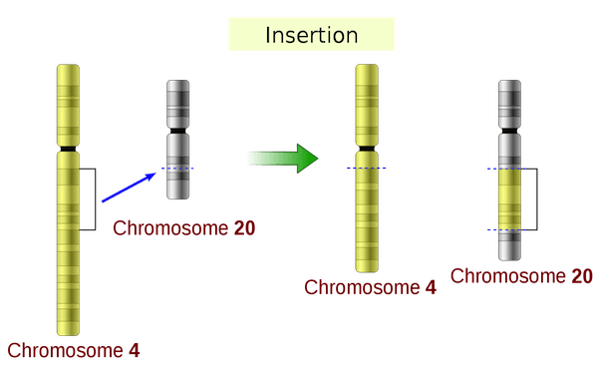
      - Part of a chromosome is inserted into a non-homologous chromosomes

Nature vs. Nurture—The debate?
- Nature = passed on to next generation through _________________ (ex. Blood types)
- Nurture = controlled by _____________________________ factors
  - Body size, ________________________, personality, _______________________________/____________________________________
- Geneticists can measure the influence of both heredity and environment on the development of a trait by studying ___________________, especially those ______________________ twins who were raised in different ____________________________________
Twins
- Fraternal Twins—the most __________________________ ones.
  - They develop from _____ different eggs, each one fertilized by a ___________________ sperm.
  - They are genetically _____________________________________ people.
- Identical Twins
  - They develop from a ______________________________ fertilized egg.
  - Early in the development, the zygote splits and separates into _____ embryos.
  - Since they come from the ____________ fertilized egg and sperm, identical twins have the same ________________________ makeup.
  - They are always the same _____________________________.

Chromosome Disorders
  - Biologists can examine chromosomes of human cells under the microscope to see if there are any abnormalities. They photograph them and cut out individual chromosomes from the picture and arrange them in homologous pairs. This type of arrangement of chromosomes is called a __________________________________________________.

Detecting Genetic Disorders
  - Testing people for genetic disorders is called ____________________________ _______________________________________.
  - Today, many genetic defects are being detected in babies before they are born by a process called ____________________________________. By this process, a sample of the baby’s cells is taken and the chromosomes within them are studied for genetic disorders.

