

Name: _________________________________Period: ____Date:________

 **VOCABULARY:**

* _________________________= a cell containing TWO sets of chromosomes.

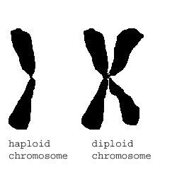

* + one set inherited from each parent
  + 2n (number of chromosomes)
  + ___________ (somatic cells)

* _________________________= a cell with only ONE set of chromosomes. 
  + 1n (number of chromosomes)
  + _____________ (gametes)

* ________________________= sex cells
  + ___________= male gamete
  + ____________= female gamete

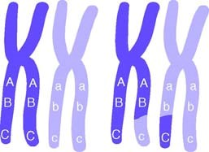

* ____________________________________= paired

chromosomes that have genes for the same traits arranged in the same order.

* + One homologous chromosome is inherited from the organism’s father, the other from the mother.

o ______________________= a two stage type of cell division that results in **gametes** with HALF the number of chromosome number as the body cells.

* ____________________________= when non sister chromatids of homologous chromosomes exchange genetic information, results in a new combination of genes.

o _________________________= the process of joining gametes.

* ____________________= when sperm (haploid) fertilizes the egg (haploid), the resulting cell is the zygote (diploid).

1. **GENES, CHROMOSOMES, AND NUMBERS:** 
   * In humans, each ________________(any cell other than a sperm or egg, has ___ chromosomes)
     + 46 chromosomes 🡪 __________(humans get ___________from each parent)
   * ____________________________- determine the sex of an individual
     + 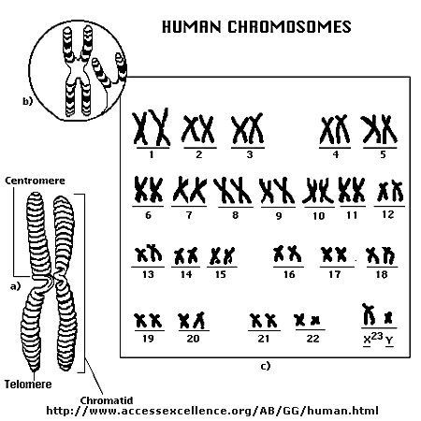last pair of chromosomes—23rd pair for humans

XX = ______________

XY = ______________

* + The ______________________for an organism is NOT related to the

_______________________of that organism!!

* + - Ex: A dog has 78 body chromosomes and humans have 46 body chromosomes
  + A thousand or more genes are lined up on a chromosomes at one time
  + **Diploid & Haploid Numbers:** 
    - Each ________________of an organism contains __________chromosomes.

o Half of each pair came from each parent. These cells are said to have 2n chromosomes, or a full set.

* They are **DIPLOID**.

Ex: Humans have 46 body chromosomes

* + - * + Each ____________of an organism contains only ____________ a chromosome set.

o These cells are **HAPLOID** and have 1n chromosomes

* + - * + Ex: Humans have 23 chromosomes in their gametes (egg or sperm cell)
      * Sex cells will fuse with another sex cell during fertilization to create a

_______________________________.

* + - * + So if human sperm and egg both have 23 chromosomes, after fertilization an embryo would have 46 chromosomes!

**2 Reasons Why MEIOSIS Is Significant:**

1. ______________is another form of cell division that _______________ ___________to be used for reproduction.

* If mitosis was the only form of cell division, then new offspring would always have ___________ as many ____________________ as their parents.

• Eventually, there would be so many chromosomes, the organism would ________________or be severely_______________.

2. Meiosis provides__________________________**-** the reshuffling of genes carried by the individual members of a population.

1. **MEIOSIS vs. MITOSIS:**

* + Remember: ________________= asexual division of diploid body cells

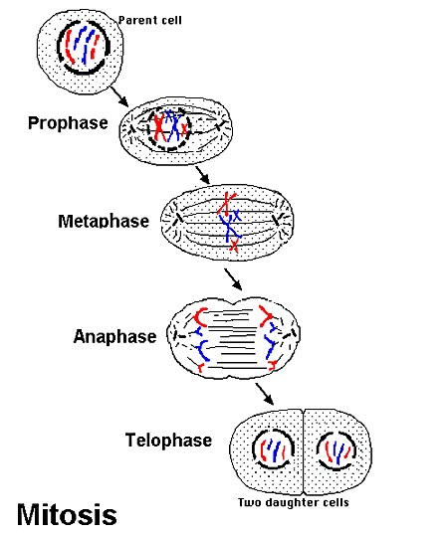

|  |  |  |
| --- | --- | --- |
|  | **MEIOSIS** | **MITOSIS** |
| Cell type of parent |  |  |
| Number of daughter cells produced |  |  |
| Number of cell divisions |  |  |
| Genetic relationship of daughter cells to parent cell |  |  |
| Genetic relationship of daughter cells to one another |  |  |

**MEIOSIS I:**

• Separates ____________________________of chromosomes, NOT sister chromatids of individual chromosomes.

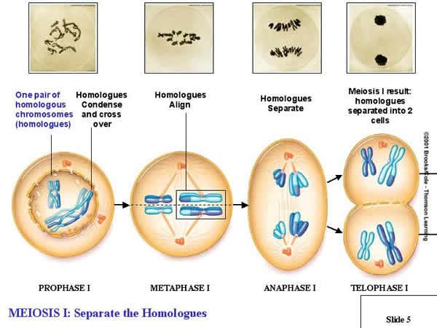

1. **Interphase**

o Metabolic activities & replicate chromosomes

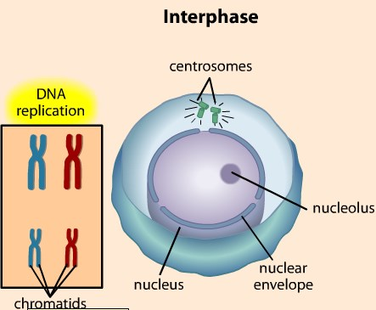

1. **Prophase I**

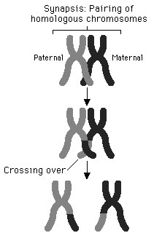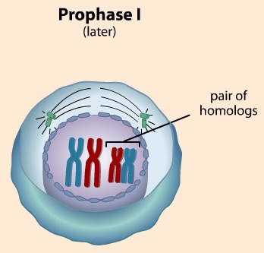

o ______________occurs- the pairing of homologous chromosomes

* + Each pair of ________________chromosomes come together to form a _________________(4 part structure)
  + Genetic material is exchanged in a process called ____________________(swapping portions of adjacent DNA)
* Must be done with great precision so that neither chromatid gains or loses any genes!

1. **Metaphase I**

o __________________________line up at the **_______________**in pairs

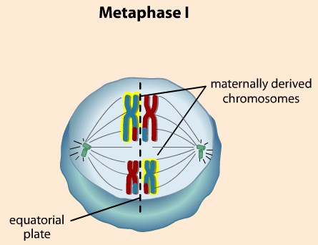

1. **Anaphase I**

o Homologous chromosomes separate and move to opposite ends of the cell.

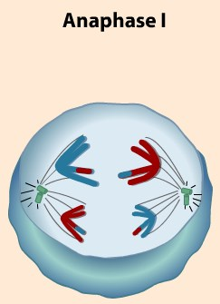

* + - This occurs because the ___________________do NOT split like in mitosis

o This ensures that each ___________will receive only ___________________ from each homologous pair.

1. **Telophase I**

o The new cells are _____________so another division is required to create ________________cells

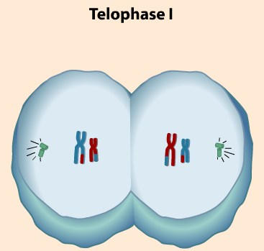

**MEIOSIS II:**

* The mechanism of **_____________**is almost the same as ____________

o However, the chromosomes DO NOT replicate between meiosis I and meiosis II.

* + The final outcome of meiosis is ___________the number of chromosomes per cell.

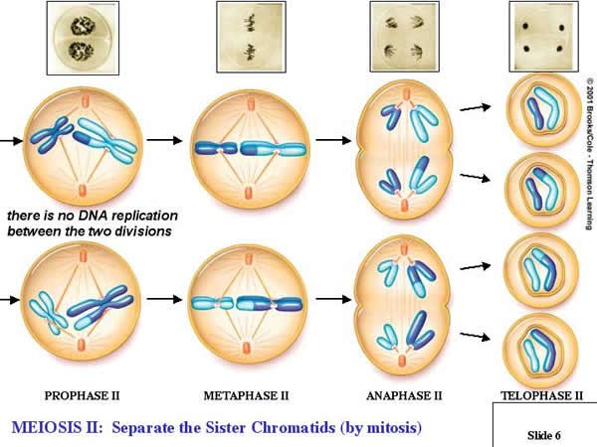

1. **Prophase II**

o Same as Prophase I except NO _______________are formed

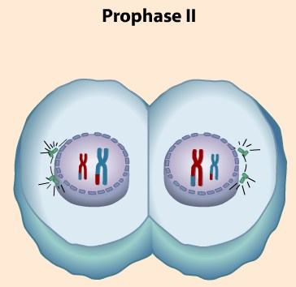

1. **Metaphase II**

o Chromosomes line up at the ______________________.

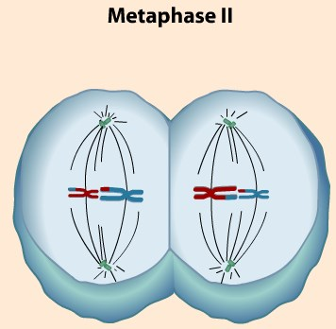

1. **Anaphase II**

o ______________________________move to the opposite ends of the cell

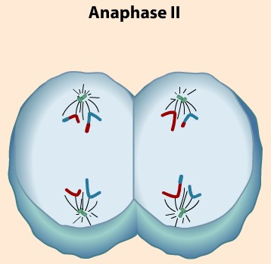

1. **Telophase II**

o Creates 4 __________________cells (gametes)

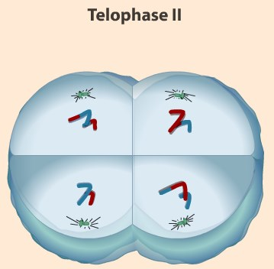

* **Meiosis Provides for Genetic Variation in 2 Ways:**

* 1. **_______________________________of homologous chromosomes during meiosis I**

o The amount of different chromosomes that can be produced increases greatly as the number of chromosomes an organism has.

* + A pea plant has 7 pairs of chromosomes. Each pair can line up 2 different ways. Therefore, each gamete can have 27= 128 possibilities!!
  + Humans: n=23; so the number of different kinds of eggs or sperms a person can produce is more than 8 million (223)

• When fertilization occurs, 223 X 223 zygotes are possible or 70 trillion!!

* No wonder brothers and sisters can be so different.

* 1. **____________________________between homologous chromosomes during prophase of meiosis I**

o Increases the number of genetic variations

* **Meiosis is NOT Flawless:**

* + - It is estimated that from 10–20% of all human fertilized eggs contain chromosome abnormalities, and these are the most common causes of pregnancy failure (35% of the cases).
    - These chromosome abnormalities:
      * Arise from errors in meiosis, usually ____________

* + - * Occur more often (90%) during ________________than during sperm formation • Become more frequent as a woman___________.

Meiosis Review Worksheet

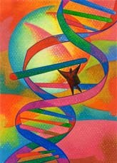

**Part 1: VOCABULARY:** *Answer the following question using the best vocabulary word.*

1. A cell with two of each kind of chromosome is called a(n) __________________ cell.
2. A cell with one of each kind of chromosome is a(n) ________________________ cell.
3. _______________________ are sperm or egg cells.
4. ___________________________ chromosomes have genes for the same traits in the same order on both chromosomes.
5. Parent cells make gametes in a process called ____________________.
6. A _______________ is the cell created when a sperm enters an egg.
7. When non sister chromatids exchange genes, it is called ____________________________________.
8. All cells, other than sperm or egg cells are called________________________________________.
9. The process of joining a sperm cell with an egg cell is called ________________________________.

**Part 2: SHORT ANSWER**: *Answer the following questions in a clear and concise manner.*

1. What is the diploid number of chromosomes in humans? ________________
2. What is the haploid number of chromosomes in humans? ________________
3. Would egg and/or sperm cells be considered haploid or diploid? __________________
4. Would somatic cells (skin, hair, muscle cells, etc.) be considered haploid or diploid? _________
5. Is the chromosome number related to the complexity of the organism? Explain.

1. When does the process of crossing over occur? ____________________________________________
2. How many daughter cells are created at the end of meiosis I? ________
3. How many daughter cells are created at the end of meiosis II? ________Are these cells considered haploid or diploid? _____________
4. In humans, how many chromosomes are present in each cell at the end of meiosis I? _____________

10) In humans, how many chromosomes are present in each cell at the end of meiosis II? ____________

11) What is the important outcome of meiosis I?

1. What is the important outcome of meiosis II?

1. Why is meiosis important? List 2 reasons.

1. In what 2 ways does meiosis provide genetic variation? Explain how each provides genetic variety.

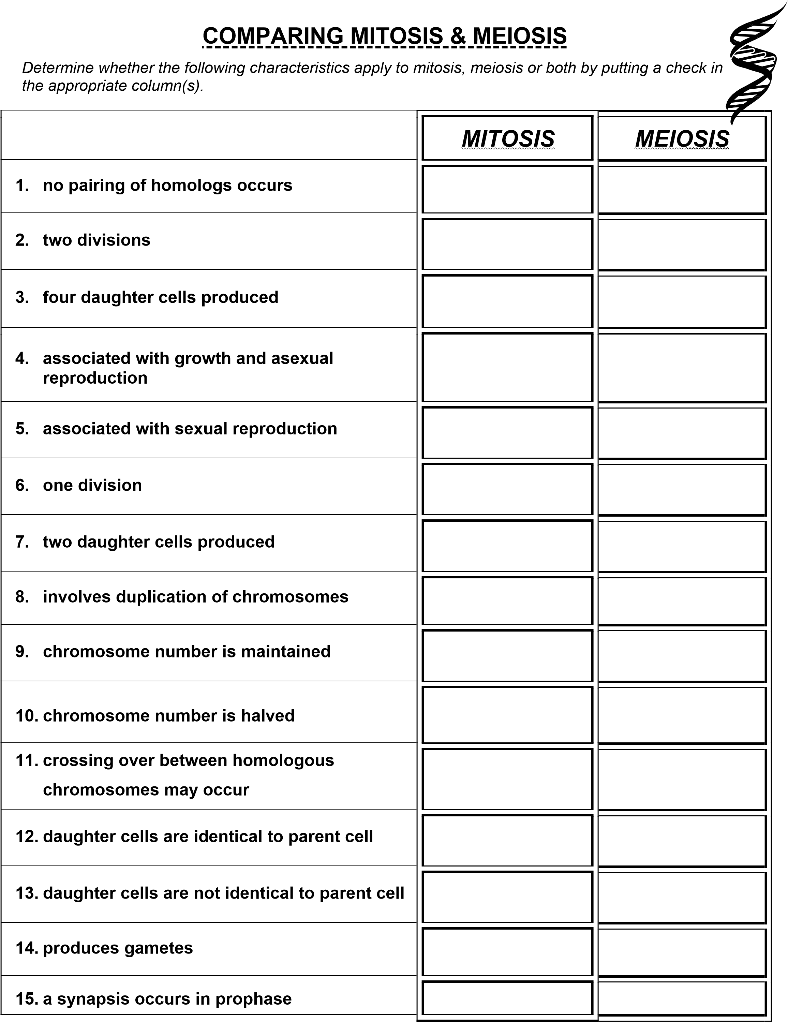

**MEIOSIS Vocabulary**

Name: _______________________________________Period:______Date:_________

**Review the Key Terms**

Use the key terms below and match each term with its definition by writing the letter of the term on the line provided.

________ 1. Body cells

* 1. **meiosis I**

________ 2. XX

* 1. **somatic cells**

________ 3. XY

* 1. **male**

________ 4. Separates homologous pairs of chromosomes

* 1. **meiosis II**

* 1. **female** ________ 5. Halves the number of chromosomes per cell

* 1. **independent**

**assortment**  ________ 6. Homologous chromosomes separate randomly

and independent of one another

Use the key terms in the box below and review the definitions of the terms. Then use the terms to fill in the blanks in the sentences below. **You will not use all the terms.**



**gametes**

**diploid**

**crossing over**

**haploid**

**meiosis**

**dominant**

**heterozygous**

**zygote**

**sexual reproduction**

**genetic recombination**

**homologous**

1. A cell with two of each kind of chromosome is called _____________________.

1. ________________________ are sperm or egg cells.

1. A cell with one of each kind of chromosome is a(n) _______________________ cell.

1. ________________________________ chromosomes have genes for the same traits in the same order on both chromosomes.

1. Parent cells make gametes in a process called ________________________________.

1. A(n) _______________________ is the cell created when a sperm enters an egg.

1. _____________________________________ occurs when male and female gametes form to make a new living organism.

1. When non sister chromatids exchange genes, it is called _________________________.

1. _____________________________________________ results in genetic variety.

**Meiosis Vocabulary:**

1. **Gamete** = sex cell

1. **Egg** = female gamete



1. **Sperm** = male gamete

1. **Haploid** = a cell with only ONE set of chromosomes

1. **Diploid** = a cell containing TWO sets of chromosomes

1. **Crossing over** = when nonsister chromatids of homologous chromosomes exchange genetic information, results in a new combination of genes

1. **Meiosis** = a two stage type of cell division that results in gametes with half the number of chromosome number as the body cells

1. **Homologous chromosomes** = paired chromosomes that have genes for the same traits arranged in the same order

* One homologous chromosome is inherited from the organism’s father, the other from the mother.

1. **Fertilization** = the process of joining gametes

1. **Zygote** = when sperm (haploid) fertilizes the egg (haploid), the resulting cell is the zygote (diploid)

1. **Somatic cell** = body cell (skin, hair, muscle, etc.)

1. **Sex chromosomes** = determine the sex of an individual; XX = female; XY = male

1. **Meiosis I** = Separates homologous pairs of chromosomes, NOT sister chromatids of individual chromosomes

1. **Meiosis II** = the mechanisms of meiosis II is almost the same as mitosis. However, the chromosomes DO NOT replicate between meiosis I and meiosis II, the final outcome of meiosis is halving the number of chromosomes per cell

1. **Independent assortment** = during meiosis I the homologous chromosomes separate randomly and independent of one another.

