**The Cell Cycle & Cellular Division**

Name:_______________________________________________ Period:_______ Date:___________

1. ***Cell Division:***
   * All _______________ are derived from preexisting cells (Cell Theory)
   * ________________________________________ is the process by which cells produce new cells
   * Cells grow in number, NOT in ____________________

o Smaller cells more ____________________ (cellular transport, cellular communication/ signaling)

o _____________________________to take in nutrients & get rid of wastes

* + ***How Often Do Cells Divide?*** 
    - Some cells must be repaired often such as cells lining the___________________,

_____________________, _________________with a short lifespan

* + - Other cells DO NOT divide at all after birth such as__________________________, nerve cells, ______________________, _____________________________

1. ***Reasons for Cell Division:***
   * Cell _________________________

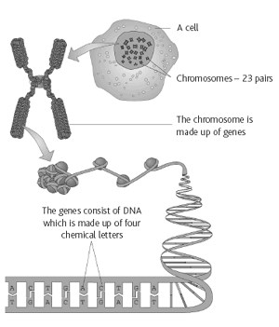

* + __________________&

___________________________of damaged cell parts

* + Growth and development of an __________________

***IV. Chromosomes & Their Structure:***

* The plans for making cells are coded in **__________**
* DNA, deoxyribose nucleic acid, is a long thin molecule that stores ____________________________
* DNA is organized into giant molecules called

__________________________

* ________________________are made of protein & a long, single, tightly-coiled DNA molecule visible only when the cell divides
* When a cell is NOT dividing the chromosome (DNA) is less visible & is called ____________________
* ______________________hold duplicated chromosomes together before they are separated in mitosis
* When DNA makes copies of itself before cell division, each half of the chromosome is called a ___________________________________

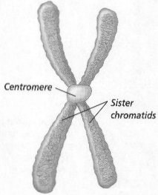

o Each sister chromatid contains the ____________ genetic information

***VI. Cell Cycle & Cell Division:***

* Eukaryotes (nucleus & membrane-bound organelles) must be copied exactly so the 2 new cells formed from division will be ____________________

o The original parent cell & 2 new __________________________must have IDENTICAL chromosomes

o Ex: Humans have 46 chromosomes in our _____________________(body cells). After one of these somatic cells goes through mitosis, 2 daughter cells are produced each having 46 chromosomes (genetically identical).

* Both the nucleus (_______________) and the cytoplasm (______________________) must be divided during cell division in eukaryotes
* Cells go through phases or a cell cycle during their life before they divide to form new cells

o Cell cycle is about ________________ hours for most animal cells

o Cell cycle is controlled by proteins and _________________________

* The cell cycle includes 3 main parts ---________________________, ____________________, and _______________________________________
* ________________________= nuclear division
* __________________________________________= division of the cytoplasm

*A.* ***Interphase:***

* + Interphase is the ___________________________________part of a cell's life cycle and is called the "resting stage" because the cell isn't dividing
  + Divided into 3 stages:

1) _________ (Gap 1) = cell is growing, carrying out normal cell functions, preparing to replicate DNA

• Cells mature & increase in size by making more

_____________________________ & _______________________________

2) ________ (synthesis) = DNA is copied or ___________________

• DNA is in the form of ______________________________(uncoiled DNA) and is NOT ________________________________

3) ________ (Gap 2) =cell prepares for nuclear division (mitosis)

* cells makes all the structures needed to ________________________

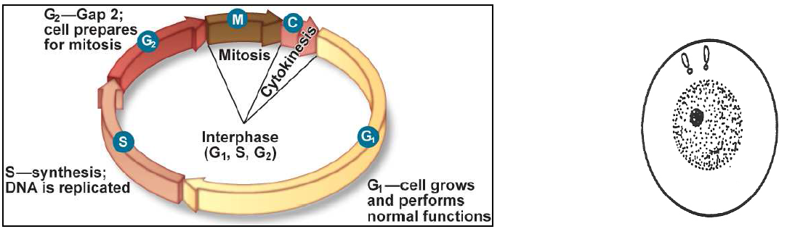

*B.* ***4 Stages of Mitosis:***

* Division of the nucleus or _______________________occurs first
* Mitosis is an _____________________________method of reproduction
* Only_________parent cell

o Daughter cells have SAME number of _____________________(genetic info.)

* Mitosis consists of 4 stages --- prophase, metaphase, anaphase, & telophase

1. ***Prophase:***
   * ______________________ phase of MITOSIS
   * Chromatin (__________________) condenses and coils into the form of chromosomes
     + - 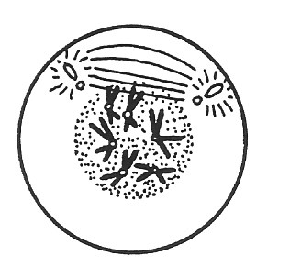Chromosomes are visible (shaped like an “X”)
   * ______________________ (half of a “X”) attach to each other by the ______________
   * Centrioles in animal cells move to opposite ends of cell
   * Spindle forms from each centriole (ONLY in _____________________ cells)
   * __________ cells ___________have centrioles (spindle forms from a microtubule)
   * _____________________dissolves (disappears)
   * _____________________disintegrates
2. 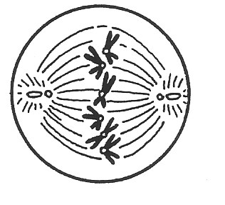***Metaphase:***
   * __________________________phase of MITOSIS
   * Chromosomes line up in center or ________________________of the cell
   * the centromere of each chromosome attaches to spindle fibers

1. 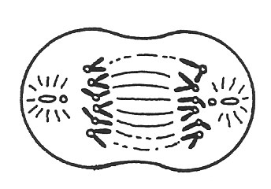***Anaphase:***
   * + Spindle fibers attached to the centriole pull the _________________________ apart at their centromere
     + Separated chromosomes travel along the _________________________ to the two poles (ends) of the cell.
2. 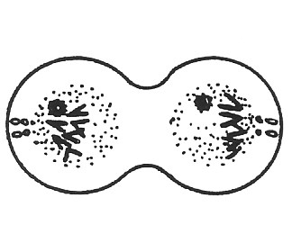***Telophase:***
   * + ____________________________ forms at each end of the cell around the chromosomes
     + ______________________________reforms
     + Spindle fibers begin to break down
     + Chromosomes become less tightly coiled & appear as _________________________again
     + Cytokinesis begins

*Animal Cell*

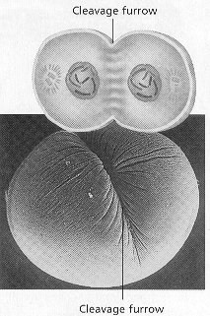

*C.* ***Cytokinesis:***

* __________________________________= division of the cytoplasm of the cell and its organelles separate into 2 new daughter cells

* In_____________________, a groove called the _______________________forms pinching the parent cell in two
* In_______________________, a ___________________ forms down the middle of the cell where the new ______________________will be

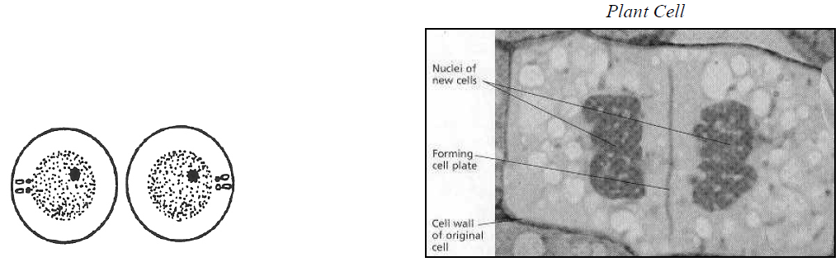

***VI. Cancer:***

* Cell division must be controlled, otherwise cell growth will occur without limit (cancer)

o _____________mutations lead to changes in the proteins/enzymes that regulate the cell cycle

* _____________________= a cell or group of cells that grow out of control and create a tumor

o Crowds out normal cells and results in the loss of tissue function

o ___________________= mass of growing, unregulated cells

* 2 types of tumors:
  + 1. _____________________________- tumor that does not spread
    2. _____________________________- tumor that spreads and destroys healthy tissue
* Causes of cancer:
  + _____________________(family history)

o ______________________

o ________________________(cancer-causing chemicals)

o _________________:

* + HPV can lead to cancer of reproductive organs

o _____________________:

* + Sunlight- skin cancer

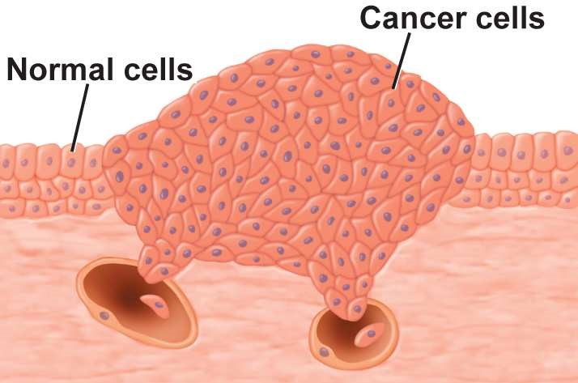

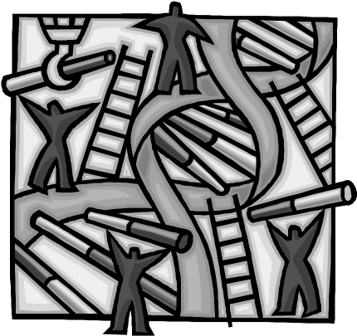**Cell Division Worksheet**

**Matching:** Match the questions below with the proper answers that follow them. Write the proper letter in the blanks.

***QUESTIONS:***

_______ 1. What is mitosis?

_______ 2. In order, what are the four main stages of mitosis?

_______ 3. What is the name of the stage a cell goes through just prior to mitosis?

_______ 4. What is the main event of interphase?

_______ 5. What are two important events of prophase?

_______ 6. What is the main event of metaphase?

_______ 7. What structure is involved in moving chromosomes during mitosis?

_______ 8. What is the main event of anaphase?

_______ 9. What are two important events of telophase?

_______ 10. At the completion of mitosis when the cell divides, what name is given to the two new cells?

_______ 11. You began life as a one-cell structure called a zygote. What process then took place over and over to build a body containing billions of cells?

_______ 12. What are the 3 stages of interphase?

_______ 13. How long does the cell cycle take in an average animal cell?

***ANSWERS:***

1. G1, S, G2
2. The chromosomes (DNA) in the nucleus of the cell make identical copies of themselves.
3. The chromosomes move toward and line up along the center, equator, of the cell.
4. The nuclear membrane disappears and the chromosomes become distinct.
5. 12-24 hours
6. The nuclear membranes form around each of the two sets of chromosomes, and the cell divides into two daughter cells.
7. Prophase, metaphase, anaphase, and telophase
8. Daughter cells
9. Spindle fibers
10. Division of the nucleus of the cell (usually followed by division of the cell itself)
11. The spindle fibers pull one set of chromosomes to one side of the cell and an identical set to the opposite side of the cell.
12. Interphase

**M.**  Mitosis

**Stages of Cellular Division**

*Directions: Number the following six stages of cell division in animal cells in the proper order. Then label each stage (interphase, prophase, metaphase, anaphase, telophase, and cytokinesis).*

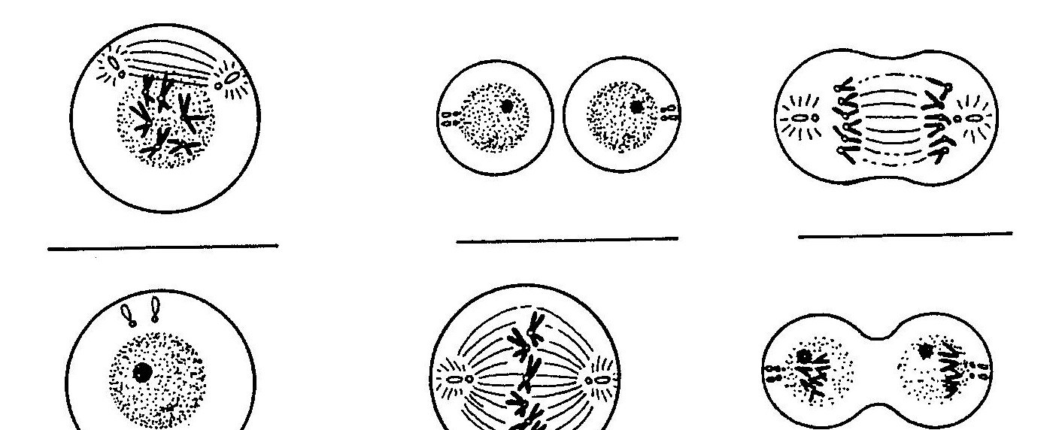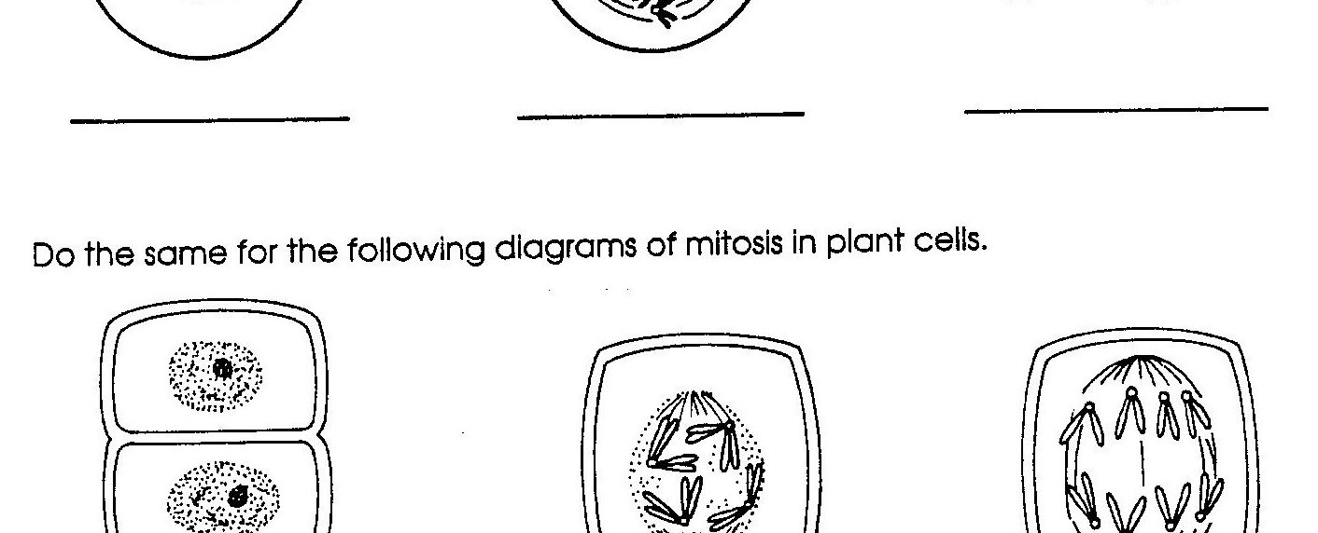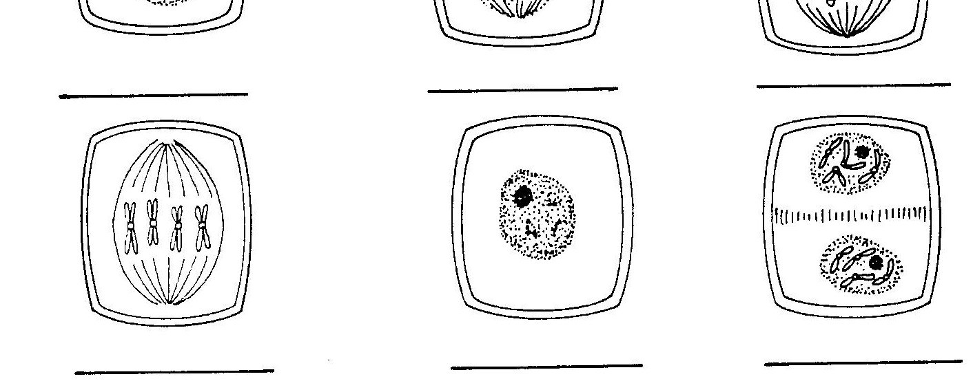

*Directions: Do the same for the plant cell below. Also label the cell plate!*

# The Cell Cycle Review Worksheet

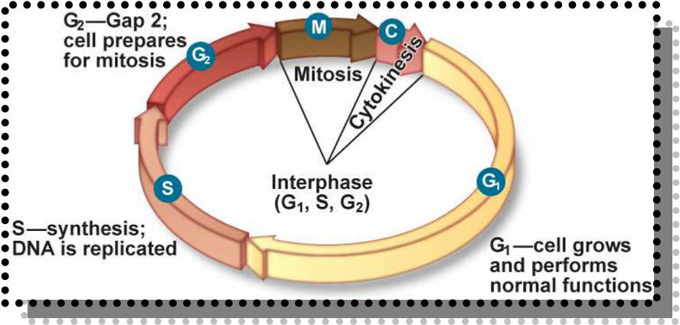

1. List the 3 main parts of the cell cycle.
   1. ______________________________
   2. ______________________________
   3. ______________________________

1. When do cell go through the cell cycle and/or mitosis?

1. What is the difference between chromatin and chromosomes?

1. The division of the nucleus is called? ____________________

1. The division of the cytoplasm is called? ____________________

1. What happens to the cell during interphase?

1. What are the stages of mitosis?________________________________________

1. What is the longest phase of mitosis?___________________

1. What is the shortest phase of mitosis?__________________

1. During what phase does the nucleolus and nuclear membrane disappear?____________

1. In what form is the DNA in during interphase? ____________________

1. What happens to the DNA during interphase?

1. What happens to the chromosomes during prophase?

1. What happens to the chromosomes during metaphase?

1. What happens to the chromosomes during anaphase?

1. What happens to the chromosomes during telophase?
2. What is the difference between cytokinesis in plant and animal cells?
3. Is mitosis a form of sexual or asexual reproduction? Provide 2 reasons for you choice.

1. What is the difference between a malignant tumor and a benign tumor?

1. Define cancer.

1. What are several causes of cancer?

1. Explain what happens during each of the 3 stages of interphase (G1, S, G2)
   1. G1 = _____________________________________________________

* 1. S = ______________________________________________________

* 1. G2 = ______________________________________________________

1. Label the following parts.



B. _______________________

A. _________________________

C. ______________________________



E. ______________________________



D. ______________________________

Cellular Division & Mitosis Vocabulary:

1. **Cancer** = a cell or group of cells that grow out of control and create a tumor



1. **Tumor** = mass of growing, unregulated cells

1. **Benign**= tumor that does not spread

1. **Malignant** = tumor that spreads and destroys healthy tissue

1. **Chromosomes** = made of protein & a long, single, tightly coiled DNA molecule visible only when the cell divides

1. **Chromatin** = uncoiled DNA (less visible); the form the DNA is in when the cell is NOT dividing

1. **Centromere** = holds duplicated chromosomes together before they are separated in mitosis

1. **Sister Chromatid** = half of the chromosome; each sister chromatid contains the same DNA

1. **Mitosis** = nuclear division (prophase, metaphase, anaphase, telophase)



1. **Cytokinesis** = division of the cytoplasm

1. **Spindle fibers** = help move the chromosomes/sister chromatids during cellular division

1. **Centrioles** = help move the chromosomes during cellular division

1. **Interphase** = longest part of a cell's life cycle; DNA is replicated, more cytoplasm and organelles are being made in preparation of diving

1. **G1** = cell is growing, carrying out normal cell functions, preparing to replicate DNA (makes more cytoplasm/organelles)

1. **S** = (synthesis) DNA is copied or replicated

1. **G2** = cell prepares for nuclear division (mitosis)

1. **Prophase** = longest phase of mitosis; chromosomes become visible; nuclear membrane dissolves; nucleolus disintegrates

1. **Metaphase** = shortest phase of mitosis; chromosomes are in the middle of the cell (equator)

1. **Anaphase** = sister chromatids are pulled apart by the spindle fibers

1. **Telophase** = nuclear membrane and nucleolus form; spindle fibers break down; DNA is going into the chromatin form

1. **Cleavage furrow** = a groove forms from pinching the parent cell into two in an animal
2. **Cell plate** = forms down the middle of the PLANT cell where the new cell wall will be formed