Name _____________________________________

History of the Cell & Organelle Worksheet

Part 1: Cell Theory:

1. ____________________ is the basic unit of life.

1. Who was the first person to observe cells using a microscope? _______________________________

1. Which scientist coined the name “cell”? ________________________________________________

1. List the 3 principles of the Cell Theory.

1. What are the two types of cells?

a. ____________________________________ and ____________________________

1. What is the difference between the two types of cells?

1. The shape of the cell depends on its __________________________________

1. What is the relationship between organs, cells and tissue?

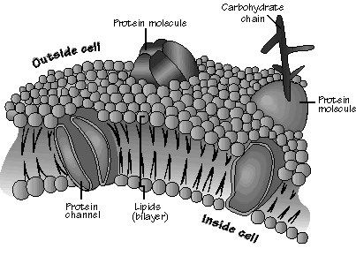

Part 2: Cell Structure:

All cells are enclosed by a cell membrane. Within the membrane is the nucleus and the cytoplasm, which consists of all the material outside the nucleus and inside the cell membrane. Within the cytoplasm are organized structures that perform specific functions. These structures are called organelles.

CELL MEMBRANE: The cell membrane or plasma membrane surrounds the cell. It plays an active role in determining which substances enter and which substances leave the cell. Because some substances can pass freely through the cell membranes and others cannot, the membrane is said to be selectively permeable, or semipermeable. The permeability of the plasma membrane varies from one cell type to another and from time to time in the same type of cell, depending on the state of metabolic activity. The cell membrane is composed of lipids and proteins, known as the phospholipid bilayer.

1. Describe the function of the cell membrane?

1. The cell membrane is composed of ______________________ and ____________________.

1. Why is the cell membrane described as “semipermeable”?

NUCLEUS: The nucleus is the control center for all cell functions. It is usually the largest structure within the cell. It is surrounded by a semipermeable membrane, called the nuclear membrane. The nucleus contains chromatin, uncoiled DNA. During cell division, chromatin coils and folds to form compact chromosomes. The nucleolus is located in the nucleus and is a site of RNA synthesis, as well as, the production of ribosomes.

* 1. 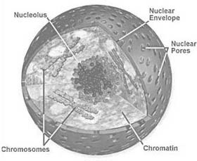The control center of the cell is the __________________.

* 1. What are the functions of the nucleolus?

CYTOPLASM: The material in the cell outside the nucleus is called the cytoplasm. Although it contains thousands of substances, it consists mainly of water and within the cytoplasm are the various organelles of the cell. The cytoplasm provides the environment in which the organelles carry on the life processes of the cell.

1. What is the main function of the cytoplasm?

1. The cytoplasm consists mainly of _________________.

MITOCHONDRIA: Mitochondria (plural) are slipper-shaped organelles found in the cytoplasm. They are enclosed by a double membrane and the inner layer is highly folded. This large surface area provides a way for a small organelle to produce a lot of energy. There are usually many mitochondria in a cell. Each mitochondrion contains its own genetic material, which is separate and distinct from the genetic material found in the nucleus of the same cell. Mitochondria are the sites of cellular respiration, resulting in the production of adenosine triphosphate (ATP). ATP is the main source of energy in cells. Because of its role in producing ATP, it is often referred to as the “powerhouse of the cell”.

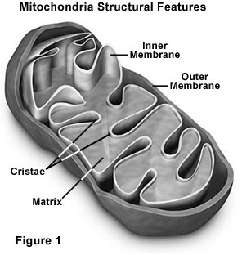

1. What is the function of mitochondria?

1. ___________ is the main source of energy in cells.

1. What is the advantage of the folding of the inner membrane of a mitochondrion?

RIBOSOMES: Ribosomes are small, dense granules found free in the cytoplasm, the nucleus, and lining of the membranes of the rough endoplasmic reticulum. Ribosomes are composed mainly of RNA and are the centers of protein synthesis in the cell. At the ribosomes, amino acids are bonded together to form proteins.

1. Where are ribosomes located in the cell?

1. What are the functions of ribosomes?

1. What happens to amino acids at the ribosomes?

ENDOPLASMIC RETICULUMS: The endoplasmic reticulum is a membrane-

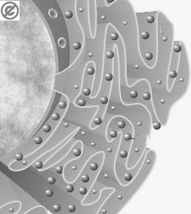

**Rough ER**

bound system of channels or tubes through which materials are transported within the cell. The membranes of the endoplasmic reticulum may also serve as sites for biochemical reactions. There are two types of endoplasmic reticulum—smooth and rough. The rough, or granular, appearance of some endoplasmic reticulum is due to the presence of ribosomes on the endoplasmic reticulum membranes. Rough endoplasmic reticulum is found mainly in cells involved in protein synthesis. Smooth endoplasmic reticulum, which has no ribosomes on its membranes. The smooth endoplasmic reticulum is found mainly in cells involved in synthesis of fats (lipids).

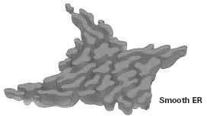

1. The two types of endoplasmic reticulum are _______________ and _______________.
2. What is the function of each endoplasmic reticulum?

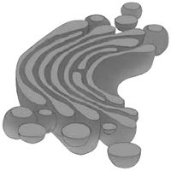GOLGI BODIES: The Golgi body is made up of a series of membrane- enclosed sacs, and it is usually found near the endoplasmic reticulum. This organelle processes, packages, and ships the fats and proteins produced by the ER. Through enzymatic activity, the Golgi body modifies proteins and lipids received from the endoplasmic reticulum and repackages and exports them to new locations within the cell or sends them to the cell’s surface.

* 1. What are the functions of the Golgi body?

* 1. Explain what happens to a protein once it leaves the rough ER.

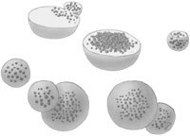LYSOSOMES: Lysosomes are “packages” or sacs that contain digestive enzymes. Lysosomes, which are found only in animal cells, are egg- shaped structures enclosed by a membrane. They keep the enzymes separated from the rest of the cell contents until they are needed. These digestive enzymes break down large molecules stored in the vacuoles (fats, proteins) into smaller constitutes. Lysosomes also serve many other functions. For example, they can break down destructive cells (bacteria) or cells and tissues that are no longer necessary for an organism’s developments (cells that form a tadpole’s tail). Because of this ability to digest, destroy, and clean out, lysosomes are sometimes referred to as the “garbage men of the cell.”

1. What are the functions of lysosomes?

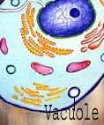VACUOLES: Vacuoles are membrane- enclosed structures that store materials such as water, starch, fats, etc. They are formed from a piece of membrane that breaks loose from the cell membrane, Golgi apparatus, or ER. In animals, there are usually several small vacuoles. In plants, there is usually only one large vacuole. Much of the inside of a typical green plant cell is filled with a large vacuole. The pressure created by the vacuole helps to maintain the rigid structure of the cell and of the plant. In protists, there are food vacuoles in which food is digested so that the cell can use it. In some fresh water protozoa there are water vacuoles that remove excess water from the cell and discharge it back into the environment.

1. In protozoans, such as the ameba, digestion occurs within _________________ vacuole.
2. How are vacuoles formed?

1. What is the function of the large vacuole present in the cells of green plants?

MICROTUBULES: Microtubules are long hollow cylindrical structures and part of the cytoskeleton. Microtubules are composed of a protein called tubulin. They give shape and rigidity to the cell. Cilia and flagella are hair like and whip-like extensions, respectfully. They are formed from specialized microtubules. Cilia and flagella aid cells in locomotion. In larger, many-celled organism, cilia also move substances across the surface of cells.

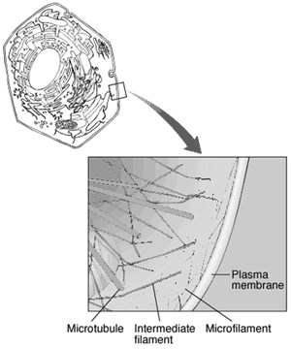MICROFILAMENTS: Microfilaments are long threadlike strands of proteins that are a part of the cytoskeleton. They are associated with cell movement, and in larger organism area associated with muscle contraction.

1. What are microtubules composed of?

1. _______________ and ___________ aid in locomotion of cells.

CENTROSOMES: Centrosomes are small organelles found just outside the nucleus in animal cells. Within the centrosome are two small structures called centrioles, which are necessary for the movement of chromosomes during cell division. Centrioles are only found in animal cells.

1. Centrioles are found only in __________________ cells.

1. What are the functions of centrioles?

Organelles found ONLY in PLANT cells:

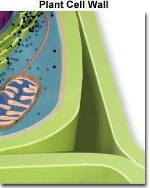CELL WALLS: Cell walls are structures found outside the cell membrane in plant cells and functions in both support and protection. The cell wall is considered to be a “nonliving” part of the cell since it does not take part in any of the functions of the cell. The cell wall is made chiefly of cellulose, is relatively rigid, and provides support for the cell. Cellulose is in the cell walls of many whole grains and is a source of dietary fiber.

1. What are the functions of the cell wall?

1. What are cell walls composed of? _____________________________

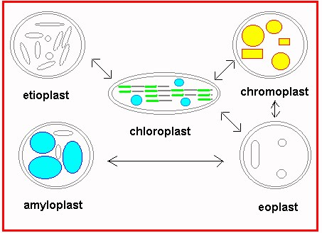PLASTIDS: Plastids, found in most plant cells, have their own DNA and can replicate themselves independently of nuclear DNA. There are three types of plastids: leucoplasts (store starch), chromoplasts (store pigment), and chloroplasts (site of photosynthesis). Chloroplasts, found in plant cells and in some protists, contain the green pigment chlorophyll, which carries on the process of photosynthesis. In photosynthesis, light energy is used for the manufacture of food (carbohydrate).

1. The source of energy for photosynthesis is _________________
2. The most important pigment in chloroplasts is _______________
3. What are three structural differences between a typical animal cell and a typical green plant cell?