Matching: Review Questions

Review Questions: Match the functions with the names of the structures that are listed below. An organelle may be used more than once.

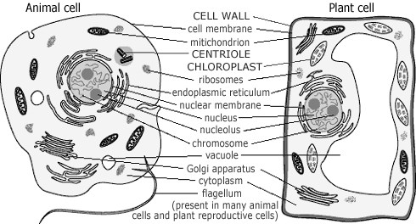**A**. Centrioles **K.** Cilia and flagella

**B**. Lysosomes **L.** Smooth ER

**C**. Cell membrane **M.** Nucleolus

**D.** Mitochondria **N.** Vacuoles

**E**. Cell wall **O.** Golgi body

**F**. Nucleus **P.** Plastids

**G**. Chloroplasts **Q.** Microtubules

**H.** Ribosomes **R.** Microfilament

**I.** Chromatin **S.** Cytoplasm

**J.** Rough ER

____1. Powerhouse of the cell; site of ATP production

____2. Provide shape and rigidity to the cell

____3. Also called the plasma membrane

____4. Bags of enzymes used to digest particles/bacteria; “garbage men” of the cell; work with vacuoles.

____5. Control center of the cell; contains nucleolus and DNA

____6. External surface is studded with ribosomes

____7. Formed from a piece of cell membrane breaking loose; stores substances

____8. Sites for photosynthesis; found only in plant cells; contains chlorophyll

____9. Locomotive structures; made up of microtubules

____10. Site of protein synthesis; found in cytoplasm and on rough ER

____11. Only found in animal cells; form spindle fibers during cell division

____12. Made mostly of cellulose, this encases or surrounds plant cells

____13. Watery substance that fills the interior of cells and suspends organelles

____14. Semipermeable barrier made of two layers of phospholipids

____15. Storage sacs; plant cells have a single large one; animal cells have many smaller ones

____16. Membranous structure that synthesizes fats (lipids)

____17. Membranous structure that synthesizes proteins

____18. Uncoiled DNA; coils into chromosomes during cell division

____19. Location where photosynthesis occurs

____20. Location where ribosomes are formed

____21. Makes up cilia, flagella, and centrioles

____22. Act as a transport system for newly formed proteins

____23. Processes, packages, and stores the fats and proteins produced by the ER

____24. Structures found only in plant cells; chloroplasts are one type

____25. Involved in muscle contraction in larger organisms