“A Cell Is Like a City”

Name: ________________________________________________________Period: _____________

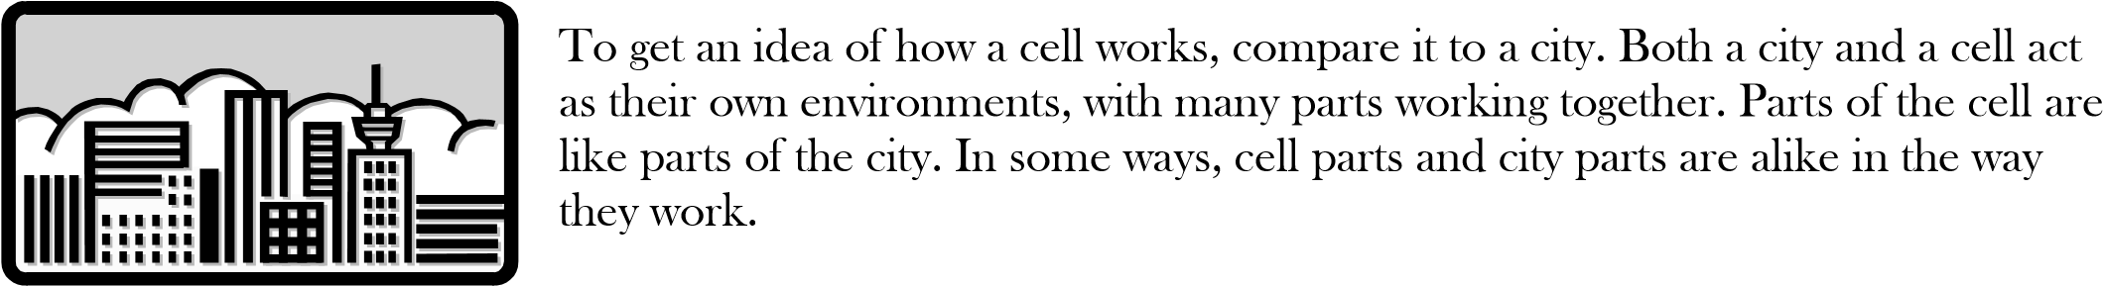

Try to figure out which parts of the cell are like which parts of the city. First, write the functions of the cell parts listed below. Then look at the list of parts of a city. Think about how each part of the city works. Finally, next to each cell part write the letter that goes with the part of the city that has the most similar function.

Parts of a City:

* 1. power plant E. warehouse
  2. fence around the city with gates F. city hall with planning department
  3. storage company G. factories
  4. streets H. wrecking company

_____ Cell Membrane _______________________________________________________________

____________________________________________________________________________

_____ Nucleus _____________________________________________________________________

_______________________________________________________________________________

_____ Endoplasmic reticulum __________________________________________________________

_______________________________________________________________________________

_____ Ribosomes ___________________________________________________________________

_______________________________________________________________________________

_____ Golgi bodies __________________________________________________________________

_______________________________________________________________________________

_____ Mitochondria _________________________________________________________________

_______________________________________________________________________________

_____ Lysosomes ___________________________________________________________________

_______________________________________________________________________________

_____ Vacuoles ____________________________________________________________________

___________________________________________________________________________