*Biochemistry: Nucleic Acids*

Name _________________________________ Pd. _____ Date _________________

**NUCLEIC ACIDS:**

* Complex polymer that stores information in cells in the form of a___________.
* Monomers (basic building blocks):_________________, which consist of C, H, O, N, P

• These elements are arranged in 3 groups: ______________________________, _________________________, and a__________________________.

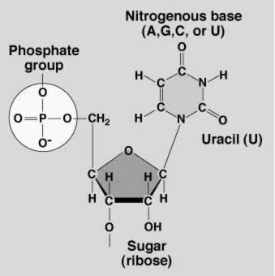

Phosphate

Group

Sugar

Nitrogen

Base

Nucleic Acid Structure

**2 types of nucleic acids:**

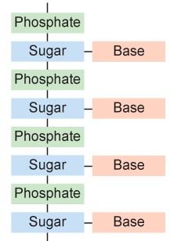

* 1. ______________(deoxyribonucleic acid) contains all the instructions for an organism’s development…..AKA genetic information
     + __________________________ stranded molecule
  2. _____________(ribonucleic acid) forms a copy of DNA and is used for protein synthesis (production**)** 
     + _____________________ stranded molecule

