*Biochemistry: Proteins*

Name _____________________________________________

**PROTEINS:**

* ____________________**:** meats, soy, cheese
* Large complex polymer composed of C, H, O, N, & sometimes S
* Monomers (basic building blocks): _____________________
  + - * + ______different amino acids

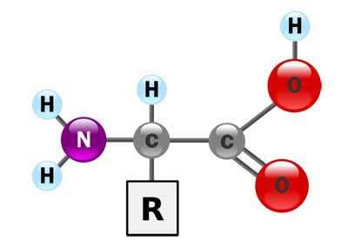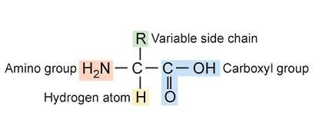

•

Example amino acids:

Structure of an amino acid:

* + Central carbon atom bonded with **_____________________**. The other 3 bonds are with an _______________ group (-NH2), a ______________group

(-COOH) and a ___________________group (-R)

o The variable group makes each amino acid _____________________!

Amino acids are linked together by _________________ ___________________ to form a protein

* + Ex: 2 amino acids joined by ___________________ ______________________

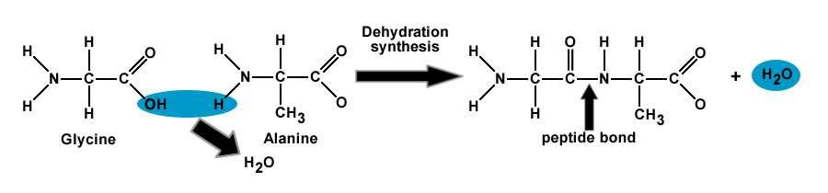

______________________= a covalent bond that joins amino acids to each other

* + Forms between the _______________ group of one amino acid and the _________________________group of the otheramino acid.

Proteins- named for the _______________of amino acids that make them

* + 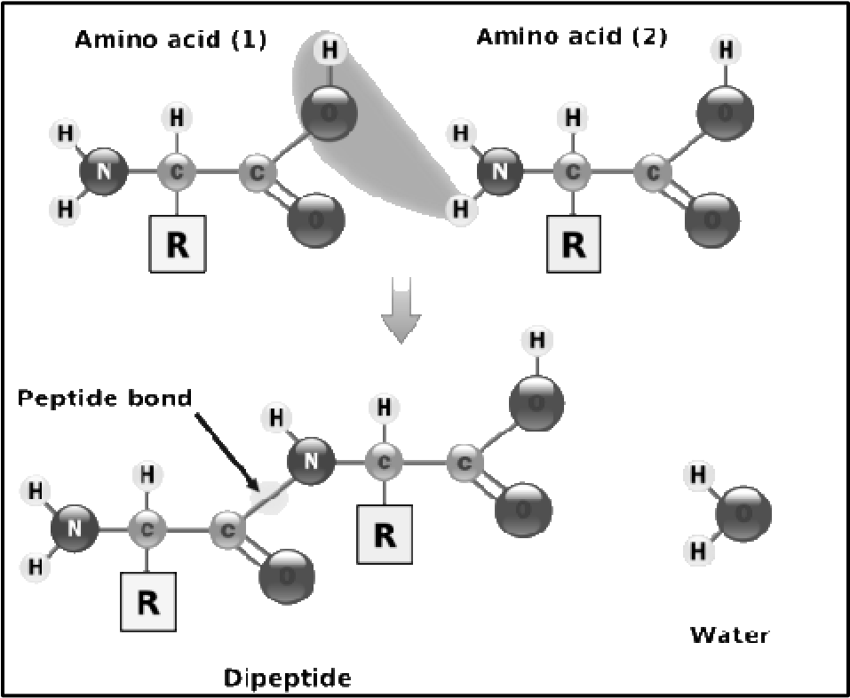Ex: o two amino acids =

____________________

* + - three amino acids =

____________________

* + - many amino acids =

_____________________

**Essential Amino Acids:**

* + ______of the _____ amino acids are “essential” because they are required by the body but are _________created by it.

o As a result, it must be provided by our______. If one is missing then proper growth and repair cannot be_________________.

**Types &** **Functions of proteins in our body:**

* + 1. ____________________________contraction (actin and myosin)
    2. Transport _______________________________in the bloodstream (hemoglobin)
    3. Provide _________________________________(antibodies)
    4. Carry out ______________________________reactions (enzymes and hormones)
    5. Collagen = _____________________ protein in animals
* Gives connective tissue ___________________________
* _______________________
  + Anti-wrinkle creams?

1. Keratin
   * **­­­­­­­­­­­­­­­­­­­­­­­**________________________ protein in humans
   * Found in __________________, nails, _________________
   * Adds __________________________________
2. All proteins help with ___________________ and ______________________ of cells in our diet

* Increase protein intake during rapid ___________________ years or ___________________________ repair.

**What happens to PROTEINS in the body?**

* + - Broken down by the digestive system via HYDROLYSIS into

_______________which are then absorbed into the body through the bloodstream, where the body cells take the amino acids and makes protein for muscles.

**Crash Course: You Are What You Eat**

<https://www.youtube.com/watch?v=H8WJ2KENlK0&list=PL3EED4C1D684D3ADF&index=3>