

Name: ___________________________________Period: _____ Date: __________

1. **LIPIDS:**

_______________**:** butter, oil, Crisco, lard

Commonly called _____________& __________

Contain __________C-H bonds and _________O atoms than______________________.

• Ex: C57H110O6

Nonpolar; therefore repels ___________ (_________________)

**Functions of lipids in our body:**

* + 1. _____________energy storage (used when carbohydrates are NOT available)
    2. _____________________
    3. _____________body tissue (cushioning)

**WHICH HAS MORE ENERGY – LIPIDS OR CARBS?**

* + - One gram of _________contains ______________as much __________as one gram of _________________. Therefore, __________are better ___________compounds!

**Fats vs. Carbs. & Energy Storage:**

* + - 1 gram of Carbs. (glycogen) = about **____________** of energy

o a short term rapid energy source (sprint events)

* + - 1 gram of Fats = about ___________of energy

o a long term energy source (endurance events - marathons)

* + - Average human contains about 0.5 Kg of stored glycogen = ______ Kcal of energy.
    - About 16 Kg of body fat = ___________ Kcal of energy

To carry the same amount of energy [144,000 Kcal] as carbs, we would have to store 36 Kg [79.4 pounds] more glycogen to lose 1 Kg of body fat.

This means you need to burn lots of calories!

**Types and Examples of Lipids:**

1.____________- steroids

2._____________– bee, furniture, ear, car

3. _____________- in egg yolks, red meat

4.__________ - from animals

5. ___________– from plants

6. _________________ - cell membranes

7. __________________________ - plants

**Structure of Lipids:**

* + Basic building blocks: __________________+ ________________
  + Fatty Acids

o Long _____________________________with a ___________group at one end

* One fatty acid

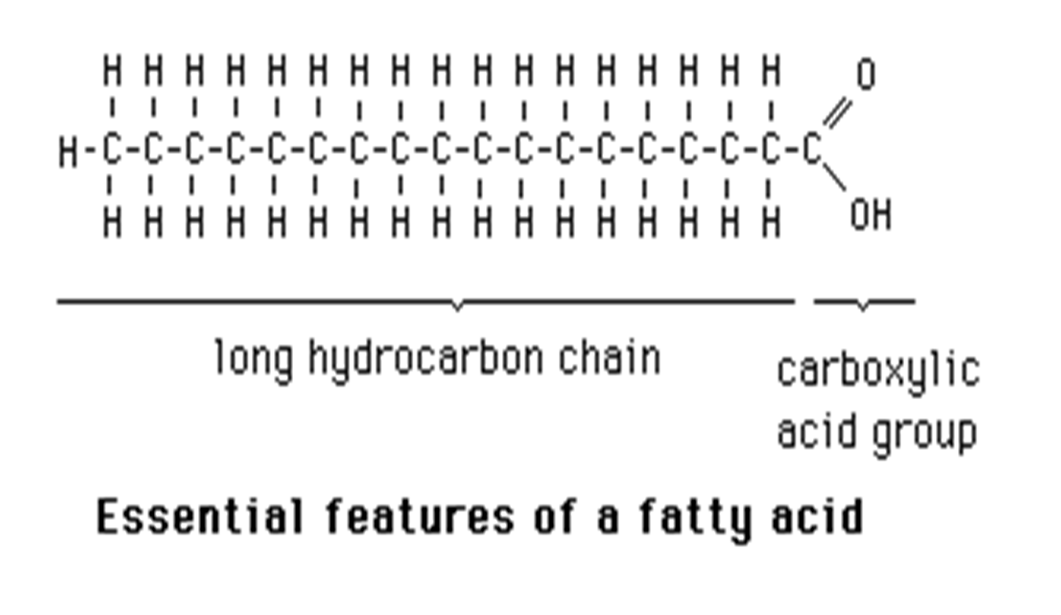

* + Glycerol and each fatty acid chain are joined to each other by __________________________________________.

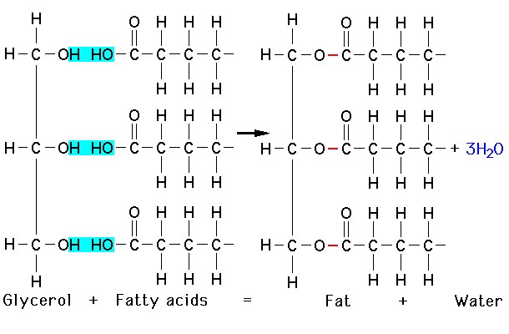

* + Structure of a lipid (1 glycerol + 3 fatty acids):

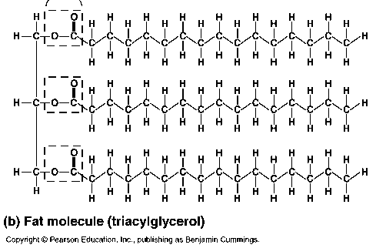

**3**

**Fatty Acids**

**Glycerol**

**4 types of fats:**

* + - 1. _____________________ = fatty acid chains of carbon with only ______________ bonds between the carbon atoms

o “_______________________”- cholesterol (heart disease)

o ___________at room temperature

Ex: _____________ , _______________________

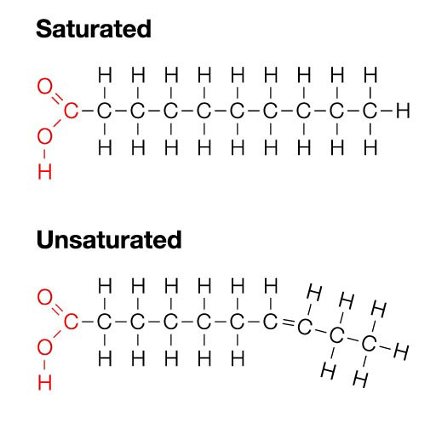

* + - 1. _____________________ = fatty acid chains of carbon with

ONE__________________ bond between the carbon atoms

o “_____________________”

o ______________at room temperature

Ex: _______________

* + - 1. _____________________________= more than one double bond between the carbon atoms in the chain

o Ex: nuts, seeds, fish, leafy greens

* + - * + Structural formulas for saturated and polyunsaturated fatty acids:

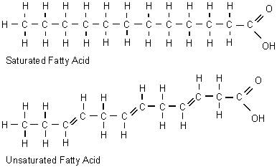

Polyunsaturated fatty acid

4. _____________________________________ (trans fat)

* + - Unsaturated fats that have been artificially saturated by addition of hydrogen atoms
      * ___________________________ at room temperature
        + Margarine
        + Vegetable shortening

**What happens to LIPIDS in the body?**

* + - Broken down by the digestive system via HYDROLYSIS into _______________ and _______________which are then absorbed into the body through the bloodstream.
    - The fatty acids can then be broken down directly to get ______________, or can be used to make glucose

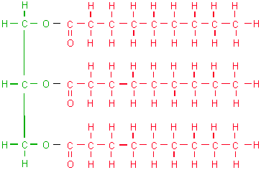 _____________________________**=** Majority of fat in an organism consists of this type of fat molecules

* + - Derived from fats eaten in ___________or made in the body from other energy sources like carbohydrates.
    - Calories ingested in a meal and not used immediately by tissues are converted to triglycerides and transported to fat cells to be stored.
    - Storage – 3 month supply of ___________vs. glycogen’s 24 hour supply

• Hormones regulate the release of triglycerides from fat tissue so they

meet the body's needs for energy between meals.

**Excess Triglycerides- Life Applications:**

* + - Cause plaque to build up

o ______________________ = walls of the arteries get thick and hard; fat

builds up inside the walls and slows the blood flow

Cause blood clots –heart attacks, strokes

* + - * 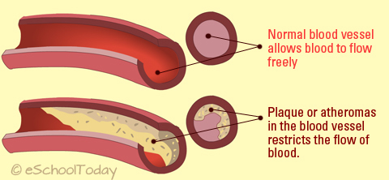 _____________________(high blood pressure)

________________________________ (part of cell membrane structure)

