**The Art of ZENTANGLE** –Inspired Creations

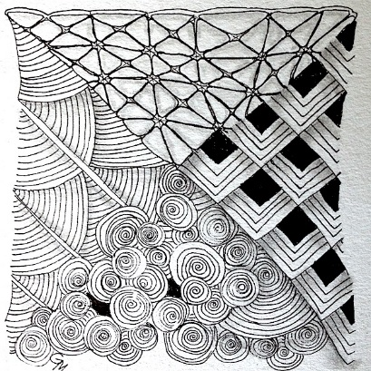**Zentangle -** created by Rick Roberts (Monk) and Maria Thomas (artist, botanical art illustrator and lettering artist)

* 1. **Traditional Zentangle-** square paper (tile), black and white, no color since that would require you to switch to your left brain, Ideally, zentangle is supposed to be abstract and does not follow a specific shape.
  2. 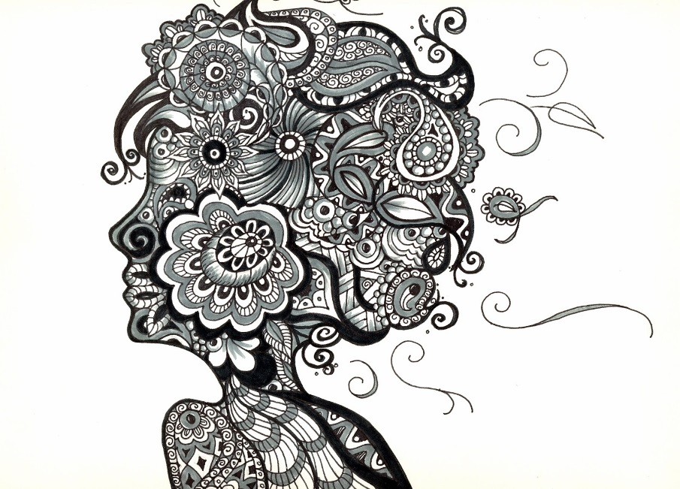**Silhouette Zentangle-** Portrait silhouette , life as a theme, pick an object that relates to your life and draw the silohette of that object and zentangle the inside.

Grace Mendez

* 1. **Motto:** No talent required, -“Anything is possible one stroke at a time.”

**Steps:**

***Homework:*** Gather samples of images from real life, plants, patterns etc. to use as inspiration and reference

Mary K. Whalen

1. Get focused
   1. “Mindfulness can be described as an awareness of yourself in the present, including an awareness of your body, your mind, your thoughts and your feelings”
2. 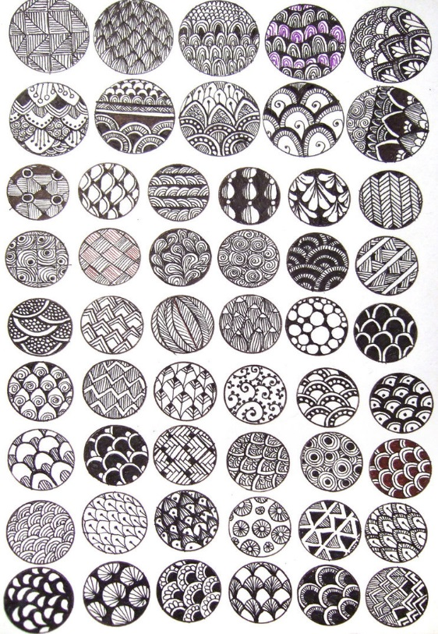***In-class work*** -Use samples of images from life to develop at least 5 different sample tangles (see samples to right)
3. Cut out 3 ½” square sheets TRADITIONAL METHOD (you can down the road consider changing the shape of the shape of tile to an oval, circle etc.)
4. Place dots in each of the 4 corners of the square – it doesn’t have to be exact
5. Connect the dots (using a pencil) to draw a border inside of your tile (can be straight, curved etc*). Imagine these edges as life’s boundaries.*
6. Inside the border you will draw your strings in pencil (lines) to separate the space. The lines do not have to be straight and ***will not*** be drawn in pen. The separation between the spaces will come from the different tangles. Let the line flow and try not to think about it. *These lines can represent the events in your life*
7. *Begin to add Tangles.* ***Tangles are all drawn in pen***
   1. no erasing and must figure out how to make the mistake work for you into the design
   2. Once the tangle is complete you may begin to add shading to enhance the depth of the work ( will demonstrate in class)
   3. Continue until your Zentangle is complete. You will know when you are finished.
8. The next step will be to pick your favorite thing in this world. It could be a favorite food, your favorite musician, or your favorite cartoon character. You choose. You will draw the silhouette of this object onto a 9x12 drawing paper. Follow the same process as above by creating strings with in the object and using your tangles develop your Zentangle. Once the Zentangle is complete you may add shading to create depth.

**Vocabulary:**

***Elements of Art***

**Line**- is a mark made by a pointed tool.

**Shape**- is a flat, enclosed area that has two dimensions.

**Value**- refers to the lights and darks of an object.

**Texture** – describes the feel of an actual surface or perceived to be felt.

**Space** – Organizes the elements of art in a composition. The area in which an object exists.

***Principles of Art***

**Pattern**- is created through a repetitious use of the same element to create an overall design

**Rhythm**- is the repeated use of similar element such as color, line or shape

**Contrast** – shows differences between the elements of art

***Tile***-square piece of paper

***String*** – a line

***Tangle***- is a pattern drawn in pen along the contours of a string

***Zentangle*** - is an abstract, patterned drawing created according to the tenets of the Zentangle Method.

***Zen***- Mindful

***Mindfulness*** - can be described as an awareness of yourself in the present, including an awareness of your body, your mind, your thoughts and your feelings”

***Zentangle-inspired creations*** - Works that are reminiscent of Zentangles but don't adhere to the official guidelines

***Meditation***- is a mental concentration on something

