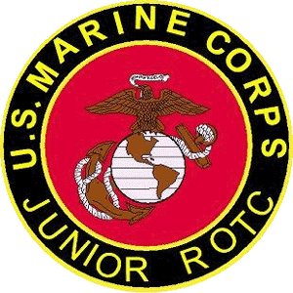

Dallastown Area High School
Marine Corps JROTC
Lt. Colonel Joseph P. Innerst, USMC (Ret.)
joseph.innerst@dallastown.net
First Sergeant Matthew Corwin, USMC (Ret.)
matthew.corwin@dallastown.net

WELCOME ABOARD PICNIC
Sunday 30 September 2018
York Water Company
Picnic Grounds at Lake Redman
296 Hess Farm Road, York, PA 17403
1500-1800

$5 Donation Per Individual
$15 Donation Per Family

All JROTC cadets and their immediate families are invited to a “Welcome Aboard Picnic” in September at the York Water Company’s picnic grounds.

Pulled pork, chicken, chips and drinks will be provided.
Cadets with the last name between
A-N – bring a covered dish
O-Z - bring a dessert

Please keep this date open as we are hoping to have everyone attend for food, fun and information on all Dallastown JROTC 2018-2019 events. Tennis, basketball, frisbee, softball and other events will be available so please bring your rackets, frisbees, balls, bats, and gloves. JROTC apparel will be available for purchase at this event.

*We will not be using the pool, lake, or dock so please avoid these areas as the York Water Company has been gracious in giving us the use of their land.

