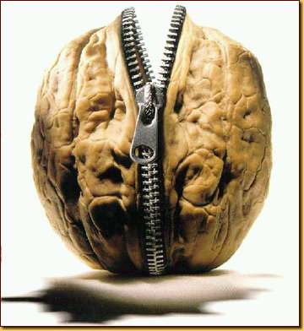**Antigone:** In a Nutshell

[Sophocles](http://www.theatrehistory.com/ancient/sophocles001.html) is considered one of the great ancient Greek tragedians. Among Sophocles' most famous plays are [*Oedipus the King*](http://www.shmoop.com/intro/literature/sophocles/oedipus-the-king.html), *Oedipus at Colonus*, and ***Antigone***. These plays follow the fall of the great king, Oedipus, and later the tragedies that his children suffer. The *Oedipus* plays have had a wide-reaching influence and are particularly notable for inspiring [Sigmund Freud](http://www.bbc.co.uk/history/historic_figures/freud_sigmund.shtml)’s theory of the "Oedipus Complex," which describes a stage of psychological development in which a child sees his/her father as an adversarial competitor for his or her mother’s attention.  
  
The three plays are often called a trilogy, but this is technically incorrect. They weren't written to be performed together. In fact they weren't even written in order. *Antigone*, which comes last chronologically, was the play Sophocles wrote first, around 440 B.C. It wasn't until about 430 B.C that Sophocles produced his masterpiece *Oedipus the King*. He finally wrote *Oedipus at Colonus* in 401 B.C., near the end of his life. Also note that the plays were rarely if ever revived during the playwright's lifetime, so it's not like it would have been easy for Sophocles' audiences to compare them.  
  
These facts probably explain some of discrepancies found in the plays. For example, while Creon is the undisputed King at the end of *Oedipus the King*, in *Oedipus at Colonus* it’s Polyneices and Eteocles who are battling for the throne. In *Antigone*, Creon assumes the throne with no mention of the fact that he's ever sat on it before. It's pretty unlikely that Sophocles forgot this key fact. But it could very well be that it just didn't matter very much. Each play is a separate interpretation of the myth, not a part of a trilogy. Sophocles would've been under no obligation to make the plays coherent in every detail.  
  
Of course, while the plays aren't technically a trilogy and do have discrepancies, they do share many similarities. Several of the key characters put in repeat appearances, including Oedipus, Creon, Teiresias, Ismene, and Antigone. Also, the plays have a lot of the same themes. The plays all deal in some way with the will of man vs. the will of the gods. Self-injury and suicide also plague the family until the end. It seems that Oedipus's family is never quite capable of escaping the pollution of his terrible mistakes.

**Why Should I Care?**

*Antigone* matters because it wrestles with civil disobedience. Remember how Ismene asks Antigone to just forget about burying their brother’s body (which, according to the king's latest law, is an act punishable by death) and to instead marry the king’s dreamy son and live happily ever after? Antigone isn't willing to forget her brother. She sees burying her brother as a moral imperative, which supersedes human-created laws. And she's not the only person who has courageously placed morals over state laws.  
  
Reach into the depths of the history room in your mind. You have lots of modern examples of people who have chosen to fight for justice rather than preserve their own safety. Consider [Dr. Martin Luther King, Jr.](http://nobelprize.org/nobel_prizes/peace/laureates/1964/king-bio.html) or [Gandhi](http://www.bbc.co.uk/history/historic_figures/gandhi_mohandas.shtml), both advocates of civil disobedience and peaceful demonstrations, who were assassinated as a result of their fights against oppression. Or think about [Nelson Mandela](http://nobelprize.org/nobel_prizes/peace/laureates/1993/mandela-bio.html), who risked years in jail to stand up against the apartheid government in South Africa.   
  
Antigone chooses to express her dissatisfaction with what she believes to be the unethical new regime of King Creon by burying her brother's body. Antigone resolves to sacrifice her own life in the service of a greater justice. It's this kind of almost superhuman resolve that changes the course of history, and that's something that we can admire equally in the 5th century B.C. and the 21st century A.D.