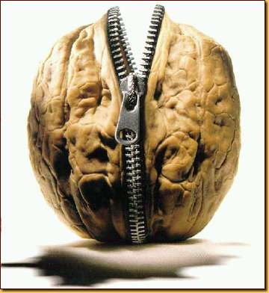**Orpheus and Eurydice:** In a Nutshell

Have you ever ended a relationship with someone, only to find that you can't stop thinking about them? (Ouch, right?) Have you ever gotten a second chance and then totally blown it? (Double ouch.) Well then, the story of Orpheus and Eurydice might just be for you.

Orpheus, the rock star of Greek mythology, falls head over heels in love with Eurydice, a beautiful wood nymph. The two get married and are ready to embark on an blissful life when *BAM!,* Eurydice dies of a snake bite. Didn't see that one coming, did you?

Overcome with grief, Orpheus starts to play some majorly sad songs on his [lyre](http://www.carnaval.com/saturnalia/OrpheusLyreAnimal.jpg) (the electric guitar hadn't been invented yet) and decides to heroically travel to the Underworld to free his main squeeze.

It's a story of passionate love, gut-wrenching heartbreak, and musical awesomeness–and it's got a twist ending that'll have you singing the blues. So break out the tissues and turn on a sad Taylor Swift ballad, because Orpheus and Eurydice might beat [*Romeo and Juliet*](http://www.shmoop.com/romeo-and-juliet/)for Most Tragic Love Story Ever.

**Connections**

Explore the ways this myth connects with the world and with other topics:

A statue of Orpheus is mentioned in Vladimir Nabokov's short story, "[The Return of Chorb](http://www.shmoop.com/return-of-chorb/symbolism-imagery.html)."The story is about a husband who becomes obsessed with the memory of his dead wife after she's killed on their honeymoon. Hmm, sound familiar?   
  
Ovid poetically describes the Orpheus and Eurydice story in [Book 10](http://www.shmoop.com/metamorphoses/book-10-summary.html) of his *Metamorphoses.* This one's for the classics dorks.  
  
In [Book 7](http://www.shmoop.com/paradise-lost/book-7-summary.html) of *Paradise Lost*, John Milton namedrops Orpheus, saying that he doesn't want to be torn to pieces like the "Thracian bard." Did we mention that things don't end well for Orpheus?  
  
Tennessee Williams wrote a play called [*Orpheus Descending*](http://www.shmoop.com/tennessee-williams/timeline.html)*,* which is vaguely based on the Greek myth. It is a pretty theatrical plot, we'll give him that much.  
  
Orpheus was the original Elvis Presley, making everyone (and every*thing*) swoon with his lyre playing. In Shakespeare's [*Two Gentlemen of Verona*](http://www.shmoop.com/gentlemen-of-verona/), Proteus talks about the power of Orpheus' music to "soften steel and stones" and "make tigers tame." Fancy.

Based on <http://www.shmoop.com/orpheus-eurydice/>