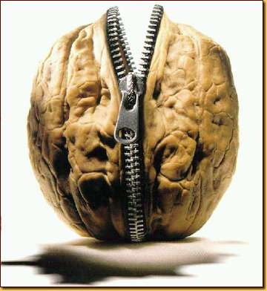**Cupid and Psyche:** In a Nutshell

Picture this: Mortal girl falls in love with supernatural boy. Relationship problems ensue. Boy makes girl immortal too. They live happily ever after.

If images of [Robert Pattinson](http://www.imdb.com/character/ch0058224/mediaindex) and his [carefully disheveled hair](http://teenchive.none18.netdna-cdn.com/wp-content/uploads/2010/08/Robert-Pattinson-messy-hair-navy-unbutton-shirt.jpg) are flitting through your mind, guess again. We're not talking about the *Twilight* series, or any other teen paranormal romance novel, for that matter. We're talking about the Greco-Roman myth of "**Cupid and Psyche**."

This story is all about what happens when Cupid gets nicked by his own arrow and falls for a mortal girl. There's love, mystery, betrayal, passion, danger . . . Heck, there's even a bit of *Beauty and the Beast* and *Cinderella* thrown in for good measure. Come to think of it, it's kind of crazy that the story of Cupid and Psyche hasn't been made into a blockbuster Hollywood movie yet. Seriously, somebody tell Disney to check out this guide. There's a gold mine here.

**Connections**

Explore the ways this myth connects with the world and with other topics:

* In Edgar Allan Poe's poem "[Ulalume](http://www.shmoop.com/ulalume/" \o "Ulalume)," the speaker is walking around the woods with his soul. His soul happens to be a winged woman named Psyche. Poe's Psyche was clearly inspired by Cupid's love.
* Cupid and Psyche's romance does have a lot of similarities to Edward and Bella's in the *Twilight* saga.
* Venus wants her son Cupid to punish Psyche by making her fall in love with the ugliest thing around. That sounds a lot like the prank Fairy King Oberon plays on his wife, Titania, in Shakespeare's [*A Midsummer Night's Dream*](http://www.shmoop.com/midsummer-nights-dream/). Oberon gets his sidekick to make Titania fall in love with a donkey-headed man. Shakespeare's play was inspired in part by Apuleius's *The Golden Ass*, the ancient Roman novel that the story "Cupid and Psyche" appears in.

Adapted from <http://www.shmoop.com/cupid-psyche/>