Unit 5 Part 1 = Bioenergetics: ATP Name __________________

ATP
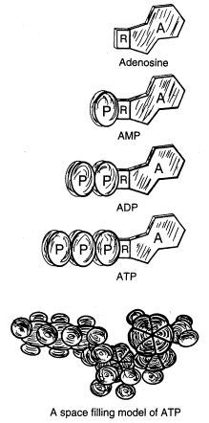

1. What doe the letters ATP represent? ________________________________

C₁₀H₁₆N₅O₁₃P₃

2. What is ATP?

3. Why do cells need ATP?

4. Cells need energy to do work. How is energy liberated from ATP?

5. When the terminal phosphate is removed from ATP, the resulting compound is
________________________________ which is represented as __________.

6. At any instant, each cell of the human body contains _____________ ATP molecules while the total content
of ATP in the human body is about _________ grams which must constantly be recycled every day.

7. What is the ultimate source of energy for constructing ATP? ________________________
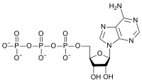
8. What is coupling?

9. Explain how ATP helps cells perform the following:

a. Transport work =

b. Mechanical work =

c. Chemical work =

10. Provide another way ATP helps cells to function (that is in addition to those listed in #9 above)
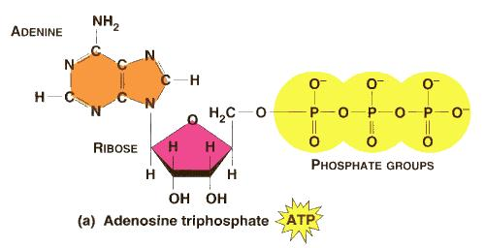

11. What 3 processes can produce ATP in a cell?

a. ___________________________

b. ___________________________

c. ___________________________

12. During aerobic respiration, the addition of a phosphate to ADP can occur in which 2 cellular locations?

13. What is the function of the mitochondria in ATP production?

14. Two important ATP generating events occur in the mitochondria during aerobic respiration:

a. The ________________ _____________ ______________ which involves thousands of enzymes in
the membranous sack on the mitochondrial wall and the a flow of hydrogen ions across the inner
membrane.

b. The ____________ _________ when food is concerted to Pyruvate and then to acetyl coenzyme A.
