Name ________________________________________ Date ______________ Period ____________
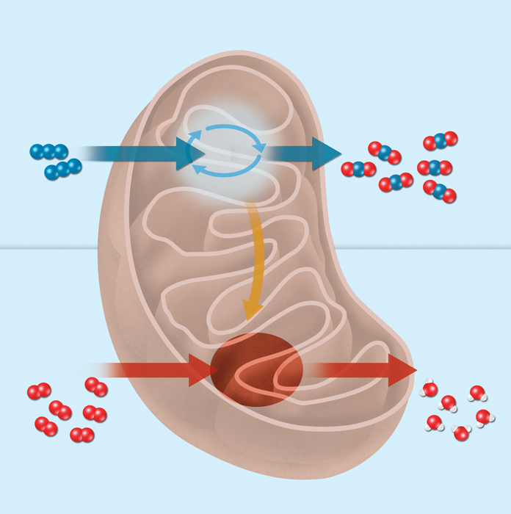
Overview of Cellular Respiration and Fermentation

KEY CONCEPT
The overall process of cellular respiration converts sugar into ATP
using oxygen.

MAIN IDEA: Cellular respiration makes ATP by breaking down sugars.

1. What is function of cellular respiration?

__________________________________________________________________________________

__________________________________________________________________________________

2. Does glucose actually react with oxygen during cellular respiration? Explain

__________________________________________________________________________________

__________________________________________________________________________________

MAIN IDEA: Cellular respiration is like a mirror image of photosynthesis.

3. In what two ways does cellular respiration seem to be the opposite of photosynthesis?

__________________________________________________________________________________

__________________________________________________________________________________

4. Write the chemical equation for the overall process of cellular respiration. Explain what the equation means. Identify the reactants, products, and the meaning of the several arrows.

__________________________________________________________________________________

__________________________________________________________________________________

__________________________________________________________________________________

5. The prefix glyco- comes from a Greek word that means “sweet.” The suffix -lysis comes from a Greek word that means “to loosen.” How are the meanings of these word parts related to the meaning of glycolysis?

__________________________________________________________________________________

__________________________________________________________________________________

6. What does it mean to say that glycolysis is an anaerobic process?

__________________________________________________________________________________

__________________________________________________________________________________

KEY CONCEPT Fermentation allows the production of a small amount of ATP without oxygen.

When oxygen is not available in cells, fermentation takes place instead. Fermentation is an anaerobic process that allows glycolysis to continue, but does not produce ATP on its own. The main function of fermentation is to remove electrons from molecules of NADH, the energy-carrier produced by glycolysis, to form NAD+. The molecules of NAD+ are recycled to glycolysis, which can continue to produce a small amount of ATP without oxygen. There are two main types of fermentation.

• Lactic acid fermentation: Pyruvate and NADH from glycolysis enter the fermentation process. Energy from the NADH molecules is used to convert pyruvate into lactic acid. NADH molecules are converted into NAD+ molecules that are recycled to glycolysis to pick up more electrons. This type of fermentation occurs in many types of cells, including human muscle cells.

• Alcoholic fermentation: Like lactic acid fermentation, pyruvate and NADH from glycolysis enter fermentation. Energy from NADH is used to break down pyruvate into an alcohol and carbon dioxide. NADH molecules are converted into NAD+ molecules that are recycled to glycolysis. Alcoholic fermentation is used by many types of yeast.

Both types of fermentation are used in various commercial processes. Lactic acid fermentation is used to make yogurt. Alcoholic fermentation is used to make dough rise.
__________________________________________________________________________________

1. What is the function of fermentation?

__________________________________________________________________________________

__________________________________________________________________________________

2. When does fermentation take place in your muscle cells?

__________________________________________________________________________________

3. How is fermentation involved in the production of ATP?

__________________________________________________________________________________

__________________________________________________________________________________

4. How are lactic acid fermentation and alcoholic fermentation similar? different?

__________________________________________________________________________________

__________________________________________________________________________________

__________________________________________________________________________________

5. Name a commercial use of fermentation.

__________________________________________________________________________________

6. The term fermentation is based on a word that means “to bubble”. How is this meaning related to your understanding of the fermentation process?

__________________________________________________________________________________

__________________________________________________________________________________

