Plasma or cell membrane | Regulates what enters and leaves cell  Gives cell its shape  Separates cell from environment  Outermost layer in animal cell | 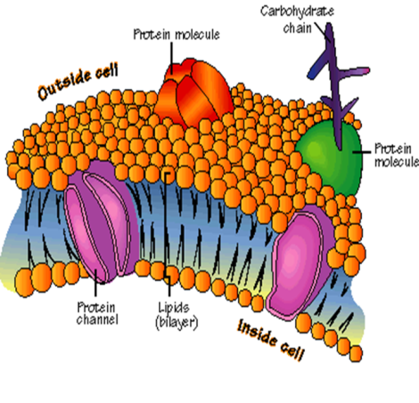
Nucleus | Brain of cell  Controls the cell’s activities  Coordinates cell division  Present in all eukaryotic cells | 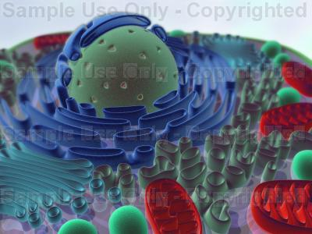
Nuclear membrane or nuclear envelope | Allows certain things to pass into or out of the nucleus  Contains pores | 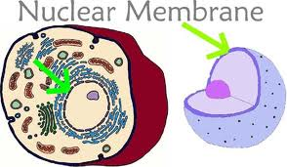
Nucleolus | Plays a role in protein synthesis  Present in all eukaryotic cells | 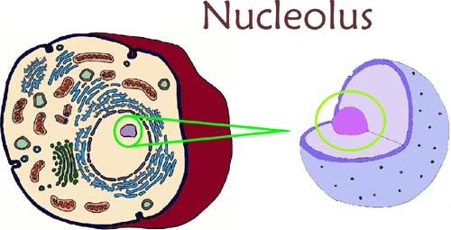
Chromatin or chromosomes | Carries the genetic information for the cell  All prokaryotic and eukaryotic cells have this | 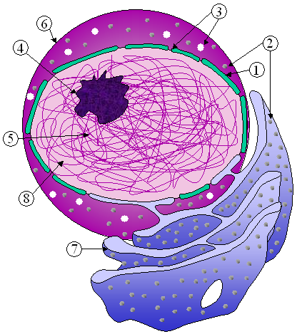
Cytoplasm | All the cell material outside the nucleus  Organelles are suspended in this  All prokaryotic and eukaryotic cells have this | 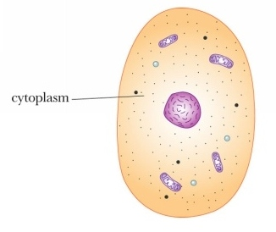
Endoplasmic reticulum | Serves as a passageway for material to transport into and out of cell  All prokaryotic and eukaryotic cells have this | 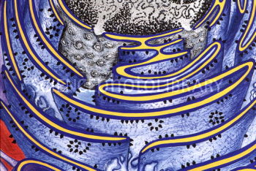
Ribosomes | Protein synthesis occurs here  All prokaryotic and eukaryotic cells have this | 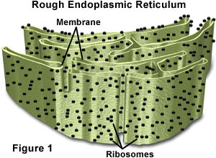
Mitochondria | Power house of the cell  Site of cellular respiration in eukaryotic cells  Energy of glucose is converted to ATP | 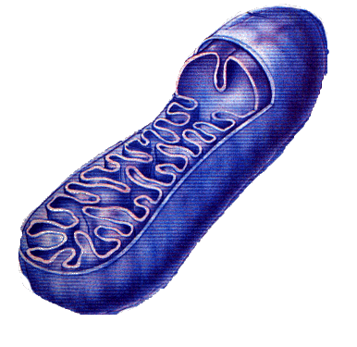
Lysosomes | Contains enzymes that break down proteins and other organic molecules  Digestion center | 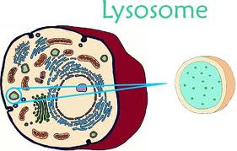
Golgi apparatus  Golgi body  Golgi complex | Packages and distributed proteins for export to cell surface  All eukaryotic cells have this | 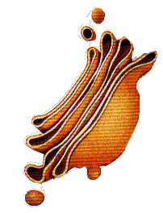
Microtubules | Part of cytoskeleton that gives support to cell  Associated with movement | 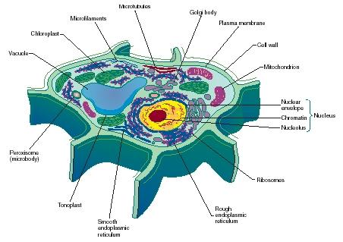
Cilia | Numerous hair like structures that are short and aid in cellular movement | 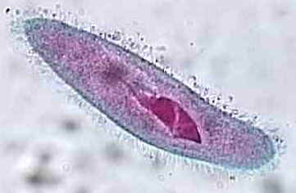
Flagella | One or two long hair like structures that are associated with cellular movement | 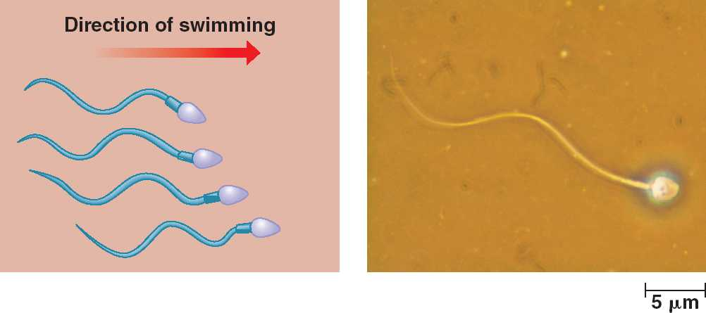
Microfilaments | Part of cytoskeleton that produces movement  Causes cyclosis  Creates muscle contractions | 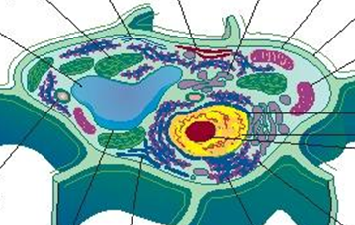
Centrioles | Located near the nucleus  Assist in animal cell reproduction  Occur in pairs | 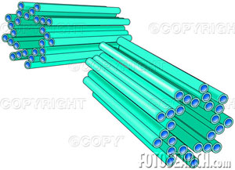
Central vacuole | Plant cells only  Large fluid filled cavity | 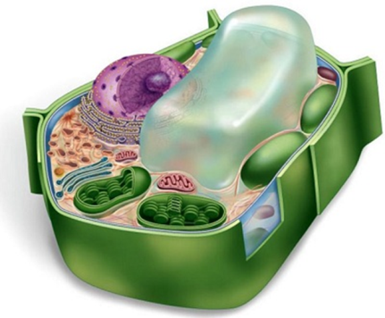
Contractile vacuole | Helps one celled water dwelling organism get rid of excess water | 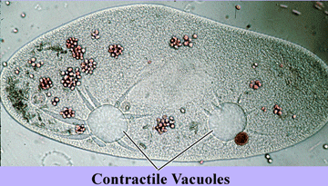
Vesicle | Storage area for water and waste products  Animal cells only | 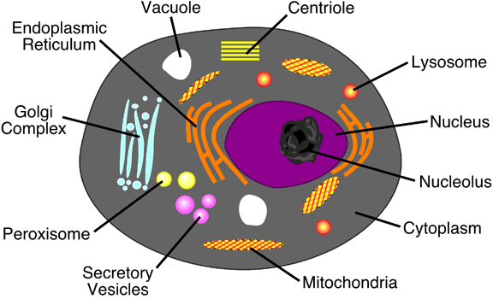
Cell wall | Protection and support for prokaryotic bacteria and eukaryotic plant and fungi cells  Outer most layer in above organisms’ cells
Chloroplasts | Contains pigment chlorophyll  where most photosynthesis occurs | 