**WORD AND BEYOND!**

Tips and tricks for using Microsoft Word

How to insert clipart and pictures: 2

How to add Wordart: 3

How to add tables: 4

How to create columns: 5

How to create screen shots: 6

How to track changes: 7

How to create an outline you can manipulate: 8

Other topics you don’t want to miss: 9

**How to insert clipart and pictures:**

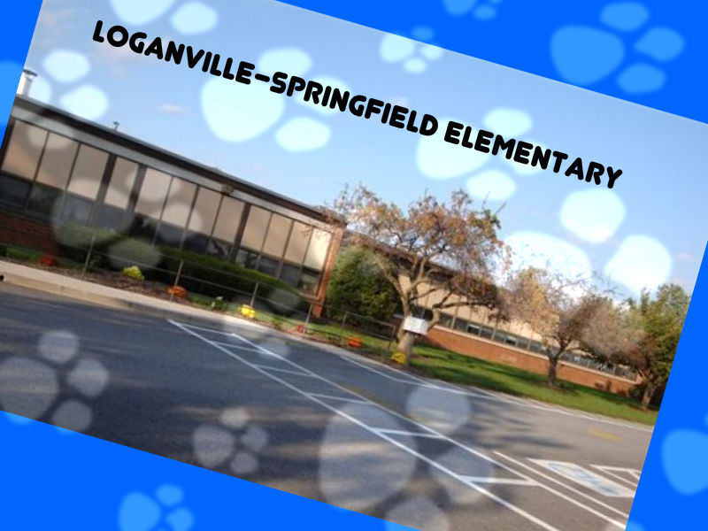

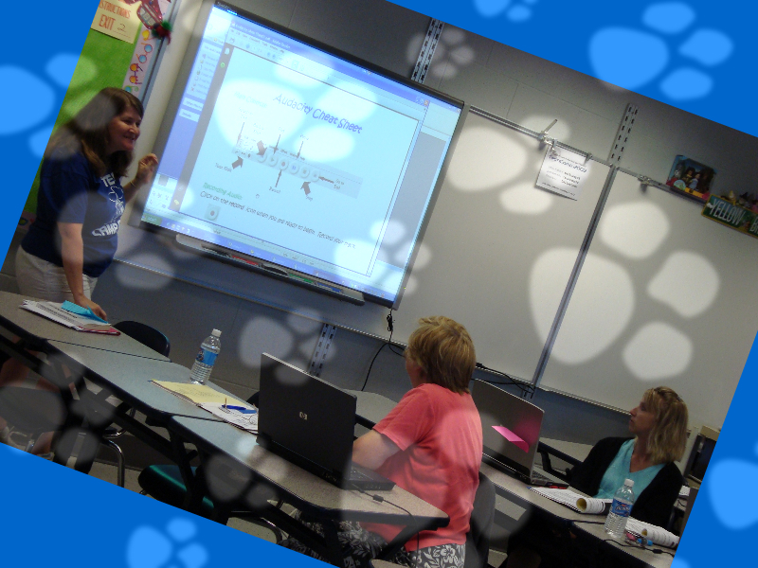****

**How to add Wordart:**

How to add tables:

**Dallastown Area School District Total Number of Staff and Students**

|  |  |  |  |  |  |  |  |  |
| --- | --- | --- | --- | --- | --- | --- | --- | --- |
|  | LH | LS | OV | YT | DT | MS | HS | Total |
| Students |  |  |  |  |  |  |  |  |
| Faculty |  |  |  |  |  |  |  |  |
| Total |  |  |  |  |  |  |  |  |

How to create columns:

The quick brown fox jumps over the lazy dog. The quick brown fox jumps over the lazy dog. The quick brown fox jumps over the lazy dog. The quick brown fox jumps over the lazy dog. The quick brown fox jumps over the lazy dog. The quick brown fox jumps over the lazy dog. The quick brown fox jumps over the lazy dog. The quick brown fox jumps over the lazy dog. The quick brown fox jumps over the lazy dog. The quick brown fox jumps over the lazy dog.

The quick brown fox jumps over the lazy dog. The quick brown fox jumps over the lazy dog. The

How to create screen shots:

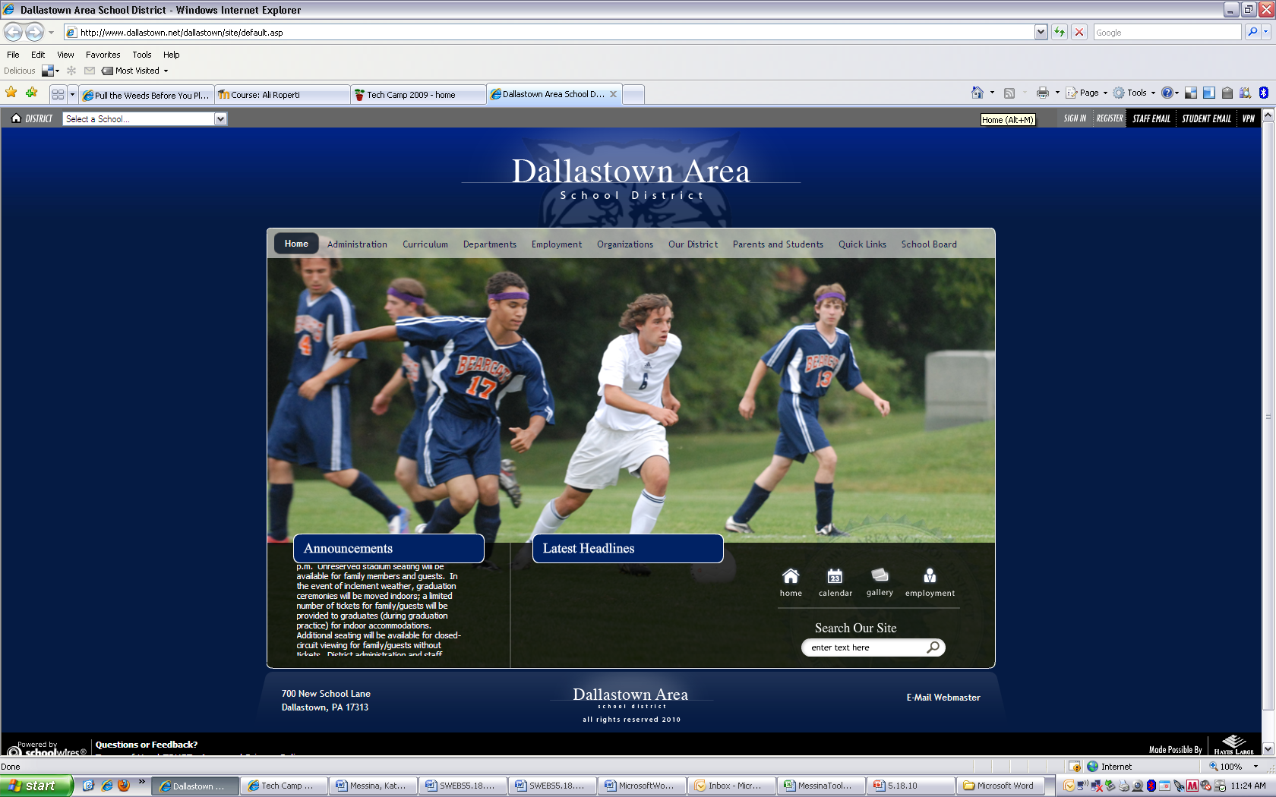

How to track changes:

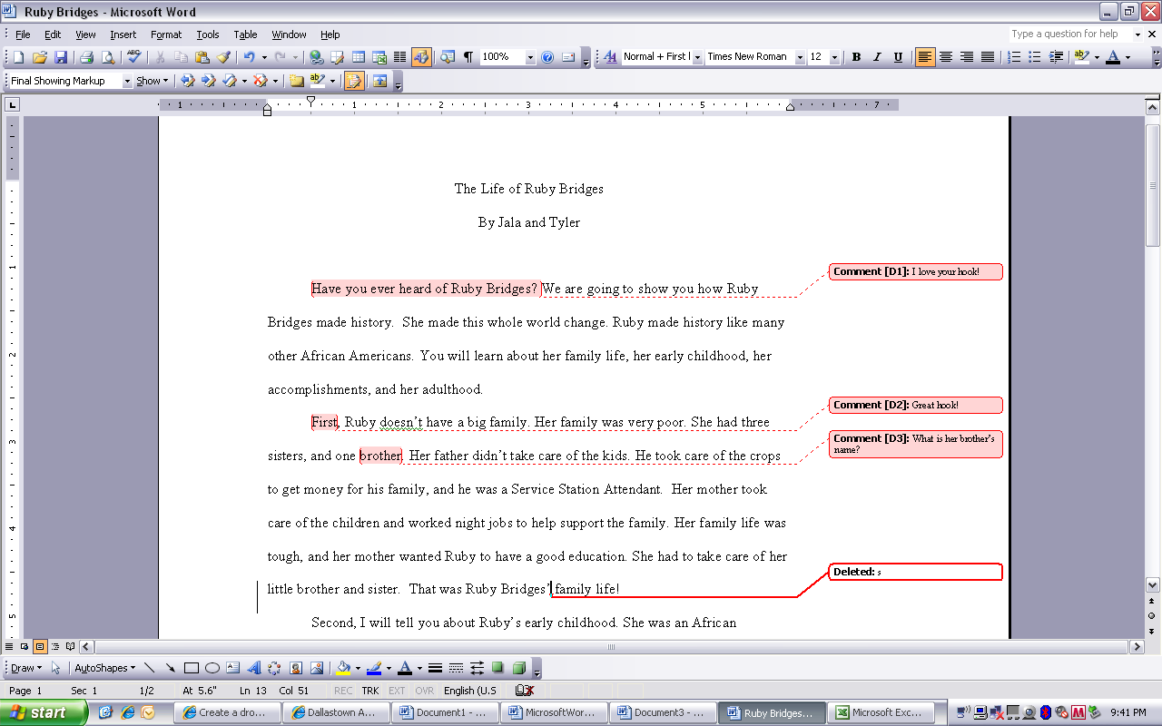

How to create an outline you can manipulate:

# Tech camp is a great way to learn new things

## Microsoft Word

### How to create outlines

## Wordpress blogs

### How to create a class blog

## Del.icio.us social bookmarking

### How to save your favorites and share them with friends

# You can earn things by attending tech camp

## Prizes

### For example, USB drives and microphones

## Two credits

### Can’t beat that!

# You can spent time with your friends at tech camp

Other topics you don’t want to miss:

How to…

✔add drop caps

✔add borders, shading, and background

✔mail merge

✔add shortcuts to access folders from your “My Places” bar

✔copy and paste Excel documents and make them look GOOD

✔use the table of contents template

✔use tabs

✔use shortcuts