FETAL PIG DISSECTION PROCEDURE

SEE FIGURES 1 and 2.

1. Place the specimen on its dorsal surface. All cuts will be made to the
ventral surface

2. Using the scalpel and scissors, start posterior to the umbilical cord and
make a cut to the right and left of the umbilical cord. (See below)

2. Cut around the umbilical cord

3. Continue cutting through the middle of the body until you reach the
pectoral area.

4. Make a cut to the left of middle and a cut to the right of middle

5. Continue cutting through the middle of the pig to the top of the throat
area.
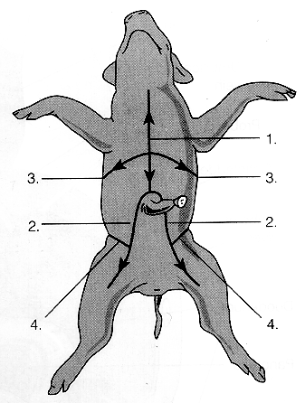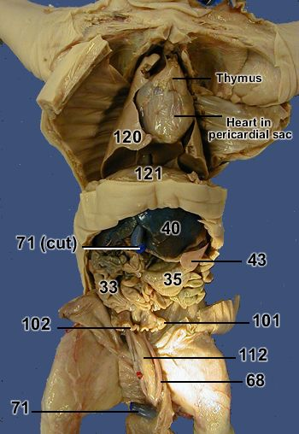
Figure 1 Where to cut on ventral
surface of the specimen.
Figure 2 Ventral view of
dissected specimen.

