The Fish

A. Class Agnatha (_______________ fish)

1. General Characteristics:

- They are believed to be the most primitive and ___________________ vertebrates.

- Lamprey and hagfish are the only 2 ________________ members of this class and are placed in the Order Cyclostomata.

- Hagfish live as ___________________ (eating dead fish) and lamprey as parasites (attaching themselves to living fish).

- Have a cartilaginous __________________________.

- Do not have ________________________ appendages.

- Do not have ________________________________.

2. The Lamprey

- Live in both ______________ water and _______________ water.

- Adult may grow to _________ inches and weigh up to a ______________.

- Soft ___________________ that is slimy and brownish-green color.

- No jaw, _________________, or ribs.

- Nasal opening on __________________ of head leading to olfactory sacs.

- Within these sacs are receptors sensitive to __________.
- Seven _______________ slits on either side of the head.
As water moves in and out of the gill slits, _______________________
dissolved in water is taken in and ____________________ is given off.

- Have funnel-like __________________________ with sharp teeth.

- Attaches itself to other ______________________ by suction.
Tears a hole in the fish's side with its __________________ and injects a chemical to keep the fish's ___________ from clotting.
Then sucks out blood and _________________ fluids.

- No __________________________.

- __________________________________ fertilization.

- Adults ________________________ after gametes are released.

- Atlantic __________________________ lamprey have caused extensive damage to lake trout in the Great Lakes.

How?

- Construction of _____________________ linking the lakes to the Atlantic Ocean permitted sea lampreys to invade the Great Lakes.

- The annual catch went from _________ million pounds to less than a__________ million pounds.

3. Hagfish
- Produces _____________________

B. Class Chondrichthyes (__________________________________ fish)
Ex. sharks, skates, and rays

1. Sharks
- The ________________________ living fishes.

- Gray-colored skin is covered by rows of ______________________
__________________.

Each scale has backward pointing _____________________ covered by enamel.

This makes the shark's ______________ feel like sandpaper.

- Scales + __________________ are the only bone-like material, in the shark's body.

- Body is _________________________-shaped.

- Most are _______________________________.

- Water enters the _____________________ as the shark moves forward.
It passes over the gills; ____________________ are exchanged, and exits through the _________________ slits.

- Have specialized _____________________________ organs:

*Two large ____________________ to see at close range.

*Paired nostrils where water enters and is tested for dissolved
______________________.

*This is a shark's sense of ______________ that guides it to food.

*They can detect blood up to ____________of a mile away.

- Sharks have a sense organ called the __________________ line present on the sides of its body.

- These are sensory cells that can detect underwater __________________ caused by an uneven swimming motion of an injured fish.

- Fertilization occurs ________________________________.

2. Rays and Skates

- Have _______________ bodies with whip-like tails.

- __________________ have diamond or disk-shaped bodies and ___________________________ are usually more triangular.

- Much slower than ________________________.

- Most are ________________________ dwellers and feed on mollusks and crustaceans.

- Have ________________________ mouth with strong jaws.

- Water enters through ___________openings on top of their
heads called ______________________.

It passes over their ______________ and exits through ventral gill slits.

- They hide themselves by lying on the ocean _______________ buried in sand or mud.

- Stingrays have a tail with a venomous barbed ___________________ and use it for protection.

C. Class Osteichthyes (_________________________ fish)

1. Body Shape and Structure

- Fish bodies are divided into a head, ____________, and tail section.

- Have a streamlined body and strong _________________ making them very fast swimmers.

- On each side of the _________________________ is a crescent-shaped slit where the gills are located.

They are protected by a hard plate called the
_____________________.

- Fish scales are thin, flat disks of ________________ that grow
from pockets in the ___________________________.

They overlap like _______________________ on a roof.

They grow larger as the ___________________ gets bigger.

As the fish grows, new __________________ form on its scales (much like growth rings on a tree).

_______________ lines show where growth has stopped for that
year.

- Fish feel slimy because their _____________ are lubricated by a mucus secreted from glands behind the scales.

This helps them __________________________ smoothly through water and helps protect them from parasites.

- Many fish have a color pattern known as________________________ camouflage.

Their __________________ surface is lighter colored than the __________________________ surface.

Others can change colors to match their _________________________.

2. Fins:

a) Paired fins

- _____________________________ fins are nearest the head and correspond to the ______________________ of higher vertebrates.

- ____________________ fins are posterior to and below the
pectoral fins and correspond to ________________ of higher vertebrates.

- Pectoral + pelvic fins are used mainly for steering and keeping ___________________________________ when resting.

b) Single fins

- ______________ fin grows from the tail.

It helps to push the fish ______________.

- _____________________________fins (anterior and posterior) help the fish to stay in an ___________________ position while swimming.

- ___________________ fin grows along the midline on the ventral surface and helps the fish maintain ___________________ while moving.

3. Organ Systems

- Digestive System

  - Most fishes have large _________________ with many sharp teeth.

These teeth slant _________________ making it hard for prey to
escape once it is in the mouth.

- Taste buds lining the tongue and mouth help it to detect ____________________ in the water.

- The ______________ (throat cavity) leads to a short esophagus which joins the upper end of the stomach.

- From the _____________________, food passes to a short intestine where digestion and absorption of food by the ___________________ takes place.

b) Circulatory System

- Fish ________________ contains both red + white blood cells.

- Have a _________-chambered heart.

Pumping chamber is called the ________________________.

- Ventricle pumps the blood from the _______________ to the capillaries of the gills where the blood picks up dissolved ________________ gas from the water and gives off __________________.

- As the oxygenated blood leaves the gills, it is carried to all parts of the body passing through the capillaries of various ___________________.

Eventually, the blood leaves the capillaries and enters the ___________________ which lead it back to the heart into the _________________.

- The ________________ pumps blood back into the ventricle.

c) Respiration

- Organs of respiration are the _____________.

- A gill consists of an _____________________ of bone or cartilage
(gill arch) fringed with a "double row of projections called ___________ filaments.

These filaments have many capillaries which brings the blood in close contact with ____________________ to exchange gases.

d) Air Bladder

- The air bladder acts as a ______________ helping the fish to move to different ____________________________ in the water.

Ex. Fish live at different ________________ at different times of the year.

- It is filled with 0₂ N₂, and C0₂ that pass into it from the _____________ and they can adjust the amount of ____________________ inside it.

e) Senses in Fish

- Olfactory (__________________) sense is the keenest sense.

They probably use this sense to ___________________ food.

- They detect sound vibrations through ________________ bones.

- Lateral ___________________ is also associated with hearing.

It is formed by a single row of pitted ________________
running along each side of the fish containing sensory _____________.

These help to detect ___________ frequency vibrations in the water.

- Fish have large _____________, but can only see clearly up to about a ___________ away.

Beyond this, they can detect ________________, but not see clearly.

f) Reproduction

- Gonads (____________ organs) lie above the intestines.

- Most bony fish have _____________________ fertilization.

Ex. Female lays her eggs (___________________) and male swims over and discharges his sperm (____________________) onto the eggs.

Internal Anatomy of Fish

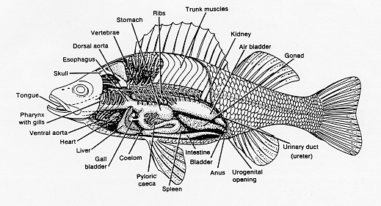
http://io.uwinnipeg.ca/~simmons/images/lb8fig1b.gif

External Anatomy of Fish

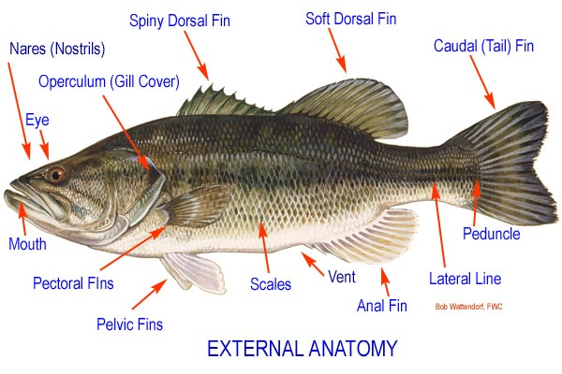
http://www.kentuckylake.com/fishing/fishfacts/pics/ext-anat.jpg

