Biology Final Exam 2012 Review

Viruses and Bacteria

- Compare the size of a bacteria cell with the size of viruses.
- List cell structures in a bacteria cell
- List the vector and pathogen of Lyme disease.
- What is the role of antibiotics?
- What is the role a vaccinations?
- List the steps in the lytic and lysogenic cycle of viral reproduction.
- Describe the structure of a virus.
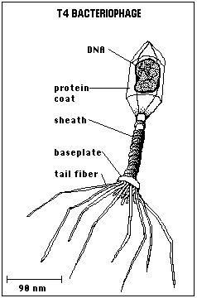
- Label the parts of the virus below.

- What was Edward Jenner’s claim to fame?
- What part of the human body possesses the most bacterial inhabitants?

Ecology

- Define the following terms:

Individual
Community
Population
Ecology
Niche
Migration
Habitat
Hibernation
Estivation
Nocturnal
Diurnal
Closed population
Open population
Parasite
Host
Commensalism
Mutualism
Parasitism
Natality
Mortality
Carrying capacity
Extinction
Biotic community
Abiotic factor
Immigration
Emigration
Predator
Prey
Competition
Ecosystem
Biome
Succession
Transpiration
Evaporation
Precipitation
Condensation
Decomposers
Extinction
Pelagic Zone
Benthic Zone
Littoral Zone
Intertidal Zone
Endangered Species
Omnivore
Carnivore
Herbivore
Arboreal-
Symbiotic relationships/types- parasitism, mutualism, commensalism
Explain levels in a food chain/web
Explain pyramid of energy
Summarize Water cycle
Summarize Carbon/oxygen cycle
Summarize Phosphorus cycle
Summarize Nitrogen cycle
Review annual rate of change problems and population density problems/ calculations
- Woody plants that lose their leaves in the fall ___________________
- Process of losing water from a plant’s leaf __________________________
- Biomes that occur in the ocean or other salt water sources are called ______________
- Primary _______________ refers to the gradual change of a land area where life never existed before.
- A piece of the biosphere where living and nonliving interact
- In the ___________ biome, animal are arboreal or tree dwellers.
- Animals that are primary consumers or plant eaters are called _________________
- In an ecosystem, _______ is transferred through the different trophic levels.
- Biomes that occur on land are called __________________________
- A type of grassland, found in Africa, that has scattered trees is called a __________
- Two biomes that receive less than 10 inches of rain a year are the ___________ and ___________
- Plants living in extremely dry environments are called ___________________
- The floor of the ocean is called the _________ zone
- This biomes receives 10-30 inches of rain a year
- Secondary consumers or animals that eat other animals are called_____________
- The thin layer of the Earth where life exists is called the _________________
- A complex system of food chains form a _________________________
- Type of succession that occurs after a disaster _________________________
- The name of the community that occurs when succession has slowed up due to the environment being in equilibrium ______________________________
- Region of the ocean that is covered and uncovered by the tides is called the ________________ zone
- A specific region of the biosphere that can be characterized by its climate and dominant vegetation is a ___________________________
- Ground that is permanently frozen in the tundra is called __________________
- Biome that contains the most biodiversity is the __________________________

Genetics
Define the following:
  - DNA – structure, function
  - RNA – structure, functions of 3 kinds
  - Transcription
  - Translation
  - Nucleotide
  - Replication
  - Heredity
  - Genetics
  - Genes
  - Genomes
  - Gametes
  - Homozygous
  - Heterozygous
  - Phenotype
  - Genotype
  - Dominant
  - Allele
  - Recessive
  - Sex linked
  - Multiple alleles
  - Incomplete dominance
  - Dihybrid
  - Gregor Mendel
  - Punnett square
  - Co dominance
  - Nature vs Nurture of traits
  - Cloning
  - Recombinant DNA
  - Genetic engineering of insulin
List the Types of mutations
Relationship of genes, chromosomes and the nuclei of cells

Evolution
- Natural selection - steps
- Antibiotic resistance of bacteria-How does it occur
- Vestigial structures
- Homologous structures
- Sexual dimorphism
- Survival of fittest, evidence of success
- Divergence
- Convergence
- Gradualism
- Punctuated Equilibrium
- Artificial Selection vs Natural Selection

Discussion questions and problems
- The following is a strand of DNA:

TAC CCG TTA ACC CGC CCC ATA

mRNA ____ ____ ____ ____ ____ ____ ____

tRNA ____ ____ ____ ____ ____ ____ ____

amino acids :

Show the mRNA, tRNA, and amino acid sequence of this strand.

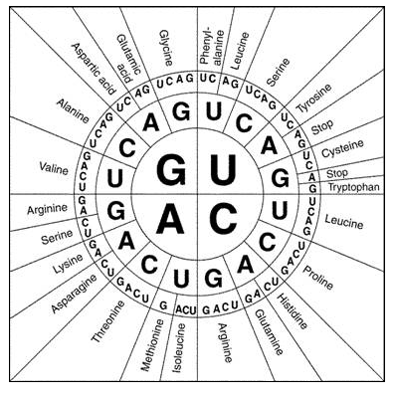

2. Sex Linked Problem
In reindeer, the red nosed condition is recessive to the black nosed condition,
which is dominant. It is also sex-linked.

Assume that a red nosed male reindeer is crossed with a heterozygous black
nosed female reindeer.

Indicate the different phenotypes of the offspring and the ratio that they will appear.

Briefly explain how this pattern of inheritance works.

3. Select one of the following ecological problems.
Ecological Problems
Greenhouse effect
Fertilizers and run off
Ozone depletion
Deforestation

For the ecological problem that you selected, briefly describe the problem and state one way to reduce it. In your answer be sure to:
- state the ecological problem you selected
- state how humans have caused the problem you selected
- describe one specific effect that the problem you selected will have on the ecosystem
- state one specific action humans could take to reduce the problem you selected.

4. Diagram a pyramid of energy and explain why a pyramid is a good representation of how energy passes through an ecosystem.

5. Explain how photosynthesis and Respiration interact with each other in terms of the effect on the amounts of carbon dioxide and oxygen in the air.

6. Diagram a strand of DNA consisting of 6 nucleotide base pairs. Label at least one of each of the following:
Nitrogen base pair, hydrogen bond, Sugar, Phospate

7. Describe the role of each of the following in protein synthesis: DNA sense strand, mRNA, tRNA, rRNA/Ribosome

8. What is nondisjunction? Name a disorder that is caused by nondisjunction.

9. If T=tall and t= short. If a heterozygous tall plant is crossed with another heterozygous tall plant, what is the chance of producing the following:

- A homozygous/pure breeding tall plant?
- A hybrid plant?
- Plants that have a tall phenotype.
10. If a man of blood type O marries a woman of blood type AB. What is the percent probability of the following blood types in their children:
a. Type A
b. Type O
c. Type AB
d. Type B

11. If Red, White and Pink flowers represents incomplete dominance and a Pink flower is crossed with a pink flower. What would the Phenotype ratio of be in the offspring?

12. Explain how each of the following would be caused by antibiotic over use and would result in antibiotic resistant strains through natural selection:
Over production, Inherited variations, Increased reproductive success, increased allele frequency.

