Biology Name ___________________________
Kingdom Protista Pd _______ Date _____________

A Comparison of Amoeba to Paramecium.

1. Comparison of Structure:
Use terms from the following list to label the diagrams of the amoeba and the paramecium. Some terms will be used more than once.

Anal pore  Cell membrane  Cilia  Contractile vacuole  Cytoplasm  Food vacuole  Gullet  Lysosome | Macronucleus  Micronucleus  Mouth pore  Nucleus  Oral groove  Pellicle  Pseudopod

2. Feeding and Digestion:
a. On a separate piece of paper, use the following terms to write a
paragraph describing the technique used by an amoeba to obtain food,
digest food, and to eliminate digestive wastes. Underline each word
when it appears in your paragraph.

Cell Membrane
Digestive waste
Enzymes
Exocytosis
Food vacuole
Lysosome
Phagocytosis
Pseudopod

b. On a separate piece of paper, use the following terms to write a
paragraph describing the technique used by a paramecium to obtain
food, digest food, and to eliminate digestive wastes. Underline each
word when it appears in your paragraph.

Anal pore
Cilia
Digestive waste
Enzymes
Exocytosis
Food vacuole
Gullet
Lysosome
Mouth pore
Oral groove

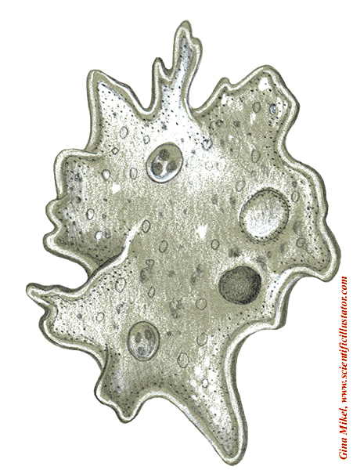
4.
2.
3.
7.
6.
1.
Figure 1 Amoeba
5.
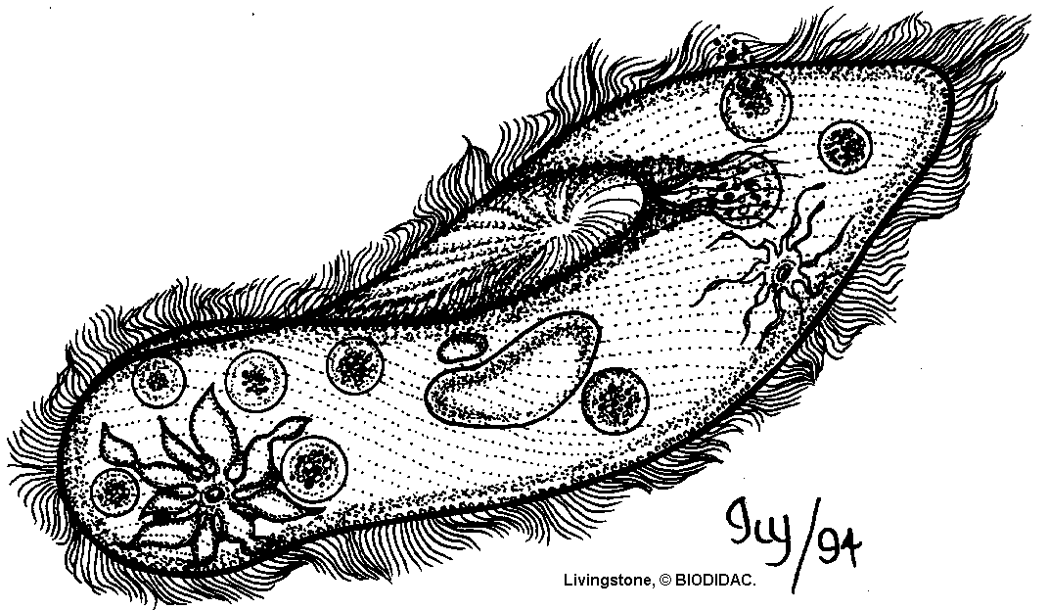
8.
9.
1.

(on surface of organism)
2.
3.
7.
6.
4.(Opening)
5.
10.
11.

And

12._____________

Figure 2 Paramecium

