Kingdom Protista A Mixed Bag of Organisms
- Protists:
- are _________________________________ (membrane bound ___________________ and other _________________________ present).
- may be _____________________________ or __________________________.
- obtain nutrients by _______________________, ______________________, or by ______________________________.
- reproduction is by _________________________ or _______________________________ means.
- There are more than __________________________ species of protists.
- They are divided into ___________________ major categories:
- ______________________________ protists (plant like) such as _____________________
- ___________________________________ protists (_________________ like) such as _________________, _______________ _________________, and ________________ ___________________________
Autotrophic Protists (algae)
- There are about _________________________ species of algae.
- Most algae are ____________________, but some grow in ______________________ and on tree _____________________.
- Many algae are ____________________________ and float in _________________ and _____________________.
- They are called ______________________________________.
- Phyto = _______________
- Planktos = ______________________________________

Autotrophic Protists (algae)
- They contain __________________________ and carry on ________________________________, so they are an important
________________________ source for many _____________________ animals.
- They form the basis for all _______________________ in the oceans.
- They produce ________________________% of the oxygen in the atmosphere.
Heterotrophic Protists (Protozoans)
- Characteristics similar to __________________________________
- ______________________________
- ability to __________________________
- Habitat:
- ______________________ __________________________ environments
- _____________________ and __________________ water
- _________________________________ of organisms
- _________________________________
- ___________ major Phyla (based on how they ____________________)
- Phylum ______________________ = ______________________
- Phylum ______________________ = ______________________
- Phylum ______________________ = ______________________
- Phylum ______________________ = ______________________

The Protist Kingdoms Protozoans and Algae
Heterotrophic Protists
The following are all ________________________________ protists.
Called the _____________________________________
Phylum Sarcodina
- Example: _______________________
- Move using _______________________________ = “false feet”.
- Motion is called ___________________ ___________________________.
- Shape of amoeba is always _______________________________________.
- Pseudopods also used for _________________________________ purposes.
- Amoebas eat ________________ and other _______________________.
- Have a _________________________ ___________________________ that is used to eliminate excess water and liquid waste.
- Respond to _______________________
- move toward ______________________
- move away from ___________, ___________________, and toxic chemicals
- Other examples include _______________________________ which have hard calcium carbonate exoskeletons
- Form ______________ ____________________ ____ ______________
Amoeba Diagram
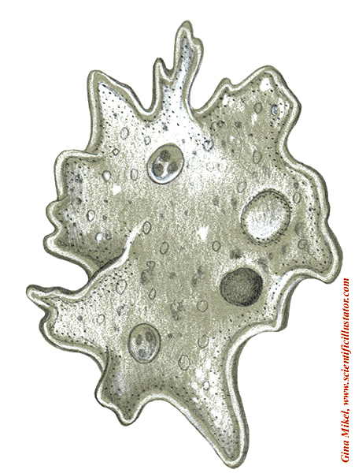

Phylum Ciliophora
- Example: _______________________
- Covered with _________________—body also rotates as it swims causing a _________________________ movement
- Feeds on ________________, bacteria, ______________, and other __________________ through the _______________ ___________________.
- ________________________ vacuole present for waste elimination.
- Thick outer covering called the ______________________________.
- _________ nuclei
- macronucleus – _____________________________________________
- micronucleus- control ________________________________________
- responds to ______________________
- move toward _______________and optimum ______________________
- move away from: extreme ____________________, areas with little or no ___________________, and __________________ chemicals
- defense mechanism = _________________________ –long thread like structures that shoot out when the paramecium is ____________________________________.
- Other examples: _______________________, __________________________

Paramecium Diagram macronucleus micronucleus
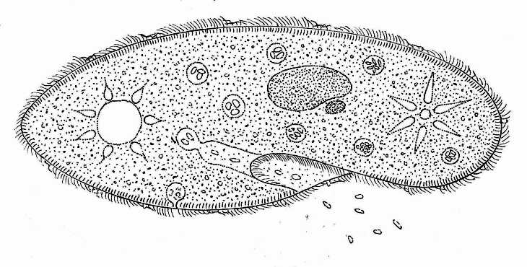
Cilia Contractile forming oral mouth food pellicle
Vacuole food groove pore vacuole
Vacuole gullet

Trichocysts

http://www.biology-resources.com/drawing-paramecium.html

Phylum Zoomastigina (Mastigophora)
- Example: ________________________________
- Move using one or more whip like ____________________________________
- Some are ______________________; some are ________________________.
- Parasitic forms attack _____________________________________________
________________________________________________________________.
- Causes _______________________________________________________
- trypanosomes in blood of _______________________________
- vector = _______________________________- bites the mammal and it gets the trypanosome
- Tsetse fly bites a _____________________________
- In human, trypanosome multiplies in the ______________________ and produces _________________________.
- Blood cells are __________________________________.
- Symptoms:_________________________________________________

Phylum Sporozoa
- Example: __________________________________
- ____________________________
- ____________________________
- reproduces by producing _______________________________
- Causes _________________________________
- Kills more than ______________________________ people per year.
- Vector= ___________________________________________ mosquito
- Female mosquito bites an ____________________ ________________.
- ____________________________ are produced in the mosquitoes body
- Female mosquito bites another person and transfers plasmodium spores to their ___________________________.
- Spores go to the ___________________and reproduce in the red blood cells (_____________________)
- RBC’s ____________________ and release new _________________ into the body (harmful to the immune system).

Importance of Protozoans
Importance # 1
- Causes ____________________________ in humans
- amoeba = amoebic ____________________________
- ___________________________ – African Sleeping Sickness
- Plasmodium = ________________________________
- Giardia = ____________________________ (infected water)
- Toxoplasma = ______________________________ (cat feces)
Importance # 2
- Members of the _______________________ organisms found in the oceans.
- plankton – small organisms that _____________________ in the water and serve as __________________ for larger organisms
- heterotrophic = _______________________________
- autotrophic = ____________________________________
Importance # 3
- Some members of Phylum ________________________________ have calcium carbonate (________________________) shells.
- When they die, the shells ______________ and accumulate on the ocean floor (______________________________________).
Algae Structure and Function
Structure
- Most algae have cell walls made of _____________________________.
- Some are made of _____________________(main ingredient of glass).
- Algae cells contain __________________ of different sizes and shapes.
- These chloroplasts often contain _____________________________
which are particular areas of the chloroplast where
_________________ is converted to _______________ and stored.
Arrangement
- There are many different types of algae.
- Some are ________________________ celled, some are _________________________ made up of rows of cells, and some are ______________________ having a body called a ___________________________.
- Each cell in a thallus acts ___________________________ from any other and does not form complex structures.
- Some algae consist of single cells that swim by use of a flagella.
- Algae that have flagella differ from each other in how many flagella they have and the position of the flagella on the cell.
Zoospores
- A zoospore is produced by a multicellular algae and has a _________________________.
- It is a ____________________, _____________________ spore.
Autotrophic Protists
The following are all ____________________________________
Make own food from __________________________________________
Classification
- There are ____________ phyla of algae.
- _______________________________ (euglena)
- __________________________ (golden algae = _______________________)

- _____________________________ (Peridinium = ______________________________________)
- ____________________________ (green algae)
- ____________________________ (brown algae = kelp, seaweed)
- ____________________________ (Red algae= seaweed)

Phylum Euglenophyta
- Example: ____________________________
- Have characteristics similar to both _________________ and _______________________.
- Photosynthetic when _________________________ is available.
- Heterotrophic when _______________________ is available, it will ___________________________ nutrients from surroundings.
- ____________________________________
- Common in ____________________ and ___________________________
- _________________________________ provides movement
- _____________________ _____________________________ present that is _________________________ sensitive
Euglena Diagram
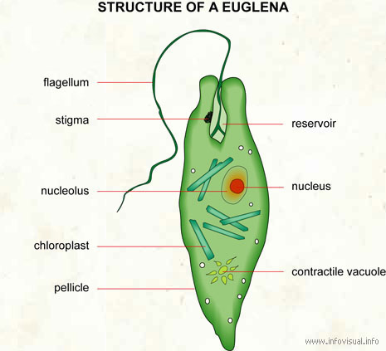

Flagella

Red eyespot

Nucleus

Chloroplast

Pellicle

Nucleolus

Contractile vacuole
http://www.infovisual.info/02/001_en.html
Phylum Chrysophyta (golden algae)
- Example: ____________________________
- Golden color due to ________________ and ______________ pigments
- Cell walls are glasslike and made of ______________________
- Composed of ____________________________ (like a pill box).
- Many designs with different ______________________________.
- When the organism dies, the shell sinks to the bottom of the ocean. The accumulation of the shells creates _______________________________.
- This is mined and used as a ________________________________, in ______________________, and ____________________________, in _____________________ and in __________________________ systems
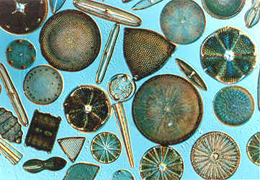
Phylum Pyrrophyta (Dinoflagellata)
- Example: ________________________________
- Composed of many _______________________ plates made of ____________________ and ________________________.
- _____________________________ provide movement.
- Some produce powerful ___________________________ which contaminate the water—may also _____________________ the water
- Example: __________________________________—Shellfish that swim in the red tide are toxic for consumption.
- Some are capable of ____________________________________—the ability to produce ______________________________.
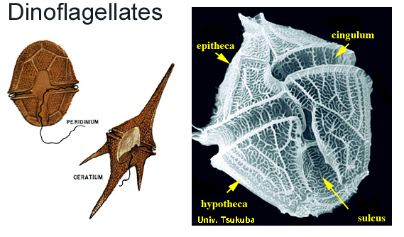

Phylum Chlorophyta (green algae)
- There are over ______________________species of green algae.
- Most are _______________________ and live in ____________________ water or on _________________
- There are some ___________________ forms.
- Example: _____________________ (sea lettuce)
- Plants are thought to have evolved from the ________________ algae because:
- Both groups have the same ________________________________ pigments.
- Both have __________________________ in the cell walls.
- Both store their food as ________________________.
- There are _______major forms of green algae

- Unicellular
- Example: Chlamydomonas—common algae in freshwater _____________ that has a cup shaped chloroplast and ______ flagella of the same size.
- There are some unicellular green algae that do not have _________________.
- Many of these live in the _______________ or on the ______________________ of trees.
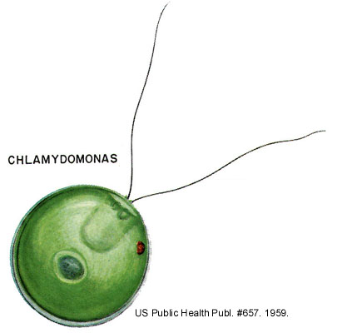
- Colonial
- Example : ______________________(thousands of cells in one colony)
- Each cell is held together with the other cells by strands of cytoplasm.
- Each cell is positioned with the _________________________- on the outside and when they beat, the colony moves as one organism. (_________)
.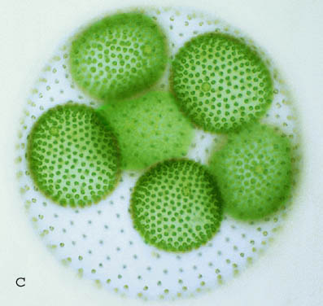
- Filamentous
- Example: Spirogyra and Oedogonium
- These are algae that grow in ___________________ ponds and streams
.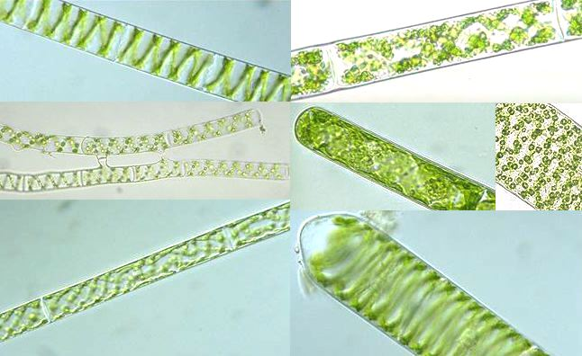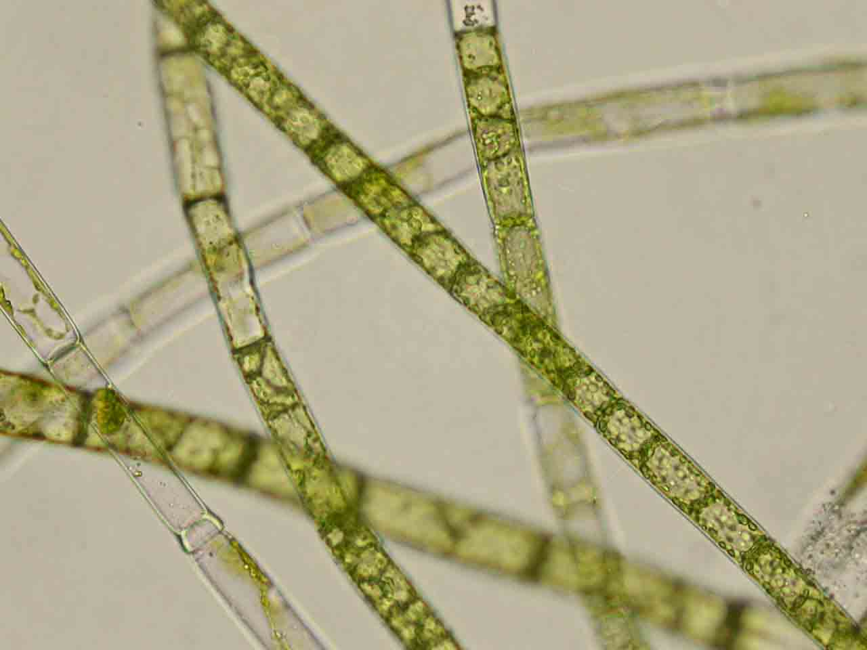
- Multicellular
- Ulva (______________________________________)
- Marine form (__________________ water)

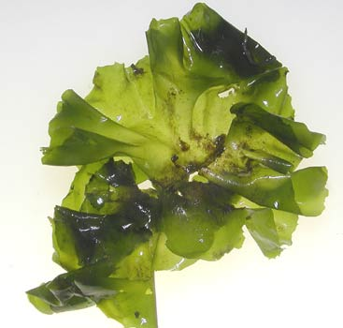

Phylum Phaeophyta (brown algae)
- Examples: _____________________________________________________
- Found in ____________________ _____________________ waters.
- ______________________ water
- Anchors to bottom with ______________________________
- _________ _____________________ keep thallus upright under water.

- Kelp- A Common ______________________ Algae
- Largest type = ________________________
- Attaches to ocean __________________ or _____________________
- Grown commercially for:
1. _____________________
2. to produce _____________________________ which are thickening agents in foods, cosmetics, and paints.
- Sargassum Sea—covered with _____________________ masses of Sargassum
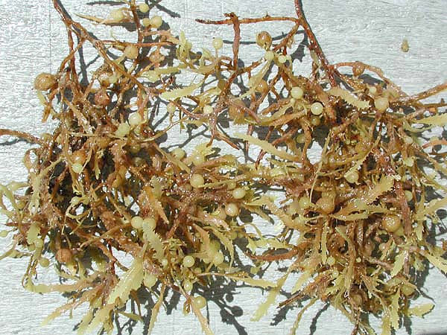

Phylum Rhodophyta (Red algae)
- Example: ______________________
- Found in ______________________ ocean waters
- Grow at __________________________ depths
- Contain __________________, ___________________, and _____________________________________________
- Carrageenan is used in foods to prevent the ______________________ of mixtures, such as _______________________________________ and ________________________________.

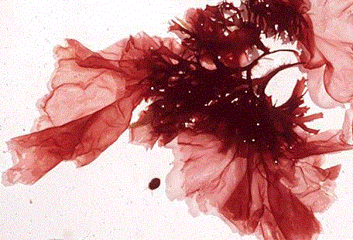
Fungus Like Protists
- Fungus-like Protists (also ____________________________________)
- look like a _____________________________
- get nutrients from ____________________ and decaying matter
- ________ groups
- _________________________ ____________________
- _________________________ ____________________

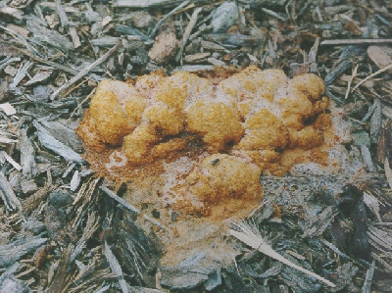
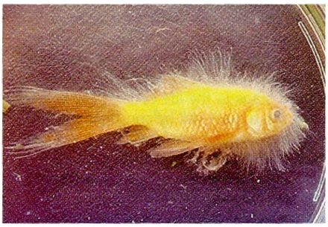

www.coopext.colostate.edu/TRA/PLANTS/slime.html www.geocities.com/ymike2002/protista.htm

