Cellular Structure & Function

Name:___________________________________________Period:_____Date:_________

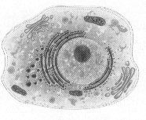**_______ – the basic unit of life!**

**I. Basic HISTORY:**

* _________________living thing-from the tiniest bacterium to the largest whale-is made of one or more cells!
* Before the seventeenth century, no one knew that ____________existed.
* Most cells are too __________to be seen with the______________________.
* Not discovered until after the invention of the_____________________in the early 17th century.

**II. IMPORTANT SCIENTISTS:**

* A Dutch drapery storeowner________________________________, became the __________ person to OBSERVE and DESCRIBE MICROSCOPIC ORGANISMS and LIVING CELLS.

* 1665: the English Scientist ________________________________used a microscope to examine a thin slice of ___________and described it as consisting of "a great many little boxes". It was after his observation that Hooke called what he saw "cells". They looked like "little boxes" and reminded him of the small rooms in which monks lived. So he called them "____________".

* 1824: the French scientist **Henri Dutrochet** concluded that ____________and ____________ tissue were always made up of cells

* 1831: **Robert Brown** named the _____________________

* In 1838: German Botanist **Matthias Schleiden** concluded that all__________ are made of cells

* 1839: German Zoologist **Theodor Schwann** reported that ___________are also made of cells
* 1845: **Felix Dujardin**- studied the living cell and noted it contained a material called________________________.
* In 1855: German Physician **Rudolf Virchow** induced that ALL cells come from __________________cells.
* The COMBINED work of **Schleiden**, **Schwann**, and **Virchow** make up what is now known as the modern_______________________.

1

**III. The Cell Theory Consists of 3 Principles:**

1. All living things are _______________of one or more____________.
2. __________are the basic units of ____________and **___________**in an organism.
3. Cells come __________from the **_________________**of_____________________cells.

**IV. TWO TYPES of CELLS:**

1. _______________________________= cells that contain a ___________________and ___________________________________________

~Ex: ____________, fish, mammals, _____________and ______________

1. ____________________________= cell that ______________a _________________and ___________________________________________

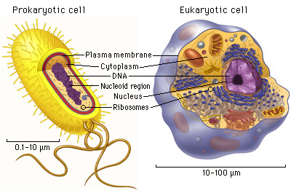 ~Ex: _____________________organisms such as __________________and their relatives

**V. CELL DIVERSITY:**

* Not all cells are_____________.
* Cells within the same organism show enormous diversity in___________, **__________**, and ____________________________.

o Your body contains at least ___________different cell types!

**VI. CELL SIZE**:

* A few types of cells are large enough to be seen by the ______________eye.

o ____________________is the_________________ cell in the body, and can be seen without the aid of a microscope.

* Most cells are visible only with a____________________.

* **Most cells are small for 2 reasons:**

1. Cells are limited in size by the _____________between their _____________________ and their _________________.

* + As a cell’s size increases, its volume increases much faster than its surface area. (see picture below)

2. The cell’s nucleus (the brain) can only control a certain amount of living, active cytoplasm.

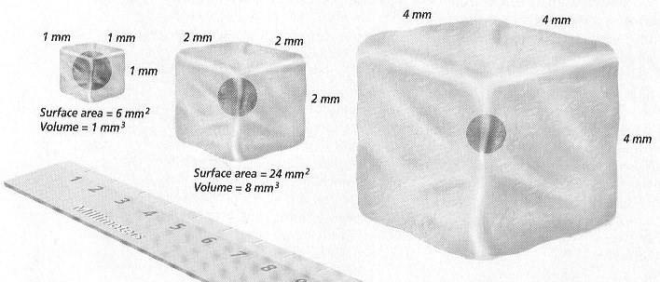

**VII. CELL SHAPE:**

* ________________of shapes.

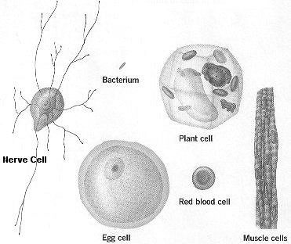

* The ______________of the cell depends on its

___________________

* Ex: _________________that carry information from your toes to your brain are long and threadlike.

* Ex: ____________________are shaped like round disk that can squeeze through tiny blood vessels.

**VIII. CELLULAR ORGANIZATION:**

* ________________________are made up of many

cells, each of which is specialized to perform a distinct function.

o Digestion, movement, respiration, filtering, etc…

* ____________________DO NOT carry out ALL life functions, but rather depend on each other
* ______________= a group of cells functioning together to perform and activity
  + Ex: muscle and nerve tissues
  + Ex: Plant tissues = stem and root
* _____________________= groups of two or more tissues that function together
* Stomach, leaf of a plant
* Cooperation among organs makes life functions within an organism efficient
* __________________ ________________________ = groups of organs that work together for a common function
  + Ex: circulatory system = heart, blood vessels, blood
  + Ex: digestive system = stomach, esophagus, intestines
* _______________________________ = a single living thing
  + If multicellular, most have groups of organ systems

SUMMARY ___________________________________________________

