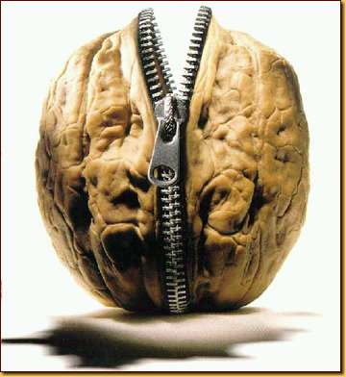**The War of the Titans:** In a Nutshell

Giant mythological super beings, dudes throwing lightning bolts, giants with fifty heads: doesn't get much better than that. Oh, you're not a fan of the action? You're more of a drama person? Well, then, here's a little something for you: this story is also full of love, betrayal, family hardship, and triumph in the face of tyranny. Oh, and bonus: the story of the war of the Titans contains the answer to life, the universe, and, well, everything.

This story of the war between the elder gods, also known as the Titans, and their younger siblings, the Olympians, is totally epic. It's also one of our best early examples of how a story can change (and boy do we mean change) when told by many different authors. The story of the Titan war was handled in bits and pieces by dozens of authors, and trying to read it is like listening to a bunch of old Greek dudes play Telephone.

To make matters worse, most of the authors who wrote about the war only covered small pieces of it. The closest thing that we have to the "whole story" is a poem about the creation of the universe. This poem, called the *Theogony,* was written sometime during the 8th century BC by a part-time poet named Hesiod. And sure, the *Theogony* is our best source for information about the war, but it's a bit dry. We don't want to say that it's boring but… it's a little boring. A good war needs juicy details, which is probably why later authors seem to have embellished (added to) Hesiod's version to make it more interesting. But all this piecing together means that just figuring out who did what to whom can be quite a challenge.

So we already talked about playing Telephone, but it turns out that this whole going-through-a-lot-of-people-before-it-gets-to-you thing is a pretty everyday occurrence. Think about it: whenever you (or your parents) turn on the news to catch up on daily events, there's a good chance that the reports you're hearing have gone through at least three of four different people before they get to you. And to top it off, people who witness the same event don't always notice the same things.

Lately, we've been seeing the Titan War pop up all over – in movies, books, TV shows, and even video games. Rick Riordan spends a lot of time with the Titans in his popular novel series, [*Percy Jackson and the Olympians*](http://www.percyjackson.co.uk/site/pj_books.php) and there have even been a handful of Hollywood blockbusters (think[*Clash of the Titans*](http://www.imdb.com/title/tt0800320/) [2010] and [*Immortals*](http://www.imdb.com/title/tt1253864/) [2011]). Finally, the Titans smash their way onto the videogame screen in games like [*God of War*](http://www.godofwar.com/Index/)*.* Now's your chance to become a Titans buff: knowing how this war *really* went down will help you better understand how today's artists are interpreting the mythology.

**Why Should I Care?**

This story is epic. So it's fitting that we find it in two of Homer's epic tales: [**The *Iliad***](http://www.shmoop.com/iliad/) (about the Trojan War) and [**The *Odyssey***](http://www.shmoop.com/odyssey/) (about Odysseus' long journey home). The war between the Titans and the Olympians was a "historical" reality both for Homer and his characters.   
  
Virgil doesn't spend more than a line or two directly discussing our rockin' Titans, but the war was definitely part of Aeneas' world in the [**The *Aeneid***](http://www.shmoop.com/aeneid/).  
  
The first story in Ovid's [***Metamorphoses***](http://www.shmoop.com/metamorphoses/) is a very, very condensed version of the creation of the universe.   
  
Milton alludes heavily to Hesiod's *Theogony* in multiple books of [***Paradise Lost***](http://www.shmoop.com/paradise-lost/allusions.html). But remember, Milton is a Christian poet and, well, the War of the Titans most definitely is not.  
  
And of course Rick Riordan gives us a modern interpretation of ancient Greek mythology in his popular series, *Percy Jackson and the Olympians.* Check out the first book, [***The Lightning Thief***](http://www.shmoop.com/percy-jackson-lightning-thief/) for some great references to Zeus' might.