**Notes: Ecology #1**

What is ecology?

**The study of the interaction of organisms with their environment**

**Levels of Organization**

* Living organisms affect and are affected by their environment.
  + Organisms and their environment interact!
* Levels of organization:

**Individual (organism)**

* An organism of a particular species that is capable of carrying out all life processes
* Cannot be divided into parts that can function independently
* Can be difficult to identify
* Examples:

**Population**

* A group of the same type of organisms (species) living in the same place in a given time.
* Example: 90 mountain lions (**type**) living in the Colorado Rocky Mountains (**place**) during the summer of 2005 (**time**)

**How do populations change?**

* The size of a population changes over time
  + _______________, or
  + _______________
* To see how a population has changed, you will need:
  + - Data on a population from a given area at two or more points in time
* Example:
  + In 1994, there were 175 cardinals living in Dallastown.
  + In 2005, there were 250 cardinals living in Dallastown.
  + Change = ______________________________________
* Example:
  + In 2003, an experiment on beetles was begun at Lion’s Park in which there were 200 beetles.
  + After 2 years there were 25 beetles.
  + Change = ______________________________________

**Calculating Rate of Change**

* Rate of Change:
  + Annual change in a population
* Calculations:

Change in pop. = Pop. from recent year – Pop. from oldest year

Change in time Most recent year – Oldest year

* Positive answer:
  + Indicates annual **______________** in population
* Negative answer:
  + Indicates annual **______________** in population

**Rate of Change Examples**

**Example 1:**

* + - In 1994, there were 175 cardinals living in Dallastown.
    - In 2005, there were 250 cardinals living in Dallastown.
    - What is the rate of change for this cardinal population?

Calculations:

**Example 2:**

* + - In 2003, an experiment on beetles was begun at Lion’s Park in which there were 200 beetles.
    - After 2 years there were 25 beetles.
    - What is the rate of change for this beetle population?

Calculations:

**Why do populations change?**

* Many factors can cause changes in population:
  + **Birth** (**natality**) = Birth rate
    - Increase pop.
  + **Death** (**mortality**) = Death rate
    - Decrease pop.
  + **Immigration** = Individuals move into a population
    - Increase pop.
  + **Emigration** = Individuals leave a population and go to another
    - Decrease pop.

**Open vs. Closed Populations**

* **Open Population**
  + A group of organisms, without boundaries, where birth, death, immigration, and emigration affect the population size
  + No rigid edges or barriers
  + Populations in nature are **open populations**
  + Growth curve in an open population:

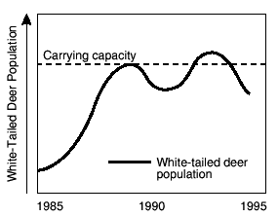

*\*\*Maximum population wavers around the carrying capacity (K)\*\**

* + **Carrying Capacity**—the maximum number of individuals an environment can support.
* **Closed Population**
  + A population where boundaries exist
  + No immigration or emigration
  + Only birth and death change the population size
  + Ex. Aquarium, lab setting, zoo, isolated island

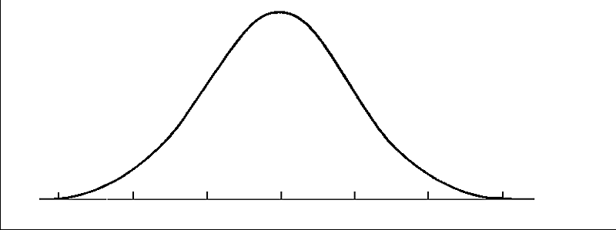

**Time**

**Population**

*\*\*Without immigration to stabilize population, closed populations can experience extinction\*\**

**Limiting Factors**

* Limiting factors:
  + Factors that Limit Population Size
  + Biotic or abiotic
* **Biotic** – Living factors that limit population size
  + ________________
  + ________________
  + ________________
  + ________________
  + ________________—among members of the same species for mates and habitat
* **Abiotic**— Nonliving factors that limit population size
  + ________________—each individual needs a certain amount of space to live
  + ___________________________________________
  + ­­___________________________________________
  + _____________________________________________
  + _____________________________________________
  + _____________________________________________
  + _____________________________________________