

Name: ___________________________________Period: _______Date: __________

1. **ROLE OF CARBON IN ORGANISMS:**

___________________________= compounds that contain carbon and hydrogen

* + - * + Ex: Carbohydrates, lipids, proteins

___________________________= compounds that DO NOT contain carbon and hydrogen

* + - * + Ex: Vitamins, minerals, water

Carbon forms ____covalent bonds to become stable

Can join with other carbons to form straight__________, branches or________________.

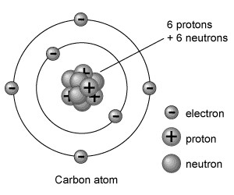

These structures may contain

______________carbon atoms

* + - * + This makes many

__________________possible!

____________________= the simplest carbon compound (CH4)

____________________= any molecule made ONLY of _______________and ______________atoms!

* + - * + Ex: Methane
        + Methane’s ________________or chemical formula is __________
        + Methane’s________________________:

o Bonds are represented by _______________

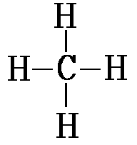

_______________ = compounds that have the same

____________________but different ______________

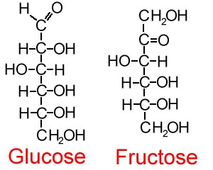

• Ex: Glucose & Fructose

o Formula- _____________

__________________ ______________can range from

_________carbon atoms to ________________of carbon atoms

1. **THE DIGESTIVE SYSTEM:**

The digestive system breaks down organic compounds into their building blocks

(____________________________)

Body cells take the monomers and put them together in the form the body can use

____________________= extremely large compounds made of smaller ones.

_________________= large molecule formed when many smaller molecules

(monomers) bond together, usually in __________ chains

* + Ex: Carbohydrates, proteins, lipids, nucleic acids
  + Polymers and their monomers:

|  |  |
| --- | --- |
| **POLYMERS** | **MONOMERS (building blocks)** |
| **Carbohydrate** |  |
| **Protein** |  |
| **Lipid** |  |
| **Nucleic Acid** |  |

**WHAT PROCESS ALLOWS BODY CELLS TO MAKE LARGE COMPOUNDS FROM MONOMERS?**

* + _________________________**_or Condensation reactions**=
  + The _______________of _____and ______ (water) from the individual molecules so that a ____________may form between them and result in a more

____________________molecule

* This is an _______________________________________ process.
* ______________________organic molecules
* ________________________ bonds = store energy

o Humans – _______________________ production

* Plants – fruit & veggie production

Dehydration synthesis represented by an equation:

Monomer + Monomer 🡪 Polymer + water

For example:

* + 1. Amino Acid + Amino Acid 🡪 ________________________________
    2. Monosaccharide + Monosaccharide🡪 __________________________
    3. Fatty Acids + Glycerol 🡪 __________________________________

**2**

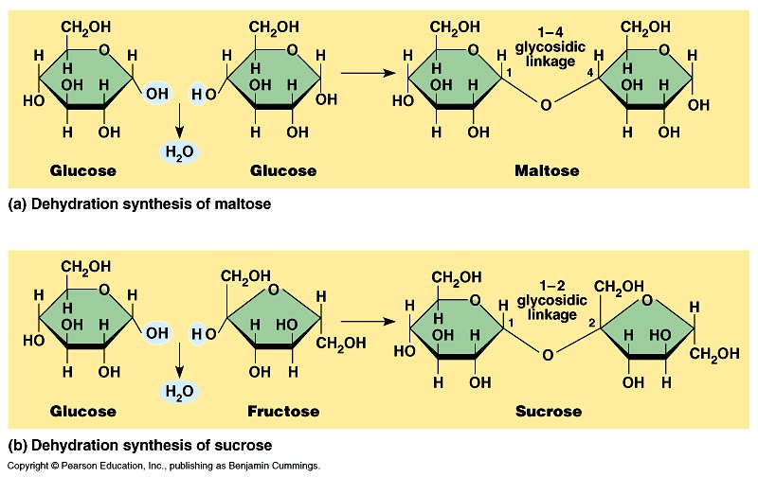

**+**

**H**

**O**

**+**

**H**

**2**

**O**

**WHAT PROCESS ALLOWS THE DIGESTIVE SYSTEM TO BREAKDOWN NUTRIENTS?**

• ________________= (hydro =______________, Lysis =__________)

* The breaking of a large compound (polymer) into smaller compounds (monomers)

through the addition of -H and –OH (water).

* This is a ___________________________ process.
* Breaks organic molecules _____________
* Break bonds = release __________________
* Occurs during ___________________– release energy from food

Hydrolysis represented by an equation:

Polymer + water 🡪 monomer + monomer

For example:

* + 1. Protein + water 🡪 _____________________________________
    2. Carbohydrate + water 🡪_________________________________
    3. Lipid + water 🡪_________________________________________

**HYDROLYSIS OF SUCROSE:**

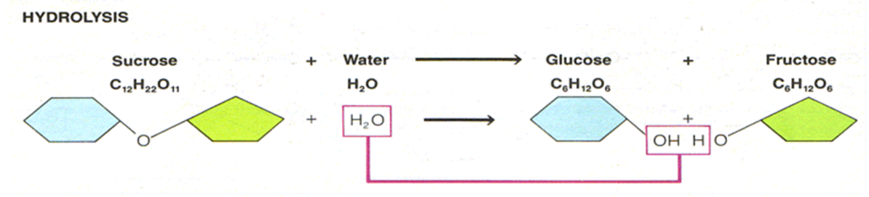

**WHAT DO ATHLETES EAT THE DAY BEFORE A BIG GAME?**

____________________________________________________

____________________________________________________

____________________________________________________

1. **CARBOHYDRATES:**

**Foods**: pasta, bread, fruits, veggies

Compounds used for ______________and release of _________________

Made of C, H, O atoms

**Reduced** formula: _____________

* H:O ratio is always _________________

**How do you identify a carbohydrate?**

• Look at the kinds and number of atoms

* Ratio is ___Hydrogen atoms: ___Oxygen atom **always!**
* Rings of C, H, O (# of rings tells type of carb)

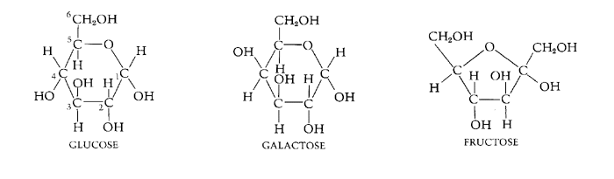

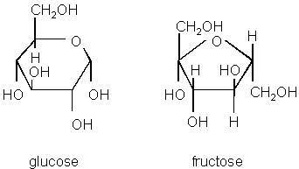**3 types of carbohydrates:**

* 1. __________________________= C6H12O6
  + _______________sugar (6 carbons)
  + Ex: _________________________________________
* Glucose = veggies
* Fructose = fruits
* Galactose = milk sugar
* Only form our ________can use for ______________________ _____________
  1. **___________________________**= C12H22O11

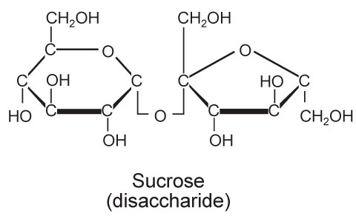

__________sugar made of 2 simple sugars (Monosaccharide + Monosaccharide)

* + - * Combined by _____________________________ reaction

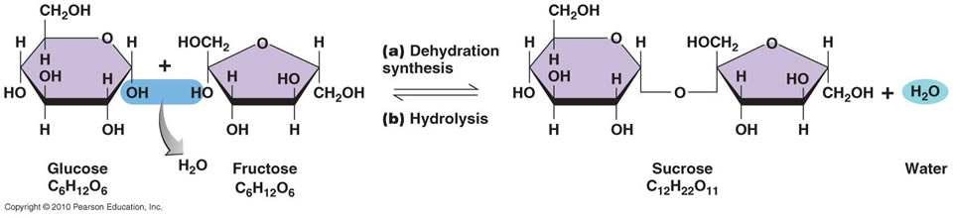

* + - * Used for ___________________ energy supply; not instant.

Ex: sucrose, lactose, maltose

* + - * ________________: (table sugar) Glucose + Fructose🡪 sucrose + H2O
      * ________________: (milk sugar) Glucose + Galactose🡪 lactose + H2O

• __________________: Glucose + Glucose + glucose 🡪 maltose + H2O

**3.** ______________________________=

More than 2 ____________________________ joined by dehydration synthesis

Ex:

* + ______________ (________________)- Plant’s energy storing molecule

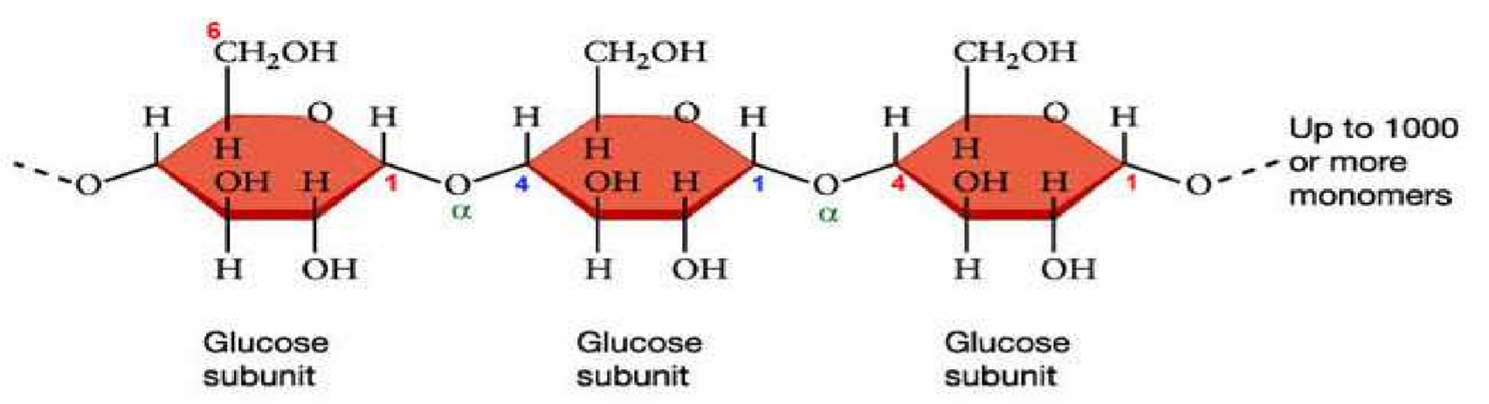

**Starch**

* + ______________________- Animal’s energy storing molecule

o Energy storage form of ______________________

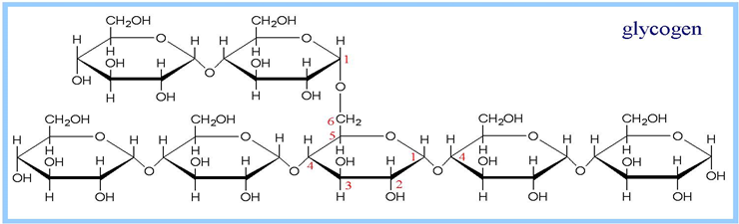o Found in the liver and skeletal muscle

o When the body needs

____________________ between

meals/physical activity, glycogen is broken down into glucose through _____________________________

* + ________________- provides structure in plant cell walls (cannot be digested by human body)

**What happens to CARBOHYDRATES in the body?**

* Broken down by the digestive system via HYDROLYSIS into _______________ which are then absorbed into the body through the_____________________, where the body cells take the monosaccharides and produce _____________.
* After the immediate energy requirements of all your body's tissues have been met, the excess glucose in your blood will be converted into a storage form of carbohydrate called ____________________ (found in your muscles and liver).
* If all of your glycogen stores are full and you still have excess glucose in your bloodstream, the remaining glucose will be converted to _________.

**IV. FUNCTIONAL GROUPS:**

Functional groups give a molecule __________________properties

_________________: (-OH) allows molecule to be more soluble in water

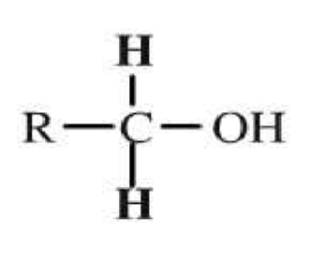

***Alcohol***

***Group***

* __________________: (-COOH) allows molecule to release H ions in water - therefore ______________!

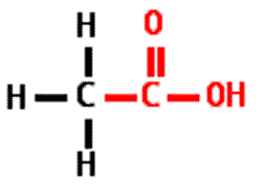• There is a ________________ ____________between carbon and oxygen

* _________________ __________: (-NH2) allows molecule to accept ions from an acid- therefore __________!

