Dehydration synthesis/Hydrolysis WS Name ________________________

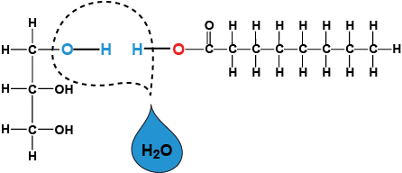1. _______________

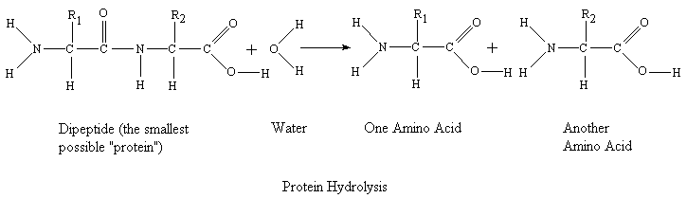

2. ___________________________

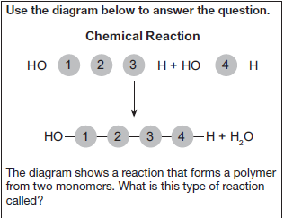3. ___________________________

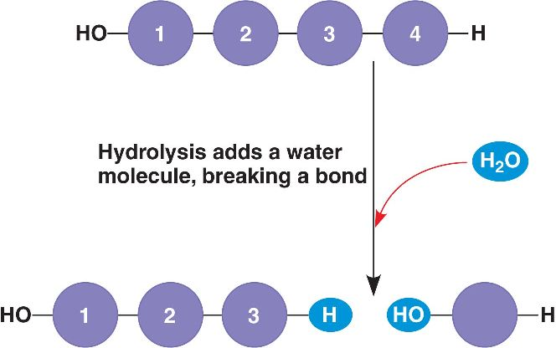 4. ____________________

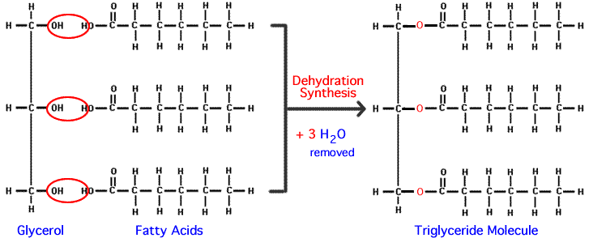5. __________

+ 3 H20

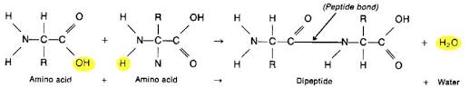6. __________

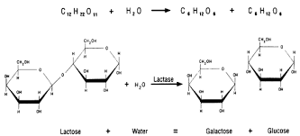7. _________________

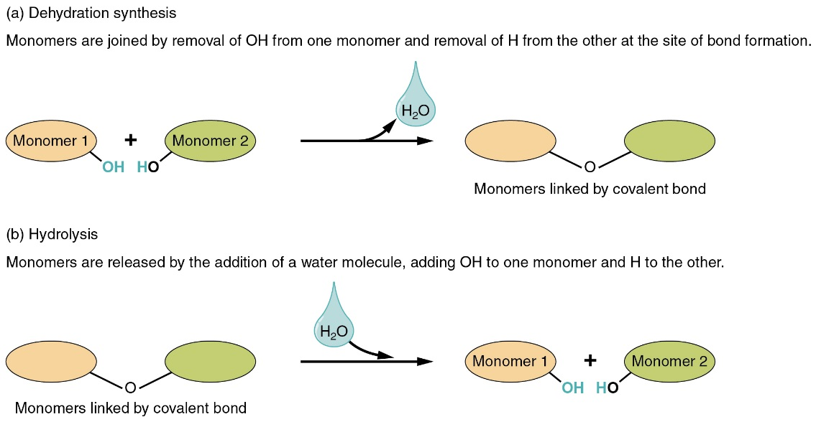8. _______

9. _______

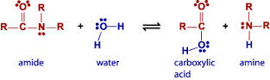10. __________