**“Search Filters OR “Operators” Rap-Poem Assignment**

**Mr. Donatelli**

**Directions:** You can work with one other person or by yourself to create a rap or poem about a search filter or operator below. The rap or poem needs to tell what it does and illustrate a situation in which someone would use a filter/operator including an example of its use. It needs to be a least 6-8 lines. When done, show me and print to be collected.

**Evaluation**: 8 points for creativity and completeness.

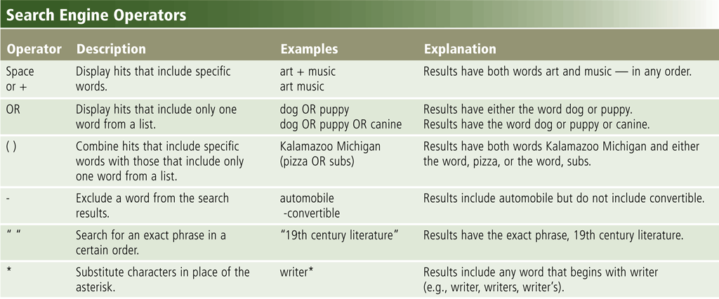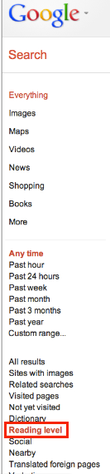

**Write your poem or rap below:**