**The Characteristics of Life**

Name: ___________________________________ Period: ____ Date: __________

***I. 8 Characteristics of Living Things:***

**1. Made of one or more ___________:**

* + - * __________ = basic unit of structure and function of all living things
      * Unicellular-bacterium, paramecium, amoeba
      * Multicellular-humans, snakes, plants, etc.
      * Prokaryotic – no membrane bound nucleus and organelles (bacteria)
      * Eukaryotic = membrane bound nucleus and organelles (everything else)

**2. _______________________________________:**

* All living things ____________ _______________ in a genetic code written _____ _________ ________ _______________________.
  + Genetic information is copied and passed from parent to offspring
  + Life’s genetic code is responsible for most of our traits and is almost the same in all living things—but for a few small differences

**3. ______________________________:**

* + - * Species must replace themselves
      * Is __________necessary for the survival of the

_________________organism; it is needed for the survival of the ____________________!

**4. _________________________________________:**

* + - * Living things grow because their CELLS grow and divide!
      * __________________= the increase in living material (cellular mass) and the formation of new structures

* + - * _______________________ = the changes that take place during the life of the organism.

**5. Responds to Stimuli:**

• _________________ = a condition in the environment that creates a response from the organism.

o Ex: temperature, weather, other organisms, etc..

* + - * _________________= the reaction to a stimulus
      * o Critical for the safety and ________________of an organism!
      * Ex: __________________= shark smells blood in the water; ______________= shark moves quickly toward the blood and attacks any organism present

**6. Requires _________________:**

• ______________ = the ability to do work or to make things move.

Powers life processes

Maintains _____________________, __________________, _________________, and ________________________.

Obtained from the _________ they eat. (Plants make their own!)

Main source of energy for all life is the ________

o Energy not only flows through the organism, but also through the community.

**7. Maintains Homeostasis:**

• ___________________________ **=** the regulation of an organism’s internal environment to maintain conditions that allow it to live.

Ex: Human’s _____________ and ______________, help the body maintain its proper ____________________-regulated by the hypothalamus

Ex: ___________________ of the blood- regulated by hormones

Ex: ______________ regulation for nerve and muscle function- regulated by the kidneys and intestine

Ex: ____________________________balance-regulated by the pancreas/insulin

Ex: __________________ balance-regulated via food/water intake and waste elimination

**8. Adaptations Evolve Over Time:**

• __________________________ = are inherited changes in structures, behaviors, or internal processes that enable an organism to respond to stimuli (survive).

o *Structure and behavior examples:*

* Long hind legs enable rabbits to quickly avoid predators; fur to _________________ body temperature; changing fur color for the different seasons

o *Internal stimuli examples:*

* + - * + 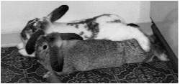____________balance, ________balance and___________________

**Movement**

* + Motion vs. Locomotion – what is the difference?
    - * + Motion = ___________________________________
        + Locomotion = _______________________________________ ___________________________________________________

***II. Basic Needs of Life:***

**1. Energy**

* + - Main source of energy—> ___________
    - Plants get energy directly from the sun
    - __________________ get energy from dead animals and plants
    - Animals get energy from eating _____________or an organism that eat plants

**2. Water and Minerals**

* + - Most organisms need ______________in order to survive
    - Living things are made up of about ________water

**3. Metabolism**

* __________________________ = all the chemical reactions that occur in an organism.
  + _______________________ = All synthesis reactions in a living organism; the building of complex organic molecules from simpler ones
    - Ex: ________________________________
  + ________________________ = Reactions involved in BREAKING DOWN complex molecules to produce simpler molecule
    - Ex: __________________ ________________________

**4. Basic Life Functions**

* **____________________ -** involves the activities involved in________________ (taking in and using materials for growth and energy), _______________________ (changing food to a usable form), and ___________________________ (getting rid of wastes).
* ____________________ - includes the ______________________ of materials into the body fluids, or through cell membranes and the ________________________________ or DISTRIBUTION OF MATERIALS to all the cells of the organism. (food, water, oxygen, wastes, etc.)
* ___________________________ - includes the chemical activities that release energy from organic molecules for use by the cells to perform all of the life functions. Requires oxygen for breathing
* __________________________ – includes all those activities involved in the ____________________________ OF CELLULAR WASTE PRODUCTS from the organism. These wastes include: __________________, ______________________ ________________________, ______________________, and _______________________ CONTAINING COMPOUNDS.
* _____________________________ - involves chemical reactions in which small molecules combine to form larger ones.
* _______________________ – increase in size brought about by _________________________ IN CELL __________________ AND CELL ___________________. The raw materials for growth are the products of synthesis
* _______________________ – involves the control and co-ordination of the life functions.
* ______________________________ – results in the production of new individuals.

**Review of the Characteristics of Life**

Name:___________________________________________________Period:_____Date:____________

Directions: *Answer the following questions specifically and concisely.*

1. What is biology?

1. What is a cell?

1. ________________ is the ability to do work.

1. What is the main source of energy for all life? _____________________________

1. ____________________ is a condition in the environment that creates a response from an organism.

1. What is the difference between motion and locomotion?

1. What is homeostasis?

1. What is an example of how our body maintains homeostasis?

1. __________________________ is an increase in living material while, _____________________ is the changes that take place during the life of an organism.

1. What is the “nature of science”?

1. List an example of how science is subject to change.

1. List an example of how science does not provide complete answers to all questions.

1. Fire has some of the characteristics of life (reproduces, needs energy, responds to stimuli). Why is it considered non-living?

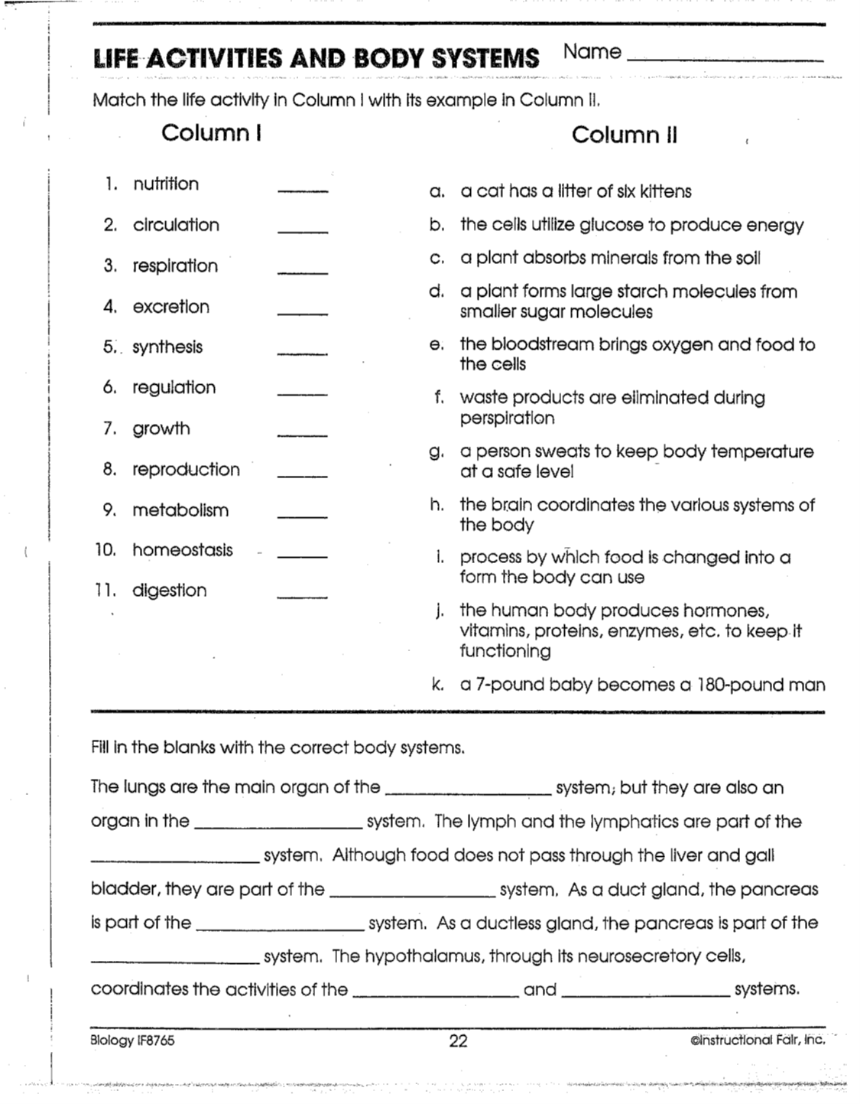

Characteristics of Life & The Scientific Method Vocabulary:

1. **Biology =** study of life

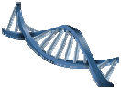

1. **Cell** = basic unit of structure and function of all living things

1. **Energy** = the ability to do work

1. **Homeostasis** = the regulation of an organism’s internal environment to maintain conditions that allow it to live

1. **Science** = Continuous process that seeks to answer questions about the natural world.

1. **Growth** = the increase in living material (cellular mass) and the formation of new structures

1. **Development** = the changes that take place during the life of the organism

1. **Stimulus** = a condition in the environment that creates a response

1. **Adaptations** = are inherited changes in structures, behaviors, or internal processes that enable an organism to respond to stimuli (survive)

1. **Motion** = movement or gestures

1. **Locomotion** = the ability to travel from place to place
2. **Metabolism** = all the chemical reaction occurring in an organisms
3. **Anabolism** = all the synthesis reaction in an organism ex: photosynthesis
4. **Catabolism**  = all the breakdown reaction occurring in an organisms ex: cellular respiration
5. **Nutrition** - involves the activities involved in INGESTION (taking in and using materials for growth and energy), DIGESTION (changing food to a usable form), and EGESTION (getting rid of wastes).
6. **Transport** - includes the ABSORPTION of materials into the body fluids, or through cell membranes and the CIRCULATION or DISTRIBUTION OF MATERIALS to all the cells of the organism. (food, water, oxygen, wastes, etc)
7. **Respiration** - includes the chemical activities that release energy from organic molecules for use by the cells to perform all of the life functions. Requires oxygen for breathing.
8. **Excretion** - includes all those activities involved in the ELIMINATION OF CELLULAR WASTE PRODUCTS from the organism. These wastes include: WATER, CARBON DIOXIDE, SALTS, and NITROGEN CONTAINING COMPOUNDS
9. **Synthesis** - involves chemical reactions in which small molecules combine to form larger ones.
10. **Growth** – increase in size brought about by INCREASES IN CELL SIZE AND CELL NUMBER. The raw materials for growth are the products of synthesis.
11. **Regulation** - involves the control and co-ordination of the life functions.
12. **Reproduction** - results in the production of new individuals.